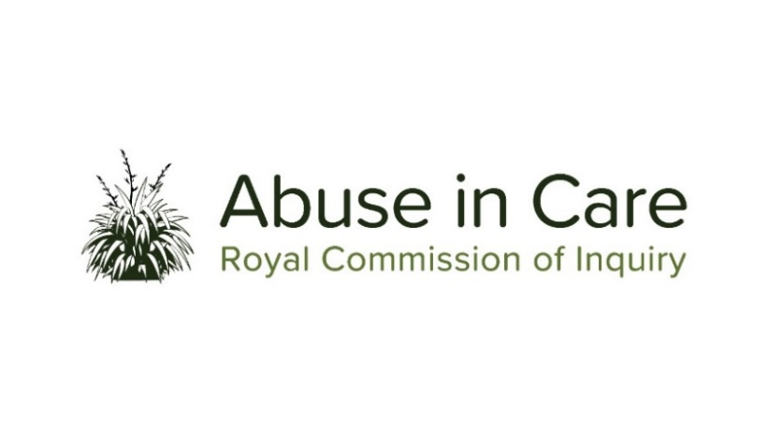
INVESTIGATION INTO ABUSE IN STATE AND FAITH-BASED DISABILITY CARE SETTINGS

SCOPE OF INVESTIGATION

- The Inquiry will investigate abuse in State and faith-based disability care settings in New Zealand. This investigation will examine the care of disabled people in settings such as psychopaedic hospitals and facilities, psychiatric institutions and services, education settings including special schools, residential and non-residential settings, community services and rehabilitation services.
- Abuse is defined in the Inquiry’s Terms of Reference as meaning physical, sexual, emotional or psychological abuse, and neglect. It includes inadequate or improper treatment that resulted in serious mental or physical harm to a person in care. Neglect is not defined in the Terms of Reference, but the Inquiry considers neglect may include physical, emotional and psychological, medical, educational, spiritual and cultural neglect.
- Disability is a broad and evolving term used in this investigation to include all physical, psychosocial, psychiatric, neurological and sensory impairments, and learning disabilities. The term disabled people includes those perceived to be disabled.
- The main period covered by this investigation is 1950 to 1999. However, the Inquiry has discretion to consider issues and experiences prior to 1950, and may also consider issues and experiences after 1999 in order to inform its recommendations.
- During the course of this investigation the Inquiry will select care providers and institutions as case studies of abuse in disability care settings, and may conduct research and examine relevant matters in public hearings, roundtables, wānanga, hui and fono.
- The Inquiry will seek out and consider the voices and experiences of victims and survivors of abuse in disability care settings. It will investigate and make findings on what happened and why including by examining:
  - The circumstances of disabled people being taken into or placed into disability care settings, and the appropriateness of those placements;
  - The nature and extent of abuse of disabled people in disability care settings;
  - The impact, including any differential impact, of abuse on victims and survivors of abuse, and on their families, whānau, hapū, iwi and communities. This will include consideration of:
    - The impact of discrimination against disabled victims and survivors;
    - Particular impacts related to disability and mental health status, including additional barriers to understanding and recognising abuse, disclosing abuse, accessing specialist wellbeing supports to respond to trauma, and receiving redress;
    - Principles of tikanga Māori when considering the impacts of abuse on Māori victims and survivors and their whānau, hapū and iwi;
    - Pacific cultural norms and values when considering the impact of abuse on victims and survivors among Pacific peoples.
  - Whether individuals experienced abuse in care because of nationality, race, ethnicity, religious belief, age, gender, gender identity, sexual orientation, physical or learning disability or mental health status;
  - The factors, including structural, systemic or practical factors that caused or contributed to the abuse of disabled people in care;
  - The adequacy of any actions by the State and faith-based institutions to prevent and respond to abuse of disabled people in disability care settings, including any lessons learned and changes made;
  - The applicable principles and obligations under Te Tiriti o Waitangi/the Treaty of Waitangi;
  - Obligations under domestic and international law, including human rights law;
  - The adequacy of redress and rehabilitation processes for victims and survivors of abuse in disability care settings.
- The investigation will also assess and make recommendations on:
  - Any gaps in legislation, policy, rules, standards and practices including oversight mechanisms that require change to prevent and respond to abuse of disabled people in care;
  - Any changes required to redress, rehabilitation and compensation processes for victims and survivors of abuse in disability care settings.
  - Any other steps the State and faith-based institutions should take to address the harm caused by the abuse in disability care settings.
- Where relevant, the Inquiry may make findings of fault or that relevant standards have been breached, or both. The Inquiry does not have the power to determine the civil, criminal or disciplinary liability of any person, but may make recommendations that further steps be taken to determine liability.

