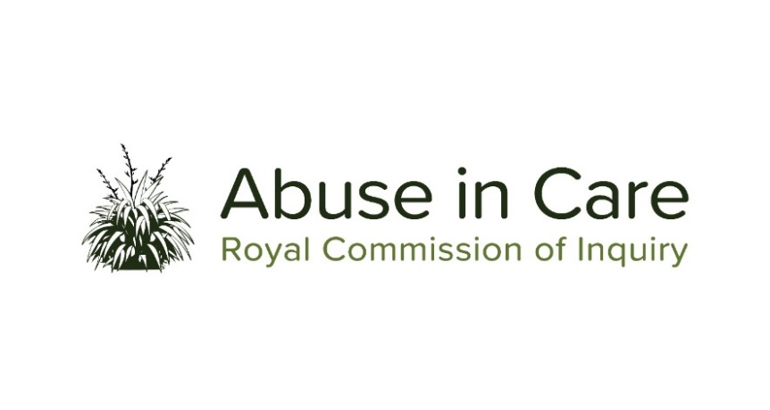
INVESTIGATION INTO ABUSE OF CHILDREN IN STATE RESIDENTIAL CARE

SCOPE OF INVESTIGATION

- This investigation will examine the abuse of children and young people in State based residential care (“State residential care”) in New Zealand in the following settings:
  - Children’s homes and institutions providing care and protection residential facilities for children and young people, including social welfare and family homes;
  - Institutions that provided remand or secure facilities as well as care and protection residential and/or training facilities for children and young people; and
  - Residential programmes or facilities provided by third parties, excluding those provided by faith-based institutions.
- This investigation will not examine abuse that occurred to children and young people in foster care, adoption placements, borstals and youth justice residences. Abuse that occurred in these settings will be examined during other investigations.
- Abuse is defined in the Inquiry’s Terms of Reference as meaning physical, sexual, emotional or psychological abuse, and neglect. It includes inadequate or improper treatment that resulted in serious mental or physical harm to a person in care. Neglect is not defined in the Terms of Reference, but the Inquiry considers neglect may include physical, emotional and psychological, medical, educational, spiritual and cultural neglect.
- The main period of investigation is 1950 to 1999, however the Inquiry has discretion to consider issues and experiences prior to 1950, and may also consider issues and experiences after 1999, in order to inform its recommendations.
- During the course of this investigation the Inquiry will select institutions, issues or themes as case studies of abuse of children and young people in State residential care, and may conduct research and examine relevant matters in public hearings, roundtables, wananga, hui and fono.
- The Inquiry will consider the voices and experiences of victims and survivors of abuse in State residential care. It will investigate and make findings on what happened and why including by examining:
  - The circumstances of children and young people being taken into or placed into State residential care, and the appropriateness of those placements;
  - The nature and extent of abuse of children and young people in State residential care;
  - The impact, including any differential impact, of abuse on victims and survivors, and on their families, whānau, hapū, iwi and communities. This will include consideration of:
    - Tikanga Māori when considering the impacts of abuse on Māori victims and survivors and their whānau, hapū and iwi;
    - Pacific cultural norms and values when considering the impact of abuse on victims and survivors among Pacific people;
    - Particular impacts related to disability and mental health status, including additional barriers to understanding and recognising abuse, disclosing abuse, accessing specialist wellbeing supports to respond to trauma, and receiving redress.
  - Whether individuals experienced abuse because of nationality, race, ethnicity, religious belief, age, gender, gender identity, sexual orientation, or physical or intellectual disability or mental health status;
  - Any structural, systemic, practical or other factors that caused or contributed to the abuse of children and young people in State residential care;
  - The adequacy of any actions by the State to prevent and respond to abuse of children and young people in State residential care, including any lessons learned and changes made;
  - The applicable principles and obligations of Te Tiriti o Waitangi/the Treaty of Waitangi;
  - The State’s obligations under domestic and international law, including human rights law;
  - The adequacy of the State’s redress and rehabilitation processes for victims and survivors of abuse as children and young people in State residential care.
- The Inquiry will also assess and make recommendations on:
  - any gaps in legislation, policy, rules, standards and practices that require change to prevent and respond to abuse of children and young people in State residential care;
  - any changes required to the redress, rehabilitation and compensation processes for victims and survivors of abuse in State residential care;
  - any other steps the State should take to address the harm caused by the abuse of children and young people in residential care.
- Where relevant, the Inquiry may make findings of fault or that relevant standards have been breached, or both. The Inquiry does not have the power to determine the civil, criminal or disciplinary liability of any person but may make recommendations that further steps be taken to determine liability.

Including those private institutions provided for in the Child Welfare Act 1925, the Children and Young Persons Act 1974, and s 396 Oranga Tamariki Act 1989.

