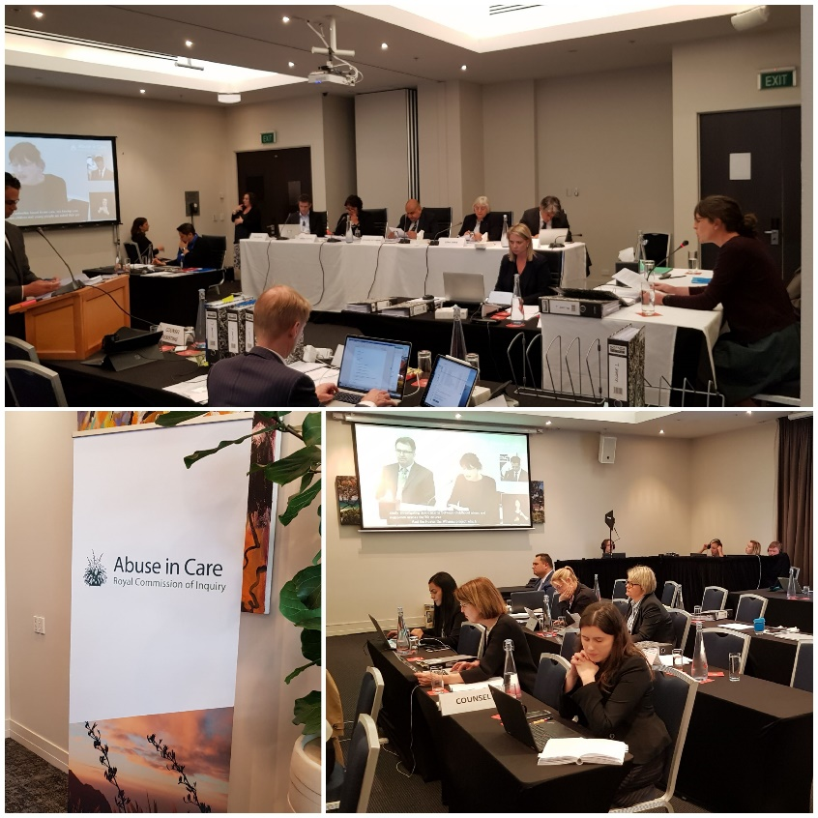
Survivors, advocates and experts speak at first public hearing
The scene has been set for the next three years of the Abuse in Care Royal Commission of Inquiry with the completion of our first public hearing this month.
This issue of the Pānui is dedicated to the survivors who bravely told of the abuse and neglect they suffered in State or faith-based care.
Evidence provided by survivors was, at times, harrowing, at times painful and, at times, hard to listen to. At the same time, it was compelling.
The scene was set by the very first witness Judge Carolyn Henwood, former Chair of the Confidential Listening and Assistance Service, who fought back tears as she read a poem to the State from a survivor. She was closely followed by Keith Wiffin who told the hearing how he was sexually abused at Epuni Boys’ Home in the 1970s; and high-profile former prisoner Arthur Taylor who told the Inquiry that his life would have been very different had he not been taken into State care at the age of 11.
There was not a dry eye in the room at times as story after story of abuse unfolded. We heard stories of sexual abuse, violence, neglect and mistreatment. We listened as people talked about the huge impact being in State care has had on their lives. Robert Martin, a disability rights activist, told how he never got to do the things that other kids did – there were no picnics, no pets, and no love. Fa'afete Taito told the hearing how he lost the ability to love.
Experts told the Inquiry about their research into the areas of abuse, colonisation, the over-representation of Māori in our State care and prisons, the effects of institutionalisation on people and many other topics.
Thank you to all those people who gave evidence at the hearing. Below are the survivors, in order of appearance, who shared their experience of abuse in care at the Contextual hearing. We know that some of the experts at the hearing were also survivors. We salute you all!
Commissioners are now busy conducting private sessions around the country. Private sessions will continue throughout the life of the Inquiry. The next hearing is on redress.

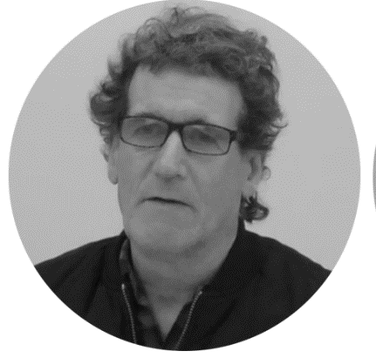
Keith Wiffin was a 10-year-old boy when he was placed into Epuni Boys Home following the death of his father. His mother, left alone with four children to look after, was unable to cope. In the back of a van on his way to the State boys’ home, one of the other boys smashed a guitar over his head. That was to be the start of years of abuse, physical and sexual, suffered by Keith in State care.
“The culture (at Epuni) was a very violent one. The boys, for example, had what we knew as the kingpin system. That system was overseen by the staff, used by the staff to sometimes sort people out as they saw fit. It was totally foreign to me and it was devastating coming from that previous environment which was essentially a loving home.”
He began working at 14 years of age but drifted from job to job, abused alcohol, linked up with other boys from Epuni, got into trouble and ended up with a criminal record. Mr Wiffin later taught himself to read and write. But for that, he claims, he would have been another statistic.

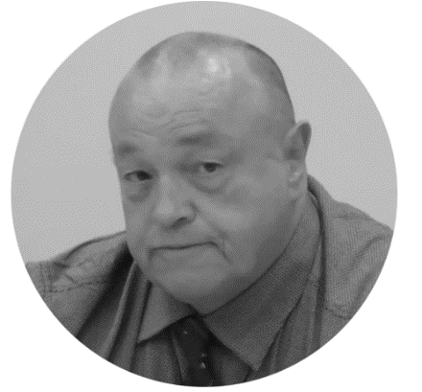
Arthur Taylor has spent 40 of his 63 years in prison. None of his siblings have been involved in the criminal justice system. None of his siblings were wrenched from the family home at the age of 11 and taken to Epuni Boy's Home like he was. He thought he had been taken to Epuni because he wagged school. It was, his records show, because he was NUPC (not under proper control).

He had come from a close and loving family and had never been exposed to the type of violence he witnessed in Epuni, he said. His life of crime began during his third visit to Epuni when he started to abscond from the Home with other boys and steal cars. He spent time in Porirua Psychiatric Hospital and borstal in Invercargill.

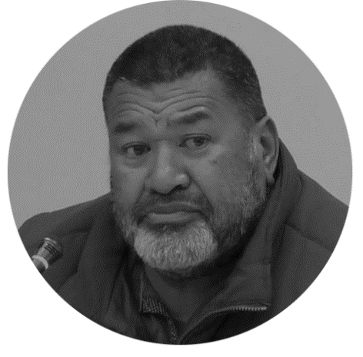
Fa’afete Taito went from being a ‘naughty boy’ growing up in a strict Samoan family to a fully patched gang member at the age of 17, via State and foster care. His parents were among the first wave of Samoan families to come to New Zealand in the 1950s and 1960s. It was, he says, a culture shock. He was made a State ward and sent to Owairaka Boys’ Home in the 1970's after running away from home and getting into trouble with the Police. Racism and abuse followed.

In a gang, drugs and violence became the norm for Mr Taito until in 2009 he turned his life around and began to study. He went on to gain a Bachelor of Arts majoring in Sociology and Māori from the University of Auckland.

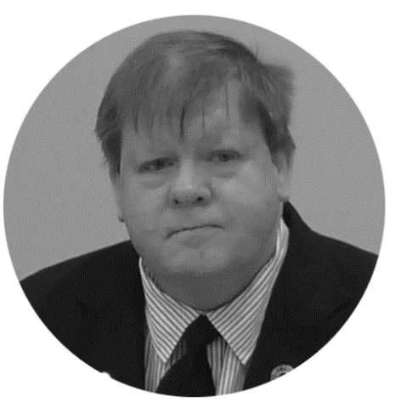
Robert Martin suffered a brain injury at birth and spent most of his childhood and early teens in institutions. His mother was told by a doctor that he was ‘mentally retarded’ and he was sent to Kimberley Centre in Levin at just 18 months old.
“I didn’t experience what other kids did. I didn’t go to birthday parties, feed the ducks or visit the zoo.
"We were locked away from the community. It was lonely. There were hundreds of people around me but as a little boy I didn’t know another human being.”
Mr Martin, now a disability rights activist, was the first person with a learning disability to be elected onto the Committee for the Rights of Persons with Disabilities at the United Nations.

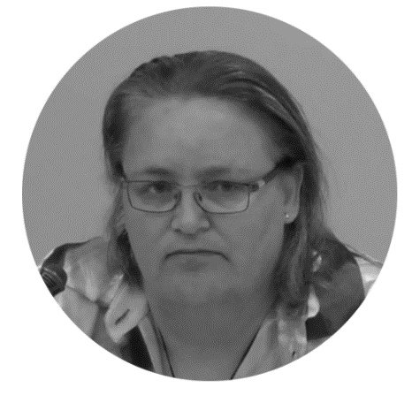
Dallas Pickering was put up for adoption at birth. She was adopted by a white middle class Pākeha family where she was neglected, ill-treated, malnourished and abused. Dallas’s birth father, she later found out, was Māori and was not told of her existence. Her whole identity, she says, was lost. The abuse continued as she moved in and out of her adopted family’s home, foster homes and family group homes.
She became pregnant at 16 and chose to keep her son and later her daughter, whom she brought up on her own. With little support and role models, it was a struggle. Drugs, postnatal depression and joining a church were the catalysts for change.
Dallas turned her life around, now has a Bachelor of Social Work and a Post Grad diploma and has been supporting families for the past 20 years.

Beverley Wardle-Jackson’s parents had been State wards as children. Her family lived in extreme poverty and did not have a lot of food. This didn’t go unnoticed by neighbours and soon the family was placed under the preventive supervision of Child Welfare.
At age seven, she was sent to the Florence Booth Salvation Army Home in Newtown, Wellington where she suffered severe punishment and lived in fear and dread. She and her siblings were made State wards in 1965. She suffered many years of abuse and violence at a number of State institutions including Porirua Psychiatric Hospital where she was taken at the age of 14.
“Some days I cannot believe I survived, but I did. I don’t deny the physical and emotional scars that I still carry but the very things I was missing throughout my childhood – love and a sense of belonging – eventually found me.
Ms Wardle-Jackson, who is a published author, could not be present at the hearing and her statement was read out by her lawyer Sonja Cooper.
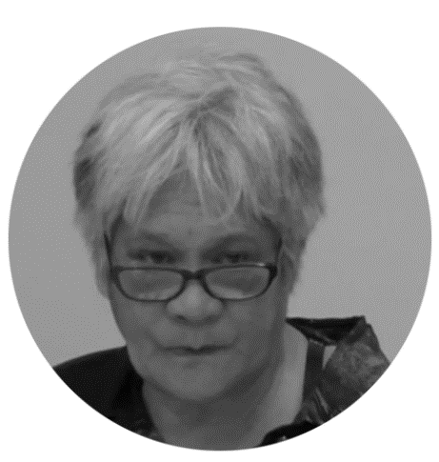
Annasophia Calman had a very poor and violent upbringing. Her mother left when she was 10 years old. She was beaten by her father and often had to eat out of rubbish bins to survive. She was sexually abused by family members. She couldn’t read or write. Eventually she became a State ward and, along with three other siblings, was sent to Nazareth House in Christchurch. Cruelty and violence followed her. She suffered physical and sexual abuse in foster care. While still a teenager and living in foster care she became pregnant but was made to give her baby up for adoption. She became pregnant again to another man who also abused her.
Mrs Calman has taught herself to read and write and now has a qualification to look after elderly people. “The elderly people are like my parents that I didn’t have in my life.”
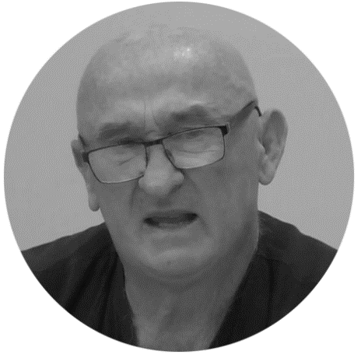
Mike Ledingham grew up, he says, in a good Catholic family with strong Irish roots. His family was typical of many others who lived in the area. The eight children were raised to respect adults and authority, especially priests of the Catholic Church. He and his brothers served as altar boys at the local church and attended the local parish convent school. There were many religious visitors to his family home.
“We became accustomed to seeing them, liked most of them and, unfortunately as it turned out trusted them implicitly.”
The abuse began in 1958 and his life suddenly turned into a total nightmare. He never told anyone until years later. He, like many other survivors, lived in confusion and silence, gained no qualifications and mistrusted authority. His two brothers were also abused.
Mr Ledingham has detailed the profound effect the abuse had on him and his brothers in his book ‘The Catholic Boys’.

Registering with the Inquiry
Not every survivor who wants to share their experience of abuse with the Inquiry has to do so through a public hearing. There are many other ways to participate in the Inquiry. Please contact us to find out how.
Call us on 0800 222 727 between 8.30am and 4pm weekdays.
Email us at contact@abuseincare.org.nz,
Write to us at PO Box 10071, The Terrace, Wellington 6143
Visit our website www.abuseincare.org.nz

