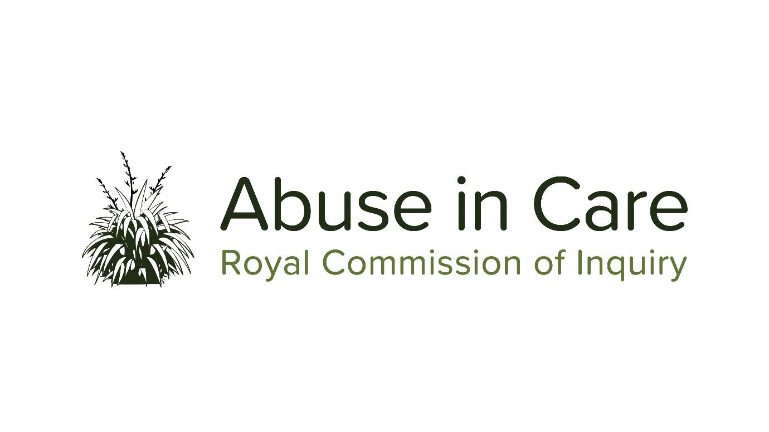
INVESTIGATION INTO REDRESS PROCESSES
FIRST REDRESS PROCESS PUBLIC HEARING SCOPING PAPER –
CIVIL CLAIMS AND LITIGATION – STATE CARE
16 – 27 March 2020

An inquiry into the experiences of survivors in making civil claims against the Crown
for abuse in State Care and whether the Crown’s responses to civil claims
have been adequate/appropriate

BACKGROUND
Redress processes
The Terms of Reference (TOR) require the Royal Commission to consider “The redress and rehabilitation processes for individuals who claim, or have claimed, abuse while in care, including improvements to those processes” (TOR, clause 10.7). The Terms of Reference define ‘redress processes’ to include ‘monetary processes (for example, historic claims and compensation or settlement processes), as well as non-monetary processes (for example, rehabilitation and counselling)”. The Royal Commission may make interim or final recommendations on improvements to claims, settlement or similar processes (TOR, clause 15).
In fulfilment of the TOR, the Royal Commission has commenced an investigation into redress processes, which will continue throughout the Inquiry.
Some elements of the investigation into redress processes will be examined in public hearings, while for other elements evidence will be gathered and tested by a range of different methods, such as issues and consultation papers, roundtables and submissions. Survivors will be able to share their experiences of redress processes in this investigation in a variety of ways, such as private sessions, submissions, participating in focus groups or giving evidence at public hearings when requested by the Inquiry. The investigation will also review information available from published and unpublished reports and reviews, Court cases, and previous investigations.
Redress processes aim to address and remedy past wrongs through a range of monetary and non-monetary responses. Over the course of its investigation, the Royal Commission will examine what redress processes have been historically and are currently for survivors of abuse in State care and the care of Faith-based institutions, what forms of redress and rehabilitation should be available in the future, and how they should be delivered. In addition to considering past, current and future redress processes, the Commission will also investigate the civil justice system. It will consider redress processes across all of the State care settings as well as those of Faith-based institutions.
Public hearings on redress processes
Against this backdrop of a comprehensive investigation that will be carried out over the Commission’s lifetime, the first public hearing on redress processes will examine civil claims and civil litigation relating to abuse in State care, and the response of the ‘Crown’ (as defined below) to those claims and proceedings.
Civil claims involve complaints made by private individuals against perpetrators who abused them and the institutions (e.g. State-run foster homes, youth justice placements, educational facilities, psychiatric hospitals, residential or non-residential disability facilities, health camps, Police custody) who failed to protect them from being abused, and through whom the complainants seek redress. They are different from cases that are brought under criminal law. ‘Civil litigation’ refers in this first public redress hearing to civil claims filed in a Court or in the Human Rights Review Tribunal.
There are a number of important areas that will not be included in this first public hearing, but will be part of our investigation into redress and will be examined in other Inquiry information gathering and consultation processes in the future, such as roundtables and issues papers, and/or future public hearings. These are :
- all civil claims and civil litigation involving Crown Entities (such as District Health Boards and School Boards of Trustees) or other institutions responsible for people in State care, but falling outside the ‘Crown’ definition below; and

- claims of abuse associated with Faith-based institutions (including integrated schools funded by Government)
As the investigation into redress processes continues, other public hearing topics will be identified and announced.
Proceedings filed with the Waitangi Tribunal will not be investigated or examined under the investigation into redress processes.

SCOPE OF THE FIRST PUBLIC HEARING INTO REDRESS PROCESSES
The Inquiry’s first public hearing on redress processes relating to abuse in State-Care will hear evidence about civil claims made against any agency, agent, department, or entity of the Crown or third party who delivered services on their behalf (e.g. Non-Governmental Organisations) (collectively the Crown), or civil litigation filed in a Court or the Human Rights Review Tribunal (separately or together referred to as civil claims), between 1 January 1950 and 30 August 2019 (relevant timeframe).
To investigate the issues set out below, the Royal Commission will identify and examine selected case studies setting out the experiences of survivors relating to civil claims against the Crown involving allegations of abuse in State Care during the relevant timeframe.
The hearing will not examine the substance of any civil claims, or resolve disputed factual issues relating to those civil claims, or otherwise adjudicate on breaches.
Civil claims involving allegations of abuse in State care
The Inquiry will investigate, examine, and seek evidence on the following:
- The experiences of survivors in relation to civil claims relating to abuse in State care made or filed during the relevant timeframe, including:

  - Where a survivor chose not to make, file or pursue a civil claim, what were the reasons (for example, difficulty accessing information about the claims process and criteria, difficulty identifying the right defendant, difficulty proving the abuse caused the harm, difficulty getting legal advice, difficulty being approved for civil legal aid, cost, delays)

  - Whether, and the extent to which, Crown policies, procedures, processes, rules, guidance or strategies, and/or the civil claims framework, rules or legislation (including but not limited to the Limitation Act 1950, the Privacy Act 1993 or the Official Information Act 1982), obstructed the ability of survivors, or their legal representatives, to make, file or pursue civil claims. This includes, but is not limited to:

- accessing information about eligibility for and how to make a civil claim;
- obtaining information necessary to frame, make or file civil claims;
- accessing complete personal records or other disclosure to make, file or pursue civil claims;
- progressing civil claims, especially in a timely manner;
- meeting the cost of pursuing civil claims (including access to civil legal aid); and/or
- achieving resolution or settlement (by whatever means) of their civil claims.

  - Whether and if so, how the Crown’s policies, procedures, processes, or strategies may have acted as a barrier for Māori claimants in filing or pursuing civil claims.

  - Whether and if so, how the Crown’s policies, procedures, processes, or strategies may have acted as a barrier to disabled claimants filing or pursuing civil claims (for example,. limiting accessibility to processes, including information and communication; threats to withdraw services; discrimination or disbelief on grounds of disability).

  - Other factors that may have obstructed the making, filing, conduct or resolution of civil claims made in relation to abuse in State care during the relevant timeframe.

  - Where civil claims were made or filed, what Crown processes (if any) were good or helpful and/or what would have made the process easier, better or more appropriate.

- How did the Crown receive, process, manage, conduct and resolve civil claims involving abuse in State care alleged to have occurred during the relevant timeframe. This will include:

  - The policies, procedures, processes and strategies of the Crown in relation to redress for civil claims (monetary and non-monetary) made or filed during the relevant timeframe and subsequently, including the reason/s for any changes made.

  - The criteria under which survivors were eligible for and able to receive monetary redress for civil claims made or filed during the relevant timeframe, how such monetary amounts were calculated, and the means by which such information was made available to survivors and/or their legal representatives.

  - The extent to which the Crown’s policies, procedures, processes or strategies had regard to Te Tiriti o Waitangi and tikanga Māori.

  - The Crown’s standing orders to Crown Law in relation to the conduct of civil litigation, the existence of civil litigation guidelines or values, and their application in the conduct of civil claims by Crown Law.

  - The approach to, use or application of legislative provisions, including but not limited to the Limitation Act 1950 (and the subsequent Limitation Act 2010), the Privacy Act 1993, the Official Information Act 1982, and the Accident Compensation Act 1972 (and successive legislation)), including whether or how legislative provisions hindered or precluded the ability of individuals to bring or pursue civil claims against the Crown.

  - The means of resolution or settlement and outcomes (monetary and non-monetary) of all civil claims within the relevant timeframe.

  - The total cost to the Crown of all monetary settlements for civil claims made or filed during the relevant timeframe, and the total expenditure by the Crown on litigation costs in the same period.

  - The extent to which the Crown’s policies, procedures, processes, strategies or outcomes conformed to international human rights obligations which were binding on New Zealand throughout the relevant timeframe.

Public Hearing Report

- Subsequent to the investigations outlined in the above scope, and the evidence gathered from this first public hearing on redress processes, the Royal Commission may publish a report setting out its findings and the lessons learned about the making, filing and conduct of civil claims relating to abuse in State care during the relevant timeframe.

Terms of Reference, clause 17.6
Refer TOR, clause 17.3, which includes social welfare settings, health and disability settings, educational settings, and transitional and law enforcement settings, whether residential or non-residential, and including voluntary or non-voluntary care.
Please see footnote 4 below, referring to the definition in the State Sector Services guidance found at https://ssc.govt.nz/resources/what-is-the-public-sector/, under “Glossary of terms used in public sector map”.
As defined in State Sector Services guidance found at https://ssc.govt.nz/resources/what-is-the-public-sector/, under “Glossary of terms used in public sector map”
A standing order is an instruction or defined/agreed procedure, including rules or guidance, that are in force permanently or until changed or cancelled
As set out in the ‘Background’ to the TOR, clause 3 (i.e. New Zealand’s international legal obligations are provided for in a range of international treaties and other instruments that include the Universal Declaration of Human Rights, the Convention on the Rights of the Child, the Convention on the Rights of Persons with Disabilities, the International Covenant on Civil and Political Rights, the International Convention on the Elimination of all Forms of Racial Discrimination, and the Convention against Torture and Other Cruel, Inhuman or Degrading Treatment or Punishment and its Optional Protocol. A number of other instruments and guidance materials are also relevant to the proper treatment of people in care.)

