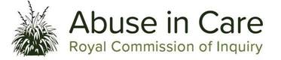

Tāwharautia:

Pūrongo o te Wā:

Interim report:
What we have found so far
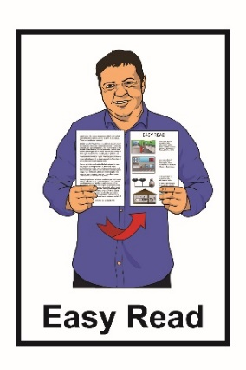
Published in Easy Read:
February 2021
Before you read this report

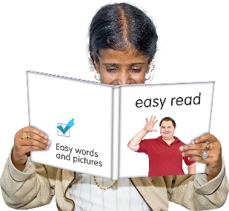
This is an Easy Read summary of a report written by the Royal Commission of Inquiry into Abuse in Care.

In this Easy Read report we will call the Royal Commission of Inquiry into Abuse in Care the Commission.
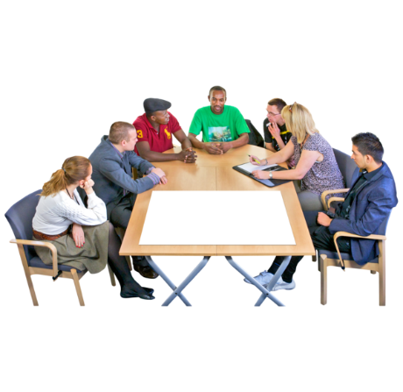

This document will give people information about the things that the Commission has found out so far.

Some of the information in this document may upset people when they are reading it.

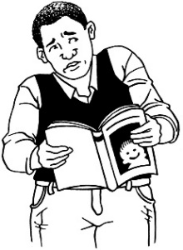
This information is not meant to scare anyone.

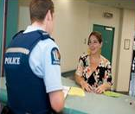
If you do not feel safe right now call the Police on 111.

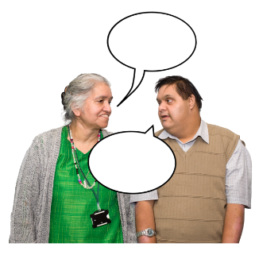
If you are worried or concerned after reading this document you can talk about it with:
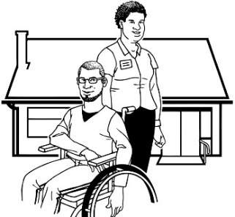
- your family / friends

- your support workers.

If you are still worried you can also talk to someone at the Commission:

Phone: 0800 222 727

Email: contact@abuseincare.org.nz

What you will find in here

Page number:
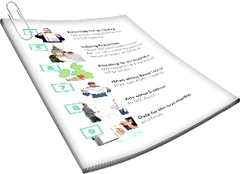

About this Interim Report……………5

What is the Royal Commission
of Inquiry into Abuse in Care?...........7

How the Commission works……….14

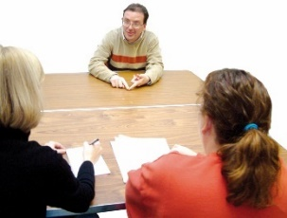
Getting the information we need….19

What we have found so far
about the abuse that happened
in care………………………………..27

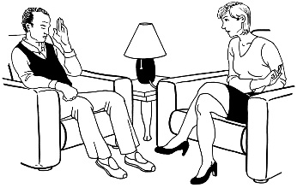
Page number:

Redress and rehabilitation…………40
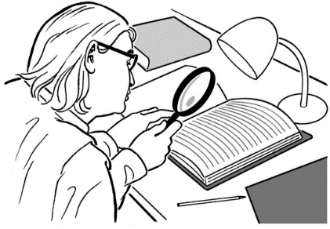

What will happen next?...................43

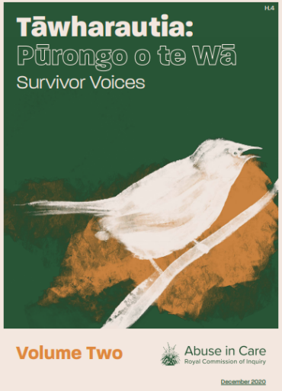
Survivor Voices……………………..45

About this Interim Report

This is an Easy Read summary of the interim report by the Royal Commission of Inquiry into Abuse in Care.

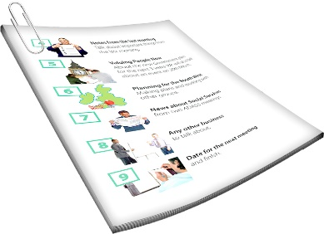
Interim means we have written a report about the things we have:

- done so far

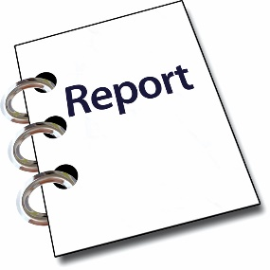
- found out so far.

This is not the final report.

You can still tell us about the abuse that happened while in care.

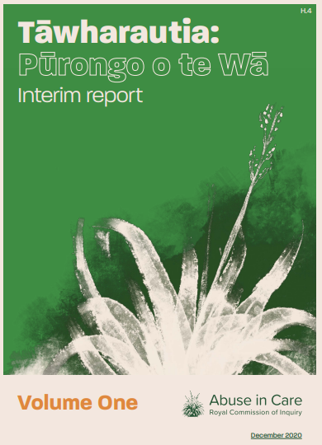
You can find the full Interim Report on the Commission website.

The full Interim Report is not in Easy Read.

You can find the full report at this website address:

www.abuseincare.org.nz/library/v/194/
tawharautia-purongo-o-te-wa-interim-report

What is the Royal Commission of Inquiry into Abuse in Care?

The Royal Commission of Inquiry into Abuse in Care is looking into abuse that happened to people in care.

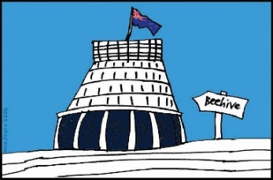
The Commission is not part of the Government.

The Government cannot tell the Commission what to do.

The Commission is not part of any faith-based organisations like churches.

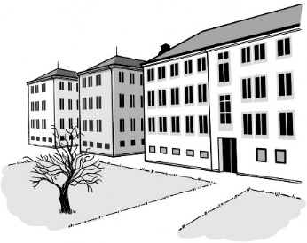
Being in care means that the government or a faith-based institution was in charge of your care.

A faith-based institutions are run by religious groups like churches.

Faith-based institutions provide care.

Abuse can be:
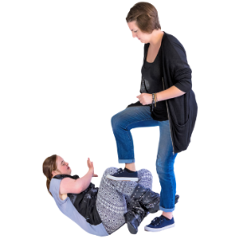
- physical – a person kicking or hitting you

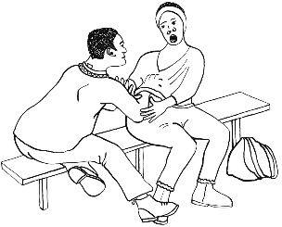
- sexual – when someone does sexual things to you that you do not want them to like:

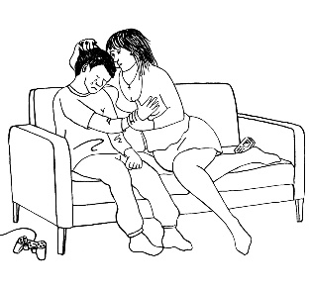
- touching your body or private parts

- kissing you

- making you have sex with them – this is called rape
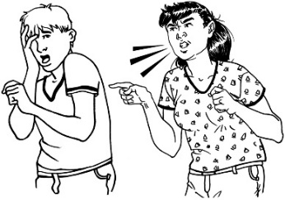
- emotional – yelling or saying things that are not nice about the person
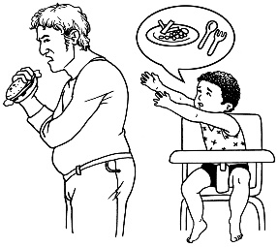
- neglect – not giving someone the things or care they need.

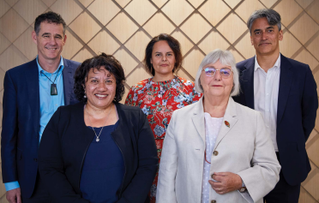
The Commission is led by:

- 1 Chair who is like the leader

- 4 Commissioners.

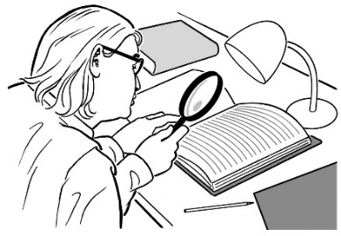
The Chair and the Commissioners are people at the Royal Commission who will:

- decide what to investigate

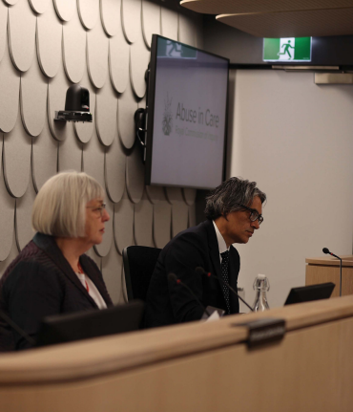
- listen to survivors

- write reports about:

- the things they find out

- what things should happen next.

The Commission calls people who have been through abuse in care survivors.

The Commission has been asked to find out:
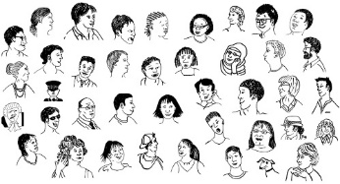
- what kinds of abuse happened
- how many people were abused in different places
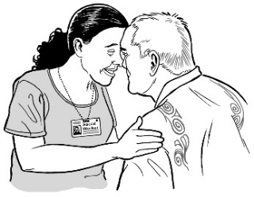
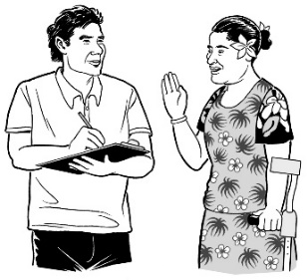
- how different groups were abused like:
  - Māori
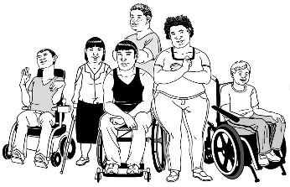
  - Pacific people
  - disabled people.
.

The Commission wants to know:

- how people ended up in care
- what abuse has happened
- why the abuse happened
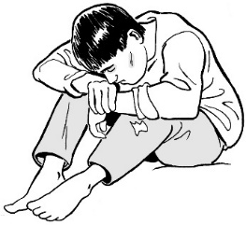
- how the abuse has changed things for people who were abused
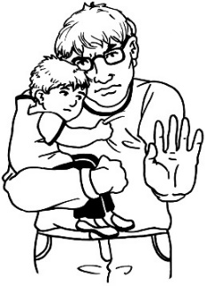
- what changes have been made to make things better
- what more can be done to stop abuse.

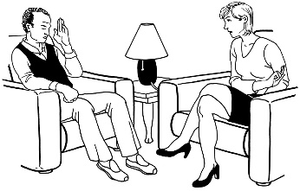
The Commission also wants to know how the government and faith-based institutions should give redress and rehabilitation to survivors.

Redress is when you try to make things right.

Sorry
It could be things like:
- saying sorry
- giving money as a way of saying sorry.

Rehabilitation is support to carry on with life like counselling.

How the Commission works

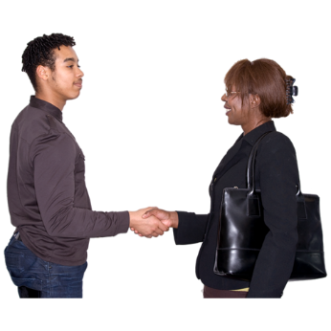
We want survivors to feel well supported when they tell us about the abuse that happened to them in care.

We have a team that makes sure survivors who tell us about what happened to them are supported with:
- keeping well
- staying safe.

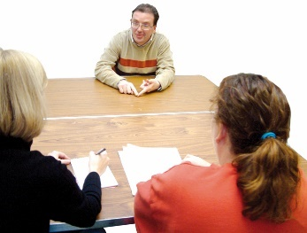
Almost 2 thousand survivors have already talked to us.

We think thousands more survivors will talk to us.
We have a Survivor Advisory Group that gives us feedback on our work.

The Survivor Advisory Group tells us their ideas about how the Commission should work to support survivors.
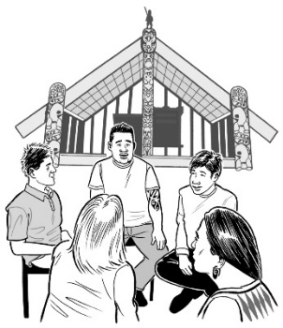

We also have a Māori advisory group called Te Taumata.
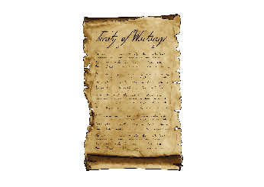

Te Taumata gives advice on Te Tiriti o Waitangi / the Treaty of Waitangi approach.

The Commission needs people to talk to us about:

- the abuse that happened to them while they were in care
- how the abuse made them feel

- what the abuse did to their life.

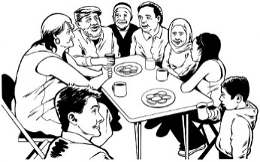
We are talking to people in the community about the work that the Commission is doing.
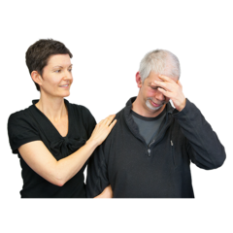

We hope that this will make people feel like they can tell us about what happened.

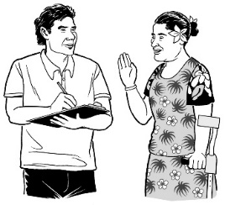
We are talking with groups like:
- Pacific people
- disabled people including people with learning disability
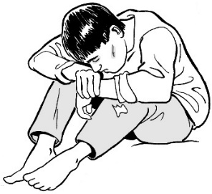
- Deaf people
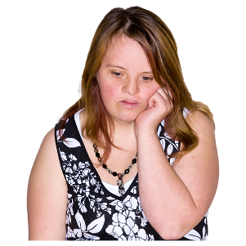
- people who do not have homes to live in
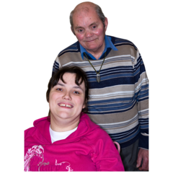
- people with mental health difficulties
- young people
- older people
- the LGBTQIA+ community.

The LGBTQIA+ community means people who are:
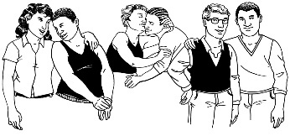
- lesbian
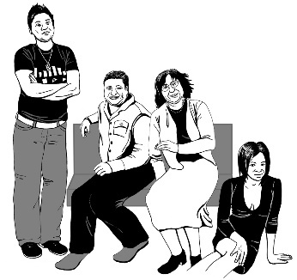
- gay
- bisexual
- transgender
- questioning which means not sure what words best fit them
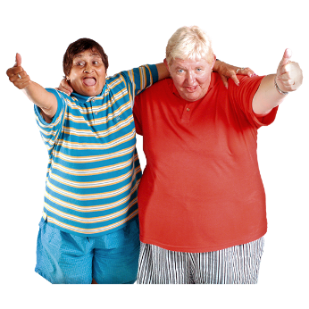
- intersex
- asexual
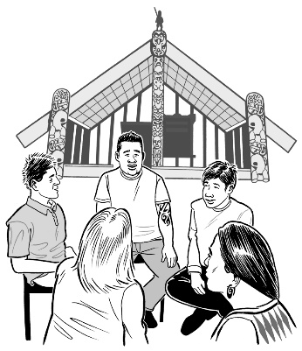
- takatāpui
or
- use other similar words to talk about themselves.

Getting the information we need

Some survivors find it helpful talking about their abuse.

The things that survivors tell us helps us with our investigations.

An investigation means looking closely at something to find out what has been happening
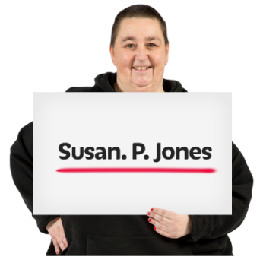

People can ask us to make sure people cannot tell who the survivors are by reading what they have told us.

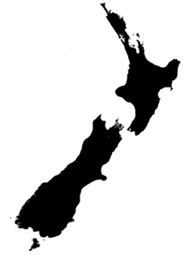
We have had meetings with lots of survivors in different parts of New Zealand.

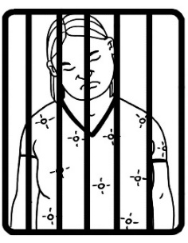
We have also been meeting with survivors who are in prisons around New Zealand.

In these meetings survivors talk to a Commissioner.

We plan to have a lot more meetings with survivors.

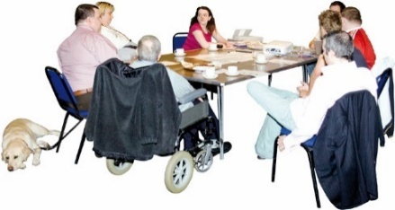
Some survivors also told us about the abuse that happened to them by:
- talking in groups with other survivors
- writing it down.

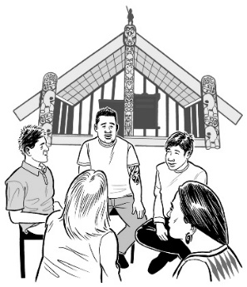
Right now we are working on 9 big investigations.

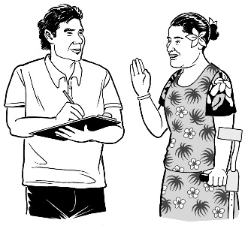
3 of the big investigations are looking at the abuse of:
- Māori
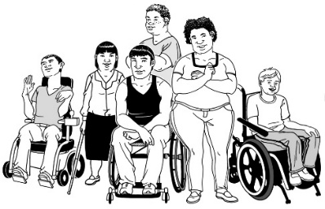
- Pacific people
- disabled people.

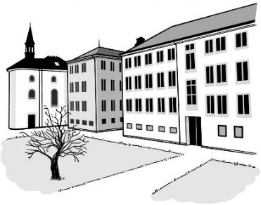
5 of the big investigations are for different places.

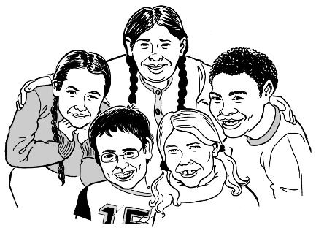
These places are:
- group homes that the government ran for children
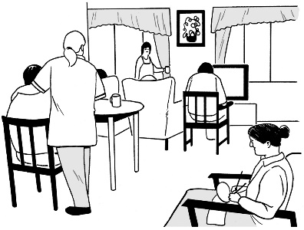
- disability care
- Catholic Church institutions
- Anglican Church institutions
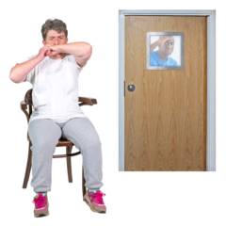
- psychiatric institutions.

Psychiatric institutions are places people go for mental health treatment.

1 of the big investigations looks at the redress survivors can get.
Sorry

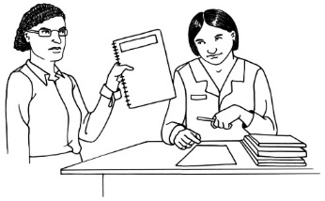
We have asked the State and faith-based institutions to give us information that will help us understand what happened.

We also have public hearings.

Public hearings are meetings anyone can go to.

Public hearings mean people can learn more about the work we do.

We have had 3 public hearings so far.

We have also started a hearing about redress from faith-based institutions.

We have heard information from:
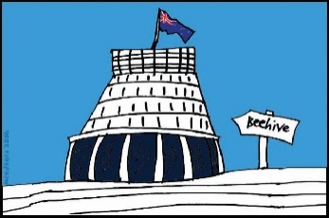
- survivors
- people from the government
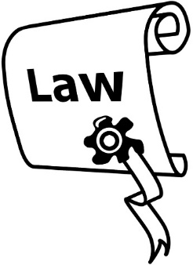
- experts who:
  - are lawyers
  - work in universities.

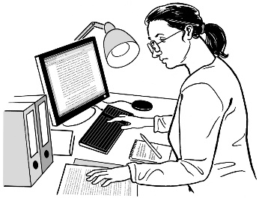
Experts are people who know a lot about something.

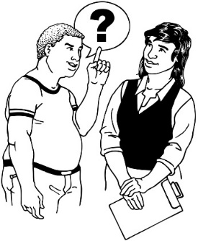
At these hearings people from the places where people were abused can be asked to talk about the abuse if they choose.

We have also been looking at:
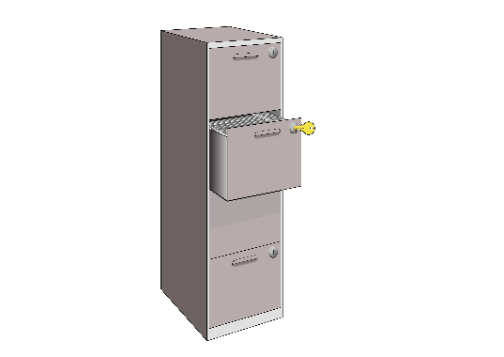
- things that have been written about abuse
- information kept by places where people were abused.

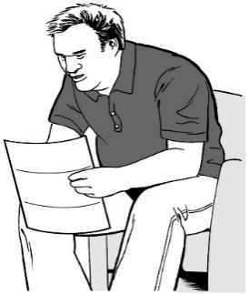
We also look again at the information given to us by:
- survivors
- people who saw abuse happen.

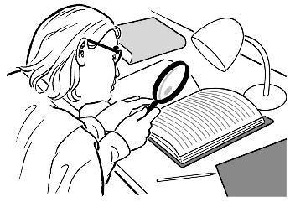
Sometimes there is information missing like if someone has died.

We try and find what we can to fill in the missing bits.

What we have found so far about the
abuse that happened in care

It is clear that abuse in care happened:
- to a lot of people

- in lots of places.
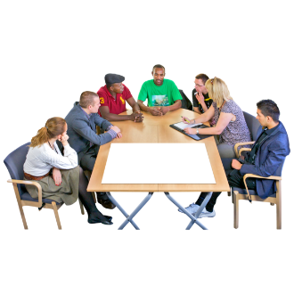

We asked how many people were at the care places we are investigating.
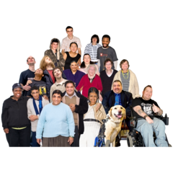

We think more than 6 hundred thousand people were in care places.

This is more than half a million.

We think up to 2 hundred and 50 thousand people may have been abused.

2 hundred and 50 thousand is the same as a quarter of a million.

We cannot be sure how many people were abused in care because not all the information is there.
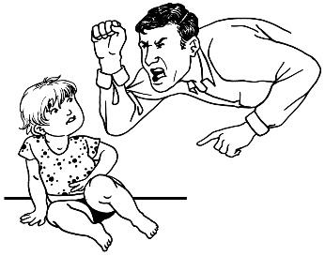

We know people are still abused in care now.

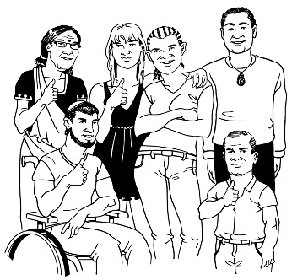
The people who have been abused in care come from all kinds of lives.

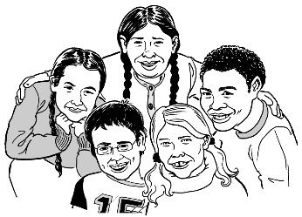
We have found many come from groups that already find things hard like:
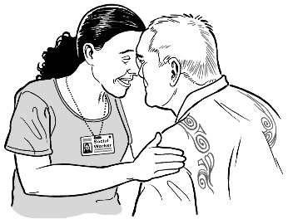
- children and young people
- adults from Māori and Pacific families
- children from families that did not have much money
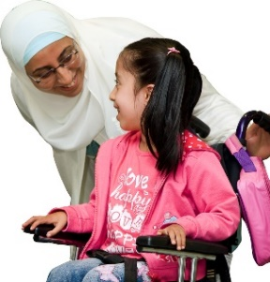
- disabled people
- women / girls
- vulnerable adults.

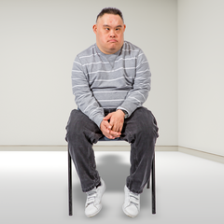
A vulnerable adult is someone who is 18 years and older.

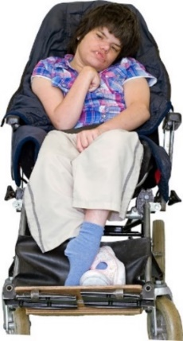
Vulnerable is a word that can mean some people need support because of:

- the things that happened in their life
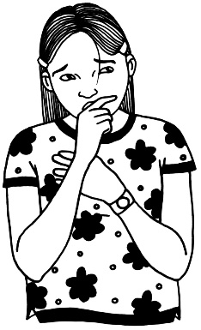
- their disability

- their mental health needs.

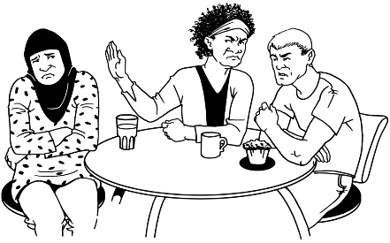
Some people are also vulnerable because of discrimination.

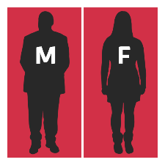
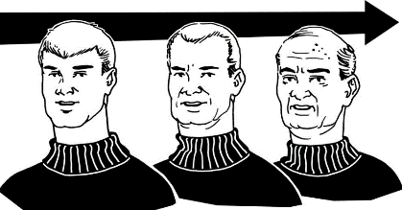
Discrimination means to treat people in a different way because of things like:
- their age

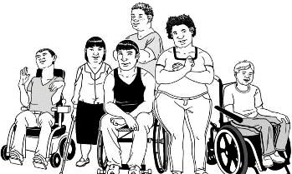
- their gender
- their disability

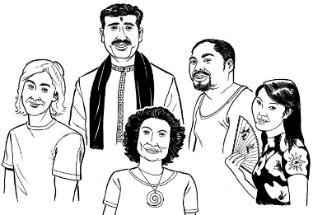
- their culture

- the things they believe in.

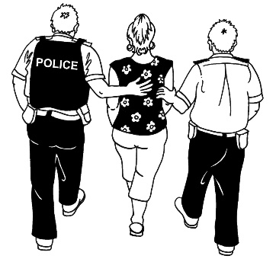
Some children were put in care because:
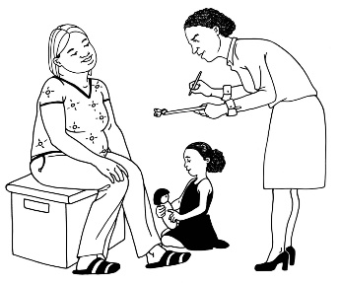
- they had acted badly
- the government thought their home was not safe
- their family could not care for them.
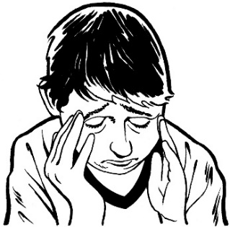

The care was meant to be good for people but lots of them had a worse time than if they had stayed at home.
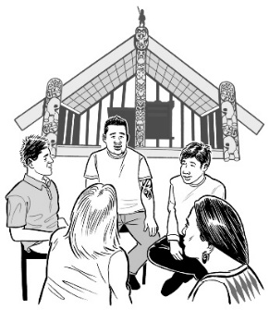
More Māori are being taken into care than Pākehā.

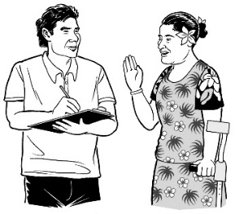
Pacific people are also more likely than Pākehā to be in care.

Lots of disabled people have also been in care.

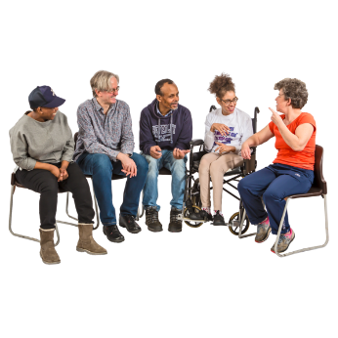
Survivors have told us about different kinds of abuse that happened to them.
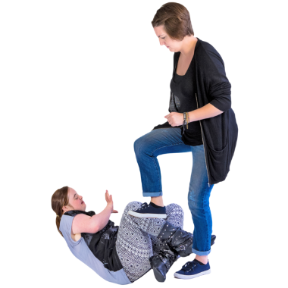

Some of the kinds of abuse people told us about were:
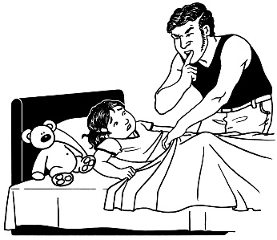
- physical abuse like being hit
- sexual abuse
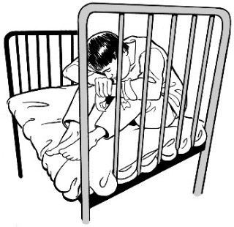
- someone holding or tying them down
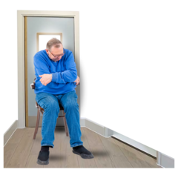
- being treated as if they did not deserve to be loved
- locking people away by themselves for a long time.

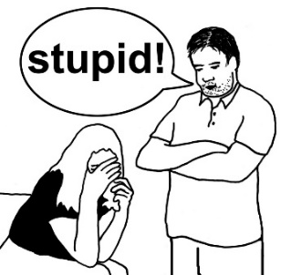
Other kinds of abuse people told us about were:
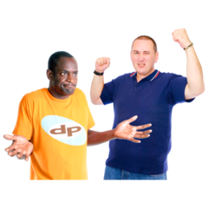
- abuse with words
- being racist
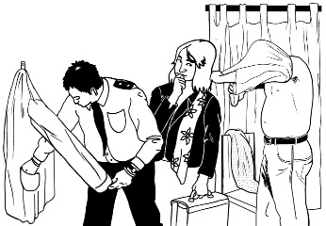
- strip searches which are when people take your clothes off to check if you are hiding something
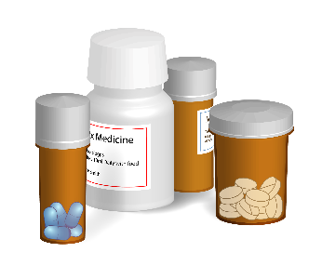
- using medical treatment as punishment like:
  - medicine
  - electro-convulsive therapy.
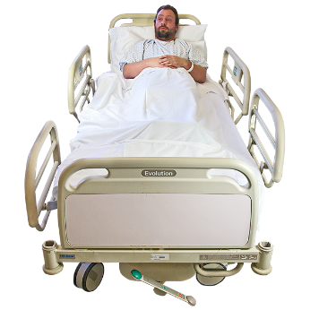

Electro-convulsive therapy is when a machine gives your body electric shocks.

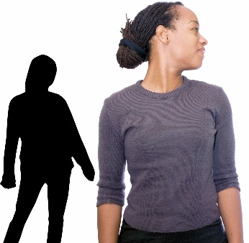
Survivors also talked about different kinds of neglect.

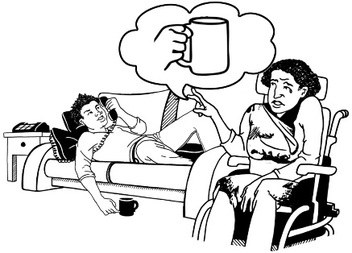
Neglect is when people do not get the things or care they need.

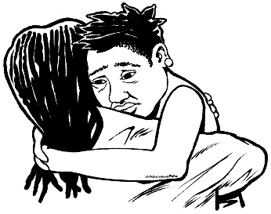
People did not get things they needed like:
- food
- support with their feelings
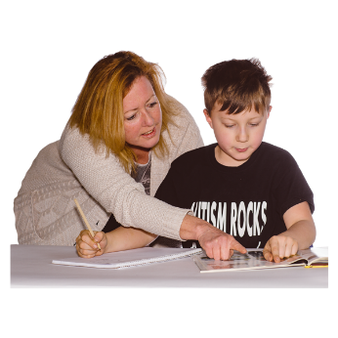
- medicine
- education.

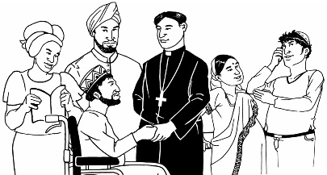
People did not get to be a part of their:
- religion or beliefs
- culture.

Culture is important for Māori to make sure they can connect to whakapapa.

Survivors with a disability said they felt:
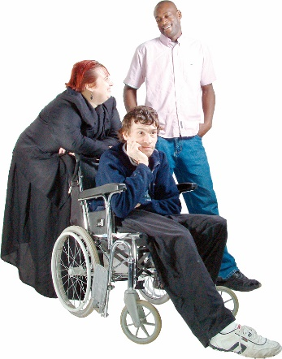
- forgotten about
- left out from their family and community.

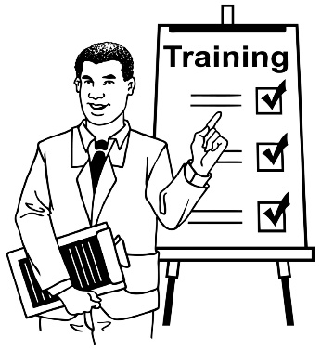
When abuse happened people who were in charge were not:
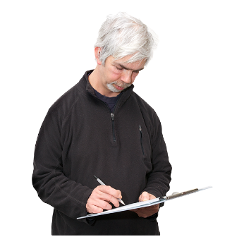
- trained as they should have been
- checked to make sure they were doing the right things.

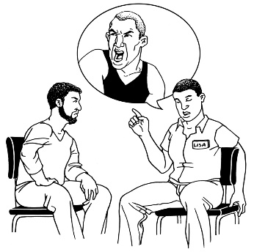
Survivors have said it was hard to tell people about the abuse.

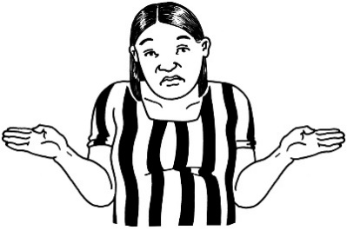
There was no way to tell people about the abuse that was:
- clear
- easy.

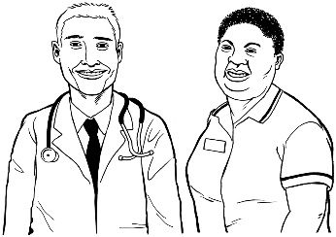
Many survivors found it hard to report abuse because medical people like doctors were often believed more than the survivor.

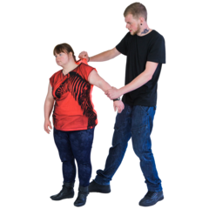
Most of the time nothing was done to stop or remove the person who did the abuse.

Sometimes when survivors told people about the abuse they were:
- punished
- sent back to places where abuse happened.

We heard about people trying to:
- keep the abuse secret so nothing happens to the person who abused people
- move the person who abused people to another place of work.

We have also learned about some of the costs of abuse when it comes to money.

A report we asked for thinks the cost of abuse in care from 1950 to 2019 could be more than 2 hundred billion.

Redress and rehabilitation

People have told us that redress from the government is not as good as it needs to be.

The way redress is done is:
- too much about how much money it will cost
- not enough about survivors getting what they need to live a good life.

Survivors have found it hard to make a claim.

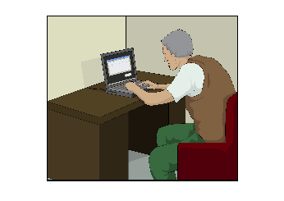
Making a claim means asking for redress.

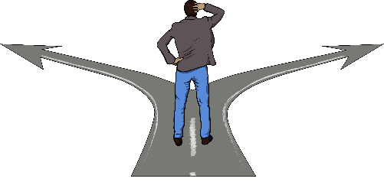
There is no 1 way of deciding what survivors get.

This means that survivors are getting different amounts of money based on which:

- part of the government they make their claim with

- organisations they make their claim with such as faith base institutions.

Other support should also be made better like:
- counselling which is talking to someone about what happened
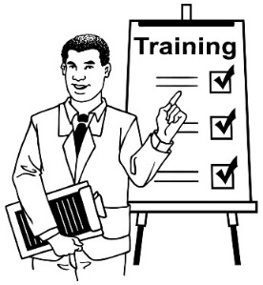
- medical treatment
- better training for people working in care.
Survivors who make a claim may have to tell the government about what happened more than 1 time.

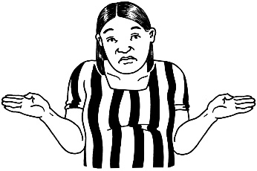
There is not enough information for people to know how to make a claim.

Many survivors do not know they can make a claim.

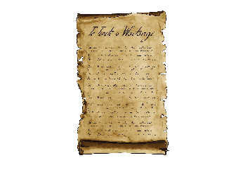
The way redress is done also does not take into account what Te Tiriti o Waitangi / the Treaty of Waitangi says.

What will happen next?

We will:
- keep going with our investigations
- start new investigations.

We will keep having:
- public hearings
- private meetings.

People will keep telling us about what happened.

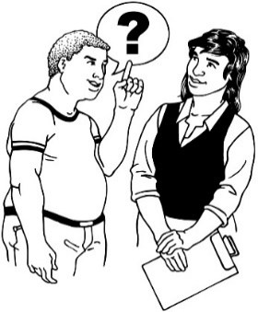
We will be asking for more information from people who were in charge of what happened.
We will:
- find out more information
- look at the information again
- say what we think should change.

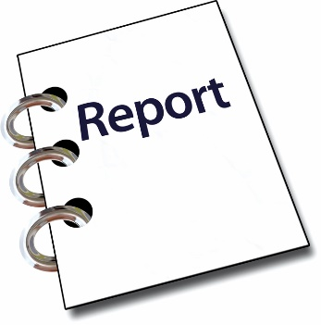
We will write reports about the:

- abuse that happened in care

- recommendations we make.

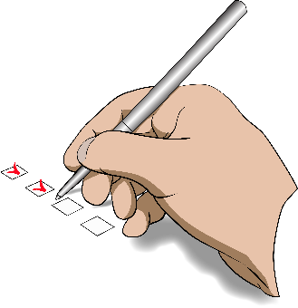
Recommendations are the things we think need to happen next to make things better for everyone.

This is very important to do.

Survivor Voices

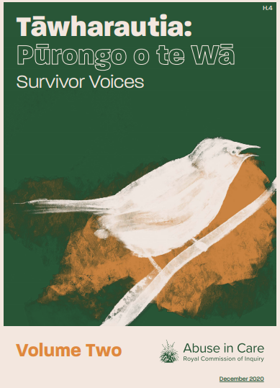
There is a second part of the Interim Report called Survivor Voices.

Survivor Voices looks at the stories of 50 different survivors.

These stories are an important part of our work.
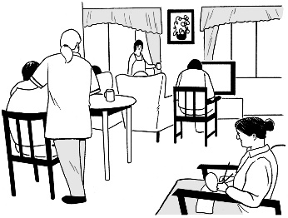

Survivors talk about things like:
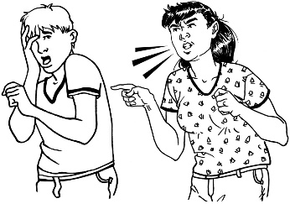
- where the abuse happened
- how it happened
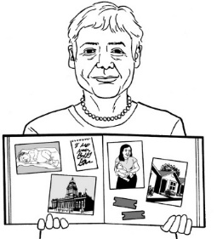
- who they told
- how it has affected their lives.

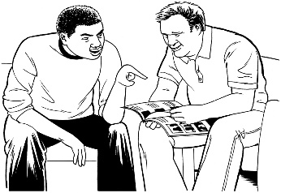
Survivor Voices is not in Easy Read.

You may want to have someone support you when you read it.

Survivor Voices can be found at this website address:

www.abuseincare.org.nz/reports/

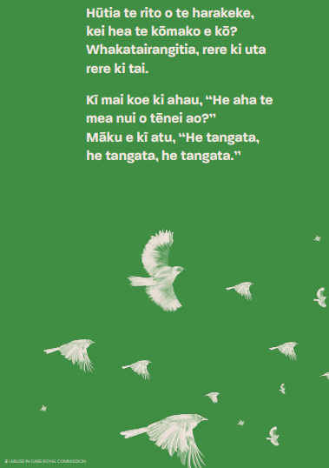

Pluck out the heart of the flax bush, and where would the bellbird sing? It would fly about aimlessly.

Should you ask: “What is the most important thing of this world? I would reply “It is people, it is people, it is people.

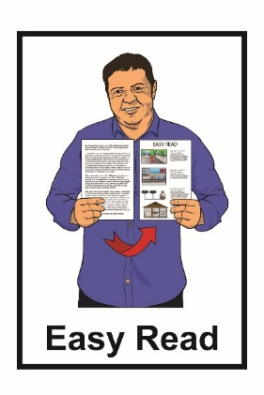
This information has been translated into Easy Read by the Make It Easy service of People First New Zealand Inc. Ngā Tāngata Tuatahi.
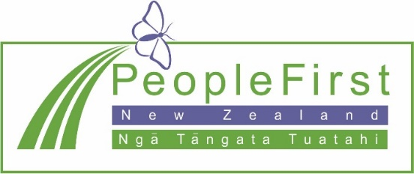
The ideas in this document are not the ideas of People First New Zealand Ngā Tāngata Tuatahi.
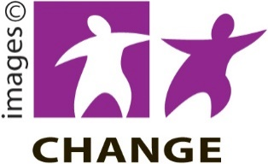
Make It Easy uses images from:
- Changepeople.org

- Photosymbols.com

- Sam Corliss

All images used in this Easy Read document are subject to copyright rules and cannot be used without permission.

