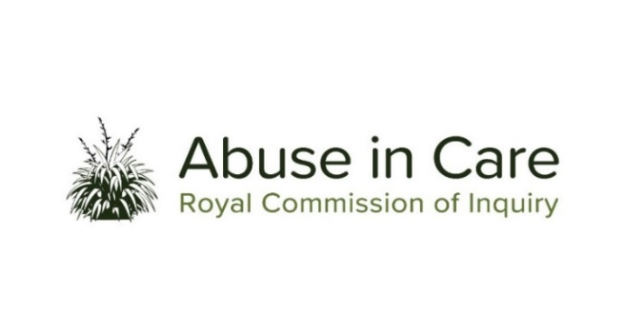
MĀORI INVESTIGATION

AN INVESTIGATION INTO MĀORI EXPERIENCES OF ABUSE IN CARE

TĪMATANGA KŌRERO | INTRODUCTION
  - The Inquiry’s Māori investigation will examine issues that are particularly relevant to Māori experiences of abuse across all State and faith-based care settings included in the Terms of Reference and will work alongside the Inquiry’s other investigations.
  - Abuse is defined in the Inquiry’s Terms of Reference as meaning physical, sexual, emotional or psychological abuse, and neglect. It includes inadequate or improper treatment that resulted in serious mental or physical harm to a person in care. Neglect is not defined in the Terms of Reference, but the Inquiry considers neglect may include physical, emotional and psychological, medical, educational, spiritual and cultural neglect.
  - The main period covered by this investigation is 1950 to 1999. However, the Inquiry has discretion to consider issues and experiences prior to 1950 and will also consider issues and experiences after 1999 in order to inform its recommendations.
KIA WHAKATŌMURI TE HAERE WHAKAMUA | MĀORI INVESTIGATION OVERVIEW
  - The Māori investigation will undertake two key strands of work – looking back and looking forward.
  - With that dual focus, the Māori investigation will investigate:
  - What happened to Māori abused in care during 1950 -1999 and why
  - The current systems for preventing and responding to abuse against Māori, to investigate whether these are fit-for-purpose and identify what changes need to be made as a result. In short, how to ensure that what occurred cannot happen again.
- The Inquiry recognises that the following are essential in informing the Inquiry’s mahi:
  - Te Tiriti o Waitangi / the Treaty of Waitangi and its principles
  - Tikanga Māori
  - Te reo Māori
  - The voices of Māori survivors and victims of abuse in care and the range of backgrounds and experiences of Māori survivors.
KIA WHAKATŌMURI | LOOKING BACK
- The Inquiry will investigate what happened to Māori children, young people, and vulnerable adults in the care of the State and faith-based institutions and why it happened, including:
    - The circumstances that led to Māori being taken into or placed into care
    - The appropriateness of care placements including whether Māori were placed with whānau, hapū and iwi or placed in non-kin or residential care
    - The factors that contributed, or may have contributed, to the decision-making process leading to Māori being taken into, or placed in care
    - The factors, including structural, systemic, or practical factors, that caused or contributed to the abuse of Māori in State care and in the care of faith-based institutions
    - The nature and extent of abuse of Māori that occurred in State care and in the care of faith-based institutions between 1 January 1950 and 31 December 1999
    - The response of the State and faith-based Institutions to the abuse against Māori during this period
    - The State’s obligations under Te Tiriti o Waitangi / the Treaty of Waitangi
    - Obligations under domestic and international human rights law
    - The impact of the abuse on Māori who were in care, their whānau, hapū, iwi, and communities, including immediate, long term, and intergenerational impacts
    - What lessons were learned from past instances of abuse of Māori in care
    - What changes were made to legislation, policy, rules, standards and practices to prevent and respond to abuse of Māori in care.
TE HAERE WHAKAMUA | LOOKING FORWARD

- In relation to State and faith-based institutions, the Inquiry will investigate:
  - Māori experiences of abuse in care since 1999 and currently
  - The ongoing intergenerational impact of abuse in care on Māori whānau, hapū, iwi, and communities
  - The current frameworks and any gaps in legislation, policy, rules, standards and practices to prevent and respond to the abuse of Māori in care
  - Whether changes to legislation, policies, rules, standards and practices, including oversight mechanisms, are required to protect Māori children, young people, and vulnerable adults in the future.
- The Inquiry will make findings and/or recommendations on the matters in [7] and [8] above.
- The Inquiry will also, informed by the matters at [4] above:
  - Where relevant, make findings of fault or findings that relevant standards have been breached, or both; and recommendations that further steps be taken to determine the civil, criminal or disciplinary liability of any person
  - Make findings and/or recommendations on any gaps in legislation, policy, rules, standards and practices that require change to prevent and respond to abuse of Māori in State and faith-based care
  - Make recommendations on changes required to redress, rehabilitation and compensation processes for Māori survivors and victims of abuse in State and faith-based care
  - Make recommendations on any other steps the State and faith-based institutions should take to address the harm caused by the abuse in care against Māori.

