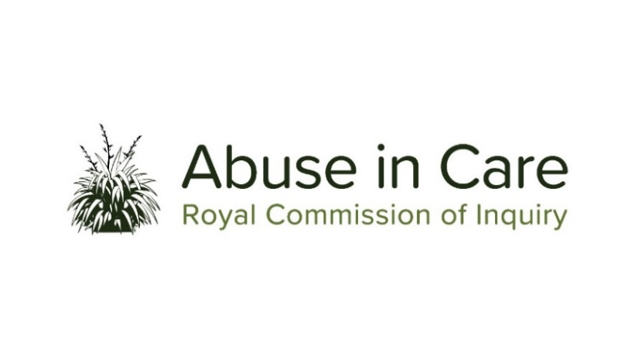
INVESTIGATION INTO ABUSE IN STATE PSYCHIATRIC CARE

SCOPE OF INVESTIGATION

- The Inquiry will investigate the abuse of children, young persons and vulnerable adults in State psychiatric care in New Zealand.
- Psychiatric care includes care in settings such as psychiatric hospitals and facilities, forensic psychiatric services, residential and non-residential psychiatric settings, community psychiatric services and psychiatric rehabilitation services. It includes voluntary and non-voluntary care.
- Abuse is defined in the Inquiry’s Terms of Reference as meaning physical, sexual, emotional or psychological abuse, and neglect. It includes inadequate or improper treatment that resulted in serious mental or physical harm to a person in care. Neglect is not defined in the Terms of Reference, but the Inquiry considers neglect may include physical, emotional and psychological, medical, educational, spiritual and cultural neglect.
- The main period covered by this investigation is 1950 to 1999. The Inquiry has discretion to consider issues and experiences prior to 1950, and will also consider issues and experiences after 1999, in order to inform its recommendations.
- During the course of this investigation the Inquiry will select institutions, issues or themes as case studies of abuse in psychiatric care and may conduct research and examine relevant matters in public hearings, roundtables, hui and fono.
- The Inquiry will consider the voices and experiences of victims and survivors of abuse in psychiatric care. It will investigate and make findings on what happened and why including by examining:
  - The circumstances of children, young persons and vulnerable adults being taken into or placed into psychiatric care, and the appropriateness of those placements
  - The nature and extent of abuse of children, young persons and vulnerable adults in psychiatric care
  - The impact, including any differential impact, of abuse on victims and survivors, and on their families, whānau, hapū, iwi and communities. This will include consideration of:
    - The impact of discrimination against victims and survivors who have or are perceived to have mental illness, or who experience mental distress
    - Particular impacts related to disability and mental illness, including additional barriers to understanding and recognising abuse, disclosing abuse, accessing specialist wellbeing supports to respond to trauma, and receiving redress
    - Principles of tikanga Māori when considering the impacts of abuse on Māori victims and survivors
    - Pacific cultural norms and values when considering the impact of abuse on victims and survivors among Pacific People.
  - Whether individuals experienced abuse in psychiatric care because of nationality, race, ethnicity, religious belief, age, gender, gender identity, sexual orientation, disability or mental health status
  - Any structural, systemic, practical or other factors that caused or contributed to the abuse of children, young persons and vulnerable adults in psychiatric care
- The adequacy of any actions by the State to prevent and respond to abuse in psychiatric care, including any lessons learned and changes made
- The applicable principles of Te Tiriti o Waitangi/the Treaty of Waitangi.
- The State’s obligations under relevant domestic and international human rights law
- The adequacy of the State’s redress and rehabilitation processes for victims and survivors of abuse in psychiatric care.

- The Inquiry will also assess and make recommendations on:
  - Any gaps in legislation, policy, rules, standards and practices that require change to prevent and respond to abuse in psychiatric care
  - Any changes required to the State’s redress, rehabilitation and compensation processes for victims and survivors of abuse in psychiatric care
  - Any other steps the State should take to address the harm caused by the abuse in psychiatric care.
- Where relevant, the Inquiry may make findings of fault or that relevant standards have been breached, or both. The Inquiry does not have the power to determine the civil, criminal or disciplinary liability of any person, but may make recommendations that further steps be taken to determine liability.

