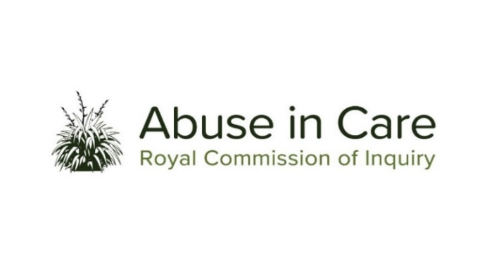
REDRESS INVESTIGATION

A CASE STUDY INTO THE REDRESS PROCESSES OF THE CATHOLIC CHURCH, ANGLICAN CHURCH AND THE SALVATION ARMY

- As the second public hearing within the Redress investigation, the Inquiry will examine the experiences of victims and survivors involved in claims against the Catholic Church, Anglican Church and the Salvation Army, and their respective subsidiary and affiliated entities and institutions including faith-based schools (“the institutions”), for abuse in their care.
- The period to be examined in this hearing is from January 1950 to the present.
- The Inquiry will investigate:
  - What the experiences of victims and survivors were in relation to the redress processes of the institutions, and the impact of those experiences on them
  - Whether structural, systemic, procedural, policy, practical or other factors present within the institutions prevented or limited the ability of victims and survivors to file or pursue claims for abuse in care, including any additional barriers for Māori, Pacific People, people with disabilities, people with mental illness or any other vulnerable group
  - What other factors, if any, may have impeded the making, filing, conduct or resolution of claims by victims and survivors
  - How claims were addressed or resolved and the outcomes (both monetary and non-monetary) of claims within the relevant timeframe
  - What processes used by the institutions, if any, were helpful in resolving claims
  - The institutions’ legal strategies and use of legal defences
  - Whether the institutions’ redress processes were consistent with applicable human rights principles
  - The extent to which institutions’ approaches to managing and resolving claims changed over time, how, and why, and how were such approaches and/or changes made known to victims and survivors
  - The extent to which the principles of Te Tiriti o Waitangi / the Treaty of Waitangi and tikanga Māori were and are incorporated into institutions’ redress processes
  - The institutions’ criteria for monetary and non-monetary redress and whether these were applied consistently and transparently
  - The total cost to the institutions of all monetary and non-monetary settlements for claims made or filed during the relevant timeframe, and their total expenditure on legal costs in the same period (whether directly, through insurance, or other means).
- The Inquiry will not examine the merits of any individual claims, nor resolve disputed factual issues relating to those claims, nor otherwise adjudicate on breaches.

Claims comprise allegations or complaints made to the faith-based institution or civil proceedings filed in a court or the Human Rights Review Tribunal. Criminal prosecutions are not included.

