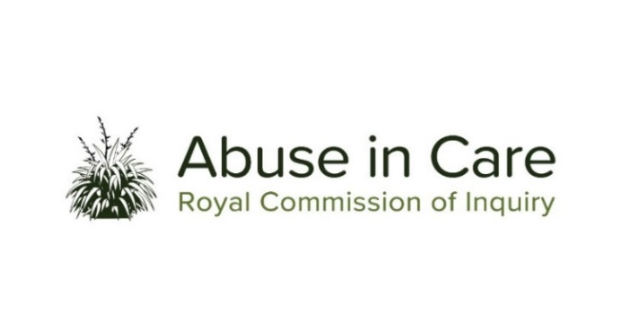
REDRESS INVESTIGATION

SCOPE OF INVESTIGATION INTO REDRESS PROCESSES FOR ABUSE IN THE CARE OF THE STATE AND FAITH-BASED INSTITUTIONS

- The Inquiry will investigate redress and rehabilitation processes (redress processes) available to children, young persons and vulnerable adults as a consequence of abuse in the care of State or faith-based Institutions.
- Abuse is defined in the Inquiry’s Terms of Reference as meaning physical, sexual, emotional or psychological abuse, and neglect. It includes inadequate or improper treatment that resulted in serious mental or physical harm to a person in care. Neglect is not defined in the Terms of Reference, but the Inquiry considers neglect may include physical, emotional and psychological, medical, educational, spiritual and cultural neglect.
- Redress processes are defined in the Terms of Reference to include “monetary processes (for example, historic claims and compensation or settlement processes), as well as non-monetary processes (for example, rehabilitation and counselling)”. The Inquiry considers redress processes can include, in relation to individual survivors and their families, whānau, hapū, iwi and communities:
- Acknowledgment of and apology for abuse that occurred
- Access to justice, including accountability of those responsible for the abuse including through civil claims and criminal prosecutions
- Access to personal information related to the abuse suffered
- Financial compensation
- Access to support services (for example physical, emotional and psychological rehabilitation through medical and psychological treatment, counselling, and other health and social services).
- In this investigation redress processes include State and faith-based redress processes.
- This investigation will cover the period 1950 to 1999, but the Inquiry will consider issues and experiences prior to 1950 as well as after 1999, to inform its recommendations.
- During the course of this investigation, the Inquiry will select issues, themes and/or settings as case studies, and may conduct research and examine relevant matters in public hearings, roundtables, hui and fono, as well as through submissions and written statements.
- The Inquiry will consider the voices and redress experiences of victims and survivors of abuse in care. The Inquiry will investigate and make findings in relation to redress processes by examining:
- The existence or otherwise of redress processes
- Barriers that may exist to dissuade victims and survivors from seeking redress and/or that make such processes challenging
- The adequacy of State and faith-based responses to complaints of abuse by victims and survivors and subsequent redress processes
- Whether lessons have been learned and/or changes made to redress processes over time and the adequacy of any changes made
- The role of entitlements under the Accident Compensation legislation within redress processes
- The impact, including any differential impact, of redress processes on victims and survivors of abuse, and on their families, whānau, hapū, iwi and communities. This will include consideration of:
- Principles of Te Tiriti o Waitangi/the Treaty of Waitangi and tikanga Māori within redress processes
- Pacific cultural norms and values within redress processes
- The impact of discrimination against victims and survivors with disabilities, mental illness or both
- The State’s obligations under relevant domestic and international law including international human rights law
- Application of human rights principles within redress processes of faith-based Institutions.
- In relation to redress processes of State and faith-based Institutions, the Inquiry will also assess and make recommendations on:
- Any changes required to existing redress processes for individuals who claim, or have claimed, abuse while in care
- Any gaps in legislation, policy, rules, standards and practices that require change to better respond to victims and survivors of abuse in care
- Any other steps State or faith-based Institutions should take to respond to harm caused by abuse in care.
- Where relevant, the Inquiry may make findings of fault or that relevant standards have been breached, or both. The Inquiry does not have the power to determine the civil, criminal or disciplinary liability of any person, but may make recommendations that further steps be taken to determine liability.

