He Purapura Ora, he Māra Tipu –
From Redress to Puretumu
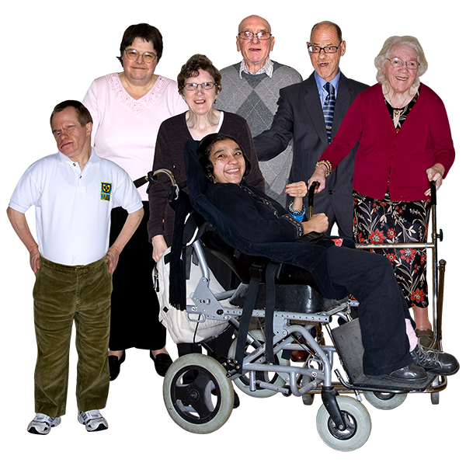

Trying to make things right for people who were abused in care

Published in Easy Read:
December 2021
Before you read this report

This is an Easy Read summary of a report written by the Royal Commission of Inquiry into Abuse in Care.
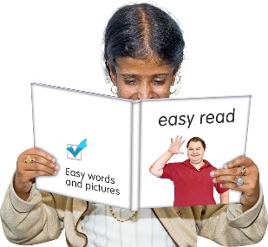

In this Easy Read report we will call the Royal Commission of Inquiry into Abuse in Care the Commission.

This document will give people information about the things that the Commission has found out so far.

Some of the information in this document may upset people when they are reading it.

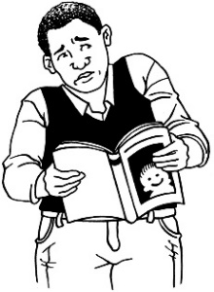
This information is not meant to upset anyone.

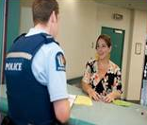
If you do not feel safe right now call the police on 111.

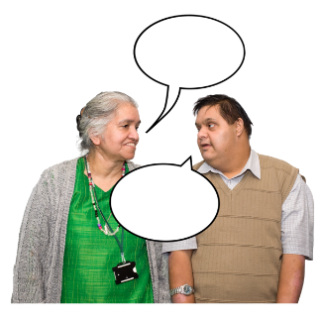
If you are worried or concerned after reading this document you can talk about it with:
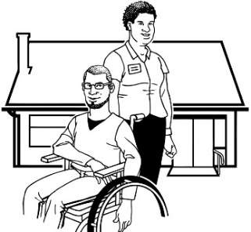
- your family / friends

- your support workers.

If you are still worried you can also talk to someone at the Commission:

Phone: 0800 222 727

Email: contact@abuseincare.org.nz

What you will find in here

Page number:

What is the Royal Commission
of Inquiry into Abuse in Care? 5

About this report 8

What the Commission found 10

What is wrong with how
redress is done now? 20

About the recommendations 29

Page number:

A new puretumu torowhānui
scheme 32

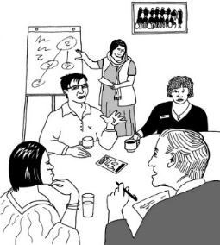
The puretumu torowhānui
system 38

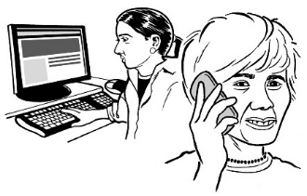
Where to find more information 44

What is the Royal Commission of Inquiry into Abuse in Care?

The Royal Commission of Inquiry into Abuse in Care is looking into abuse that happened to people in care.

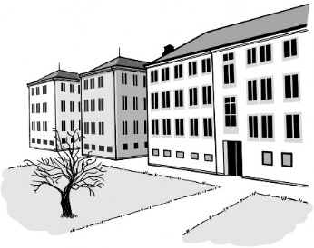
Being in care means that the government or a faith-based institution were in charge of the care.

Faith-based institutions are run by religious groups like churches.

Faith-based institutions provide care.

Abuse can be:

- physical – a person kicking or hitting you

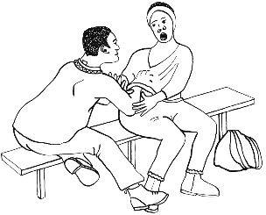
- sexual – when someone does sexual things to you that you do not want them to like:

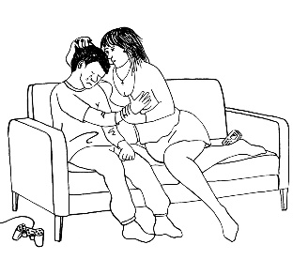
- touching your body or private parts

- kissing you

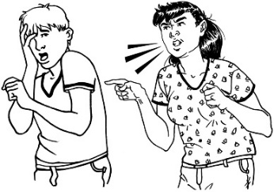
- making you have sex with them – this is called rape

- emotional – yelling or saying things to you that are not nice
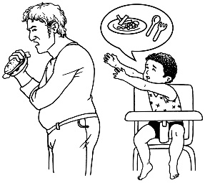
- neglect – not giving you the things or care you need.

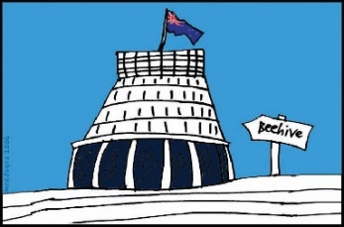
The Commission is not part of the government.

The government cannot tell the Commission what to do.

The Commission is not part of any faith-based organisations like churches.

About this report

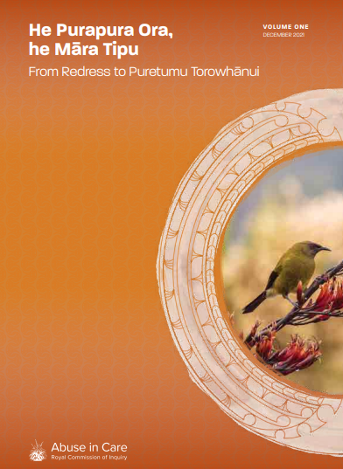
This is a summary of a report written by the Commission called:

Purapura Ora, he Māra Tipu –
From Redress to Puretumu Torowhānui

A summary:

- is shorter than the full report
- tells you the main ideas.

The report is about what redress people can get if they were abused when in care.

Redress is when you try to make things right.
Redress could be things like:
Sorry
- saying sorry
- giving money as a way of saying sorry.

You can find the full report on the Commission website:
www.abuseincare.org.nz/our-progress/
reports/from-redress-to-puretumu/

The full report is not in Easy Read.

What the Commission found

Many survivors told the Commission they:
- do not know the word redress
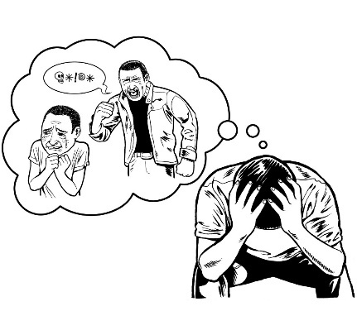
- do not think it is a good word for what is needed.

Survivors are people who have been abused.

A decision was made to use the Māori word puretumu torowhānui.

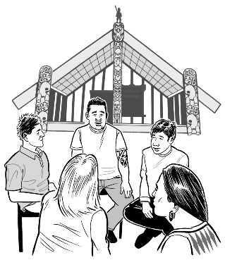
Puretumu torowhānui is what making things right should be like.

Puretumu torowhānui can include lots of different things like:
Sorry
- being told sorry
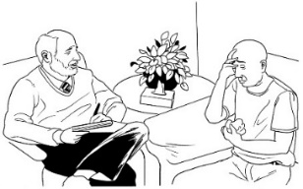
- getting money
- having support to carry on with life like counselling.

Many survivors have found it very hard to get redress.

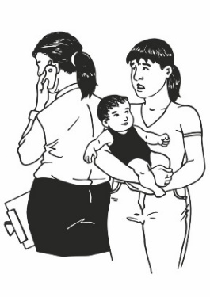
Some of the reasons it is hard for survivors to get redress are:
- people not believing them
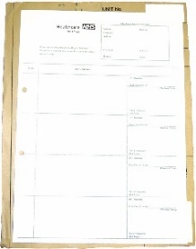
- not being able to get information that shows what happened to them in care.

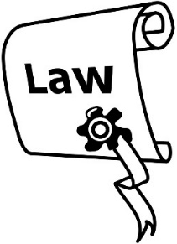
Some more reasons why it is hard for survivors to get redress are:

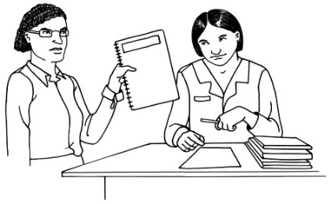
- the law making it harder for survivors
- institutions not looking at their claims for a very long time.

We call the places that were in charge of people in care institutions in this document.

These institutions may have been run by:
      - the government
      - faith-based groups like churches.

In the past the government decided to do things when people made claims.
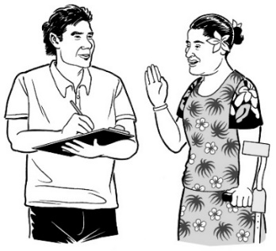

A claim is when you ask for redress.

In the past the government decided to do 2 things:

- If survivors took them to court they would argue against those survivors.

This was very hard for survivors.

Even when the government knew a survivor was right about what happened the government tried to find reasons in the law not to pay them money.
- If survivors made claims to the government they would give them:
Sorry
- some money
- a qualified apology.

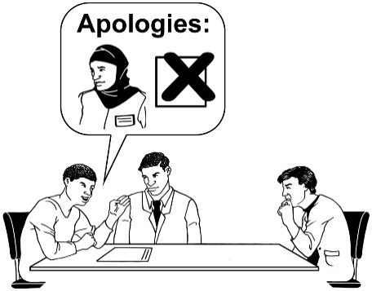
A qualified apology is when you say sorry but:
- still say some things were not your fault
- say it was only partly your fault.

This was also bad for survivors because:
- they did not get as much money as they felt they should
Sorry
- the qualified apology was not good enough
- the same institution that had abused them made the decisions about how things happened.

Faith-based institutions also did things in ways that were bad for survivors.

They also often offered just:
- some money
Sorry
- a qualified apology.

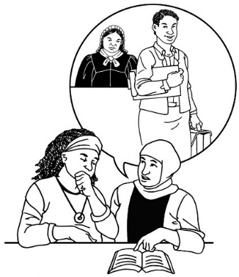
It was hard for survivors to get things if they could not get a lawyer.

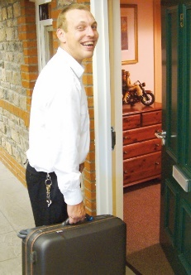
Sometimes faith-based institutions just moved people who did abuse to other places.

This meant they could keep abusing people.

It would have been easy for institutions to find out how bad the abuse was.

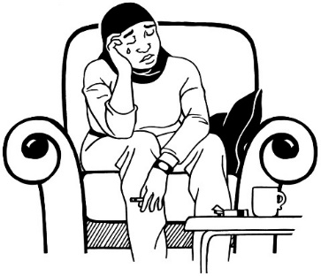
They did not find out more about the abuse because it:
- was very bad to think about
- would have cost them a lot of money.
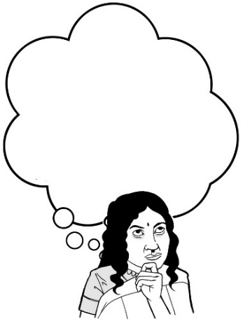
Many people in New Zealand did not want to think about the idea that so many people were being abused.

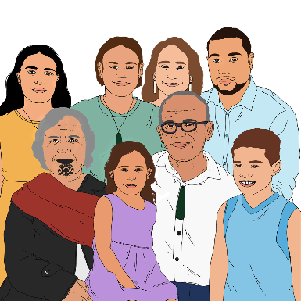
The way the government did things meant that more people were in state or faith-based care from groups like:
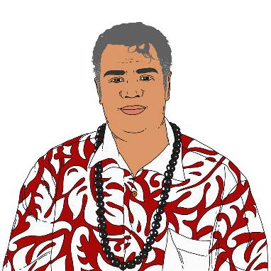
      - Māori
      - Pacific people
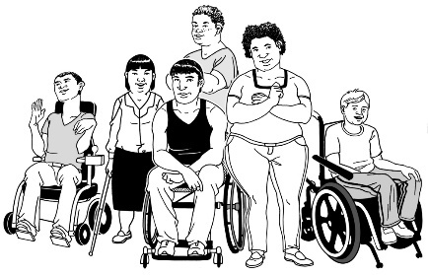
      - deaf people
      - disabled people
      - people with mental illness.

Many survivors had very bad abuse done to them.

Many different kinds of abuse and neglect happened.

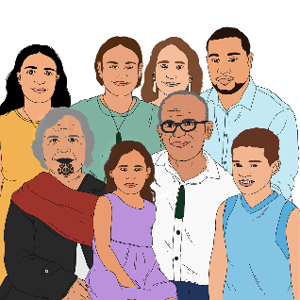
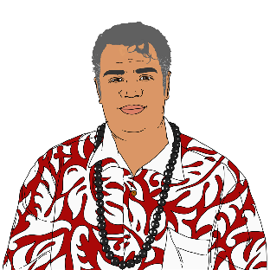
Some groups of survivors experienced particular kinds of abuse like:
- Māori survivors
- Pacific survivors
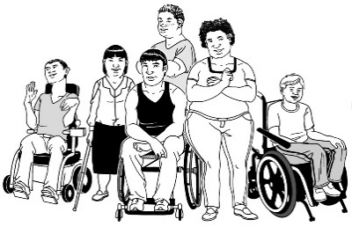
- disabled survivors
- survivors who are women.

It is very hard to understand:
- how people could do this abuse
- how institutions could handle things so badly when survivors asked for redress.

What is wrong with how
redress is done now?

The Commission has looked carefully at how redress is done by the:
- Ministry of Social Development
- Oranga Tamariki
- Ministry of Health
- Ministry of Education
- Anglican Church
- Catholic Church
- Salvation Army.

The Commission found the ways these places do redress is not good enough in many ways.

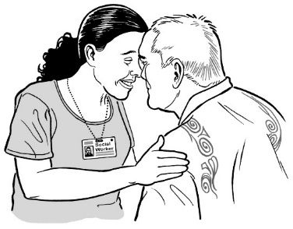
The Commission found that in most cases these places do not respect the mana of survivors.

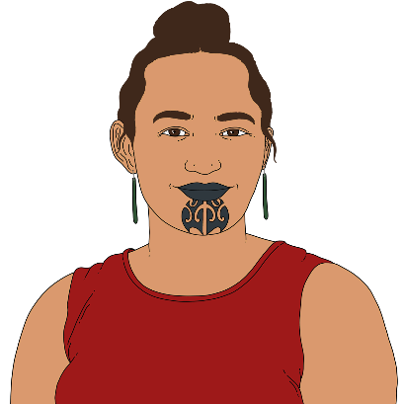
Mana means many things in Māori culture.

Mana can:
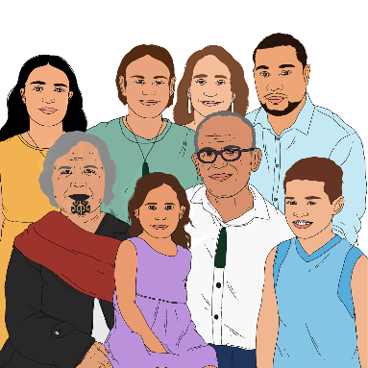
- mean to have great respect from others

- come from your whakapapa

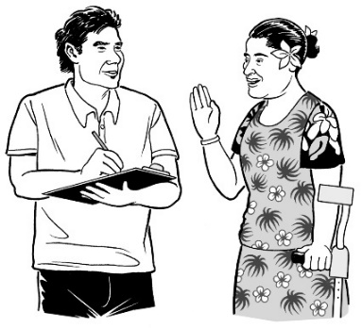
- come from doing good things for other people

- be having the confidence to speak up if something feels wrong or unsafe.
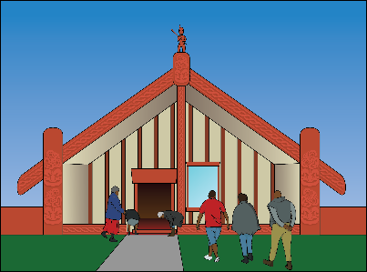
Whakapapa is the importance of knowing about:

- where you are from
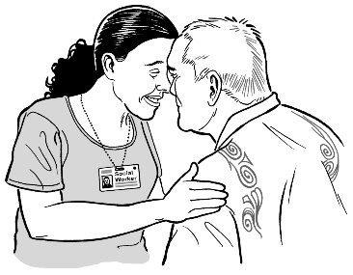
- who you are

- your whānau history / stories.

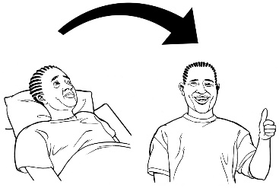
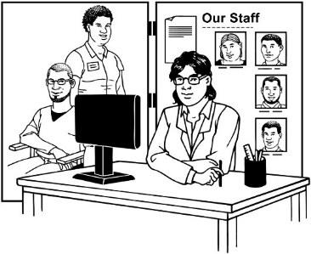
The Commission also found that the ways of doing redress do not offer the support survivors need to:
  - heal their lives
  - get back their mana
  - get back their oranga.

Oranga is to do with:
- living well

- having good food to eat

- having a home to live in
- being healthy.

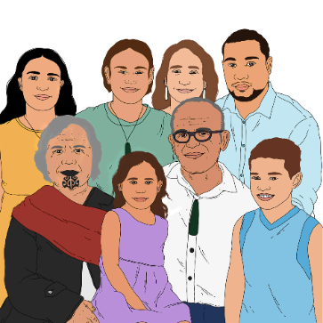
In most cases the places doing redress also do not think about how abuse affected not just survivors but their:
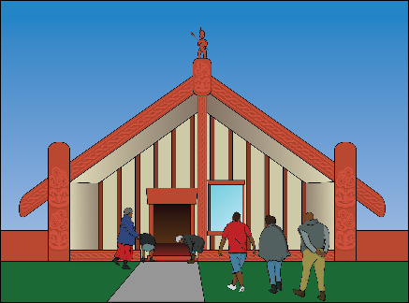
- whānau / family
- hapū
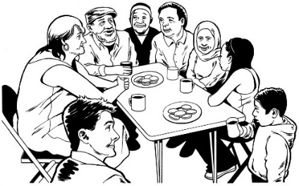
- iwi
- hapori / communities.

In most cases the places doing redress also:
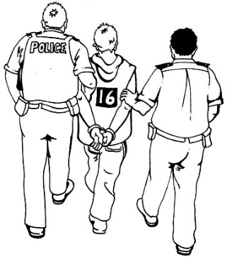
- do not look into what happened
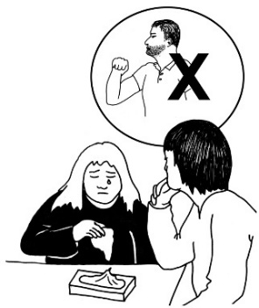
- do not do anything to make sure something is done to the people or organisations that did abuse
- do not do things to stop more abuse happening
- take far too long to offer anything to the survivor
- do not offer the amounts of money survivors should get
- do not say sorry in a way that is right for how much harm has been done.
Sorry

In most cases the places doing redress also:
- often do not believe survivors
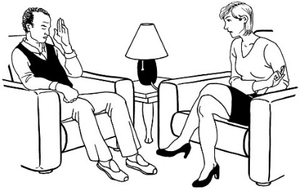
- make survivors prove the abuse happened
- do not support survivors when they are go ing through the claims process
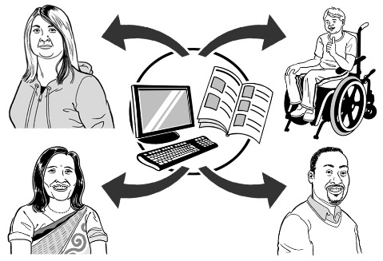
- do not give survivors enough information on how to make a claim
- do not give survivors enough information about how they make decisions.

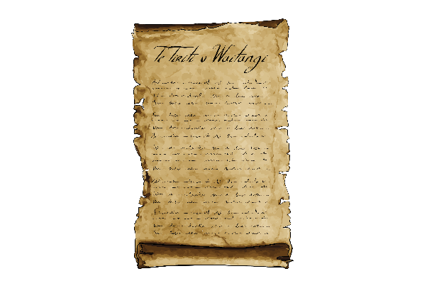
The Commision found that in most cases these places have ways of dealing with claims that do not fit with te Tiriti o Waitangi / the Treaty of Waitangi.

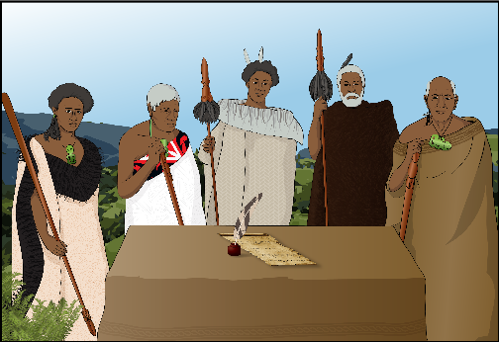
The Treaty of Waitangi / te Tiriti o Waitangi is a legal document that was signed in 1840.

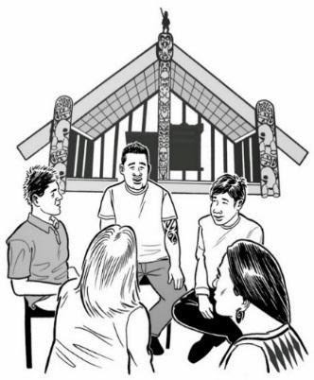
The Treaty / te Tiriti is important to New Zealand.

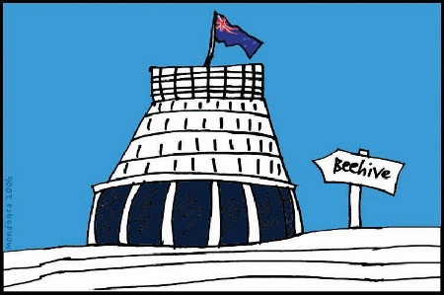
It is about Māori and the New Zealand Government:
- making decisions together
- protecting things that are important to Māori.

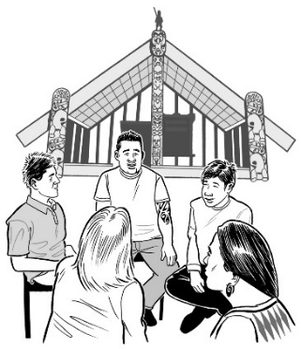
The Commision also found that in most cases these places have ways of dealing with claims that:

- do not include tikanga Māori / Māori ways of doing things
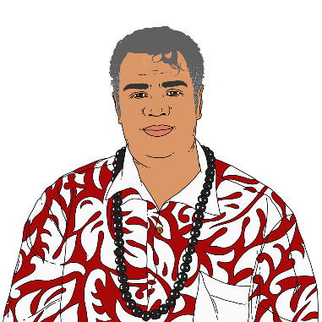
- do not fit with what is important in te ao Māori / the Māori world or way of looking at things
- do not fit with what is important to many Pacific survivors
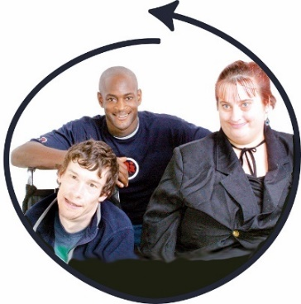
- were made without working with survivors
- suit what they need not what survivors need
- do not meet the needs of many deaf and disabled survivors.

The Commission also found that in most cases these places are not independent.

Not being independent means that the same place that did the abuse makes the decisions about how redress happened.

This makes it hard to trust they are being fair.

About the recommendations

The Commision has made almost
1 hundred recommendations.

Recommendations are things the Commission thinks should happen.

To make these recommendations the Commission has done a lot of work including:
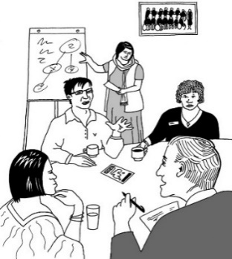
- listening to what lots of people have to say
- meeting with hundreds of survivors
- meeting with different parts of the government
- looking at a lot of documents.
To make the recommendations the Commission did work like:
- talking with groups doing similar work in other countries
- meeting with people from:
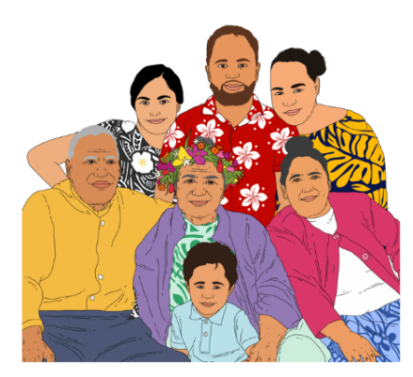
  - Māori communities
  - Pacific communities
  - deaf and disabled communities.

There is still a lot of work to do.

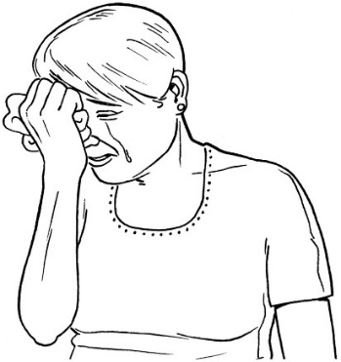
The Commission is making these recommendations now because until we do something:

- survivors will keep having a hard time
- some survivors will die while they are waiting.

It is important to do something now.

A new puretumu torowhānui scheme

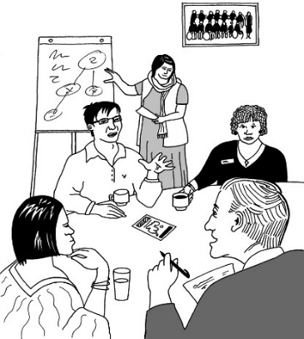
The Commission thinks a new puretumu torowhānui scheme should be set up.

A scheme is when people do things based on a plan.

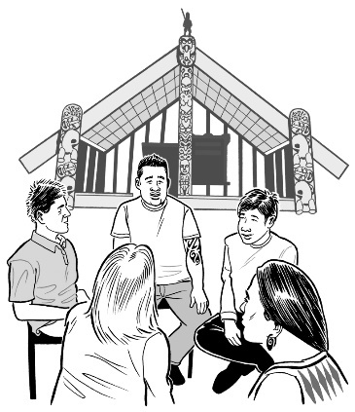
The new puretumu torowhānui scheme should be:
- based on things that are important in te ao Māori / the Māori world
- set up in a way that fits with
te Tiriti o Waitangi / the Treaty of Waitangi
- independent of the institutions where the abuse took place.
The new puretumu torowhānui scheme should also:
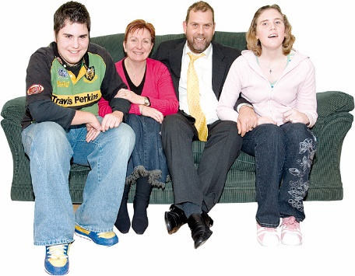
- give survivors money that is the right amount for how much they have been harmed
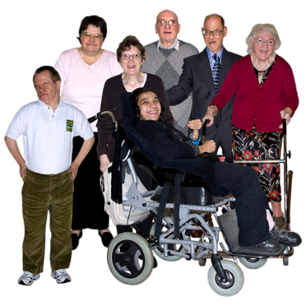
- allow family members to keep doing a claim for a survivor who dies
- put survivors who are very old or very ill first
- work to get institutions to say sorry in the way survivors need
Sorry

- make it safe for survivors to:
  - talk to the puretumu torowhānui scheme
  - talk about their abuse
  - make a claim for puretumu torowhānui.
The new puretumu torowhānui scheme should also:

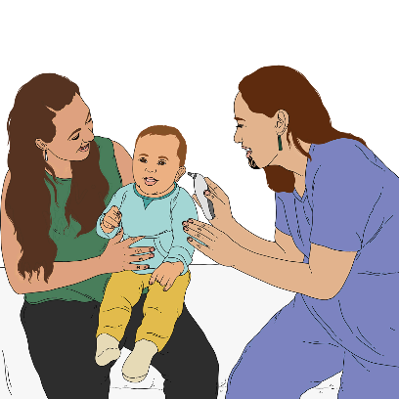
- sort out services that are a good fit with what each survivor needs like support with:
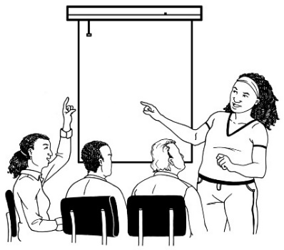
  - health
  - learning
  - getting a job
  - good housing
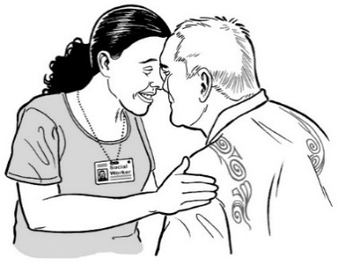
  - having good relationships with other people
  - being connected with their culture.

The new puretumu torowhānui scheme should also:

- be open to all survivors including those who have been through other processes
- deal with all kinds of abuse including neglect
- start by believing the survivor is telling the truth when they first make a claim.

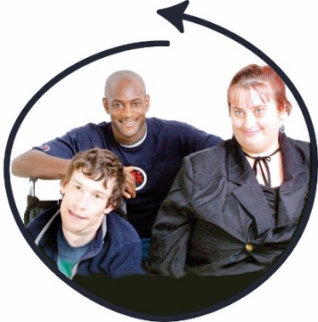
The new puretumu torowhānui scheme should also let survivors be part of:
- deciding how institutions say sorry
- choosing what kind of services they may need.

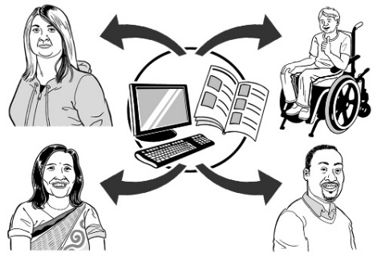
The new puretumu torowhānui scheme should also develop and make public information about things like:
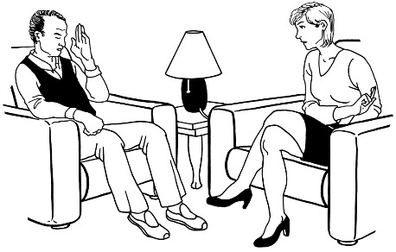
- kinds of support survivors can get
- who can make a claim
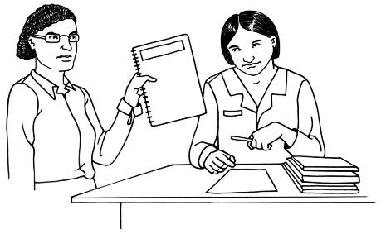
- how decisions are made on claims
- how long decisions take.
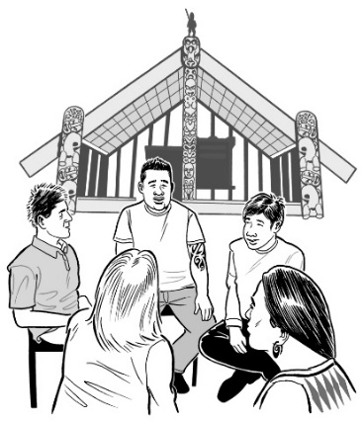

Deciding what the scheme is like will be led by a Māori group working together with survivors.

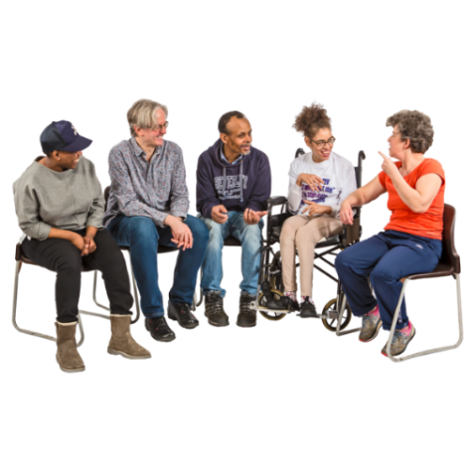
There will be a group that represents survivors called the Purapura Ora Collective.

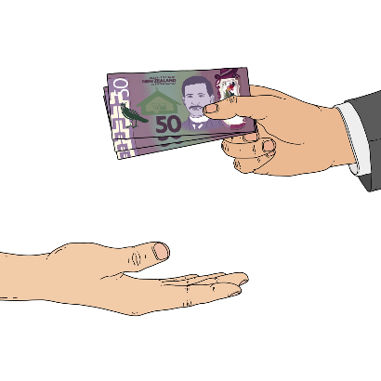
The Purapura Ora Collective will get the money it needs from the government.

All government agencies will join the new scheme.

Faith-based institutions will:
- be asked to join
- have to join later if they do not join when the scheme starts.

The puretumu torowhānui system

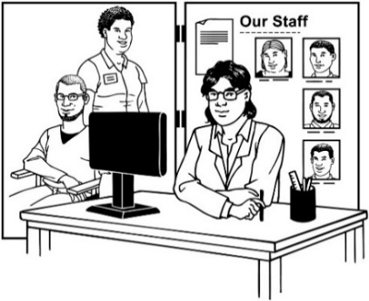
The puretumu torowhānui scheme will be part of a puretumu torowhānui system.

A system is a way of doing things that includes lots of things that fit together like:
- people
- organisations
- rules
- plans.

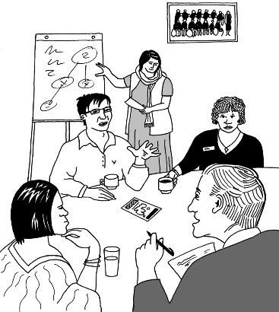
The puretumu torowhānui system will include:
- services
- laws
- rules
- ways of doing things.

All of these will be part of making puretumu torowhānui happen well.

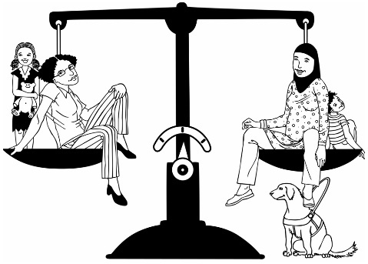
The puretumu torowhānui system needs to make sure puretumu torowhānui:
- is fair
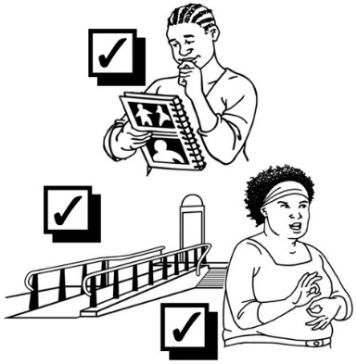
- works well
- is accessible.

Accessible means everyone can use it in a way that works well for them.

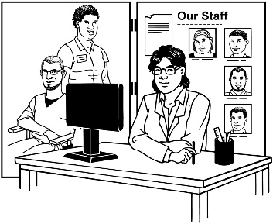
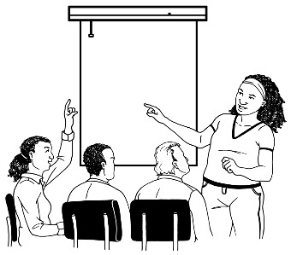
The Commission thinks the new puretumu torowhānui system should include:
- more support services for survivors / whānau
- training for people working with survivors
- better ways of checking if there is abuse.
The Commission thinks the new puretumu torowhānui system should also include:
- setting up a listening service which is a service where survivors can tell someone about the abuse
- making sure there are rules so police are told about abuse
- ways of remembering abuse like memorials
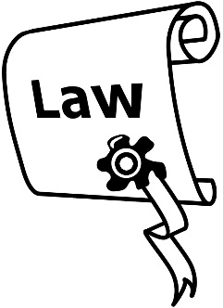
- making sure everyone has a right to be free from abuse in care

- changes to laws about taking institutions to court for abuse
- new rules about what the government should do if survivors take it to court.

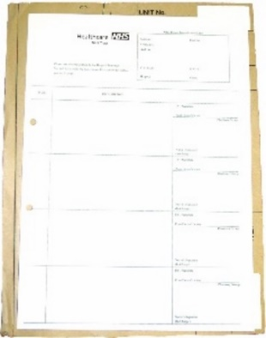
The Commission also thinks the new puretumu torowhānui system should include:
- making it easier for survivors to get information that was kept about their time in care
- looking again at how information is kept about people who are in care to see if it should be done differently
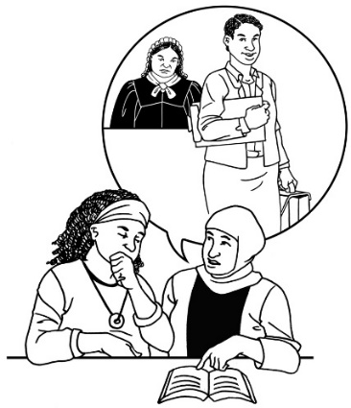
- looking at changes to how much money can be paid for legal aid.

Legal aid is money people can sometimes get to pay lawyers.

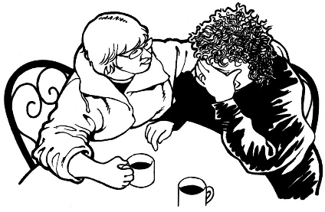
The Commission also thinks that people in charge should:
- say how bad the abuse was
Sorry
- say sorry for:
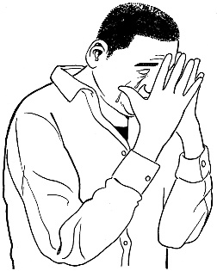
  - the abuse
  - all the harm the abuse caused.

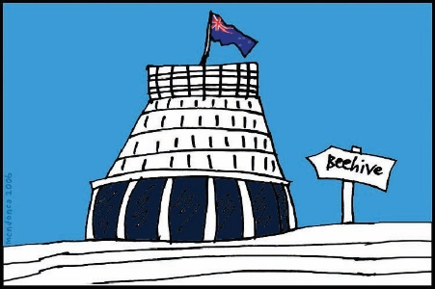
The people saying sorry should include:
- the Prime Minister
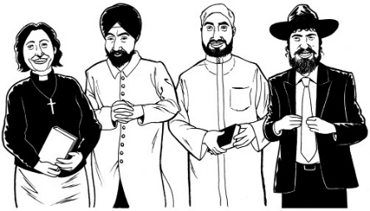
- the Governor General who represents the Queen in New Zealand
- leaders of faith based institutions.

Where to find more information

For more information you can look at:

The Commission website

www.abuseincare.org.nz

You can also find out what is happening at the Commission on Facebook:

www.facebook.com/abuseincareRCNZ/

You can contact the Commission
Contact and Support Service by phone on:

0800 222 727
You can email the Commission at:

contact@abuseincare.org.nz

You can write to the Commission at:
PO Box 10071

The Terrace

Wellington 6140.

This information has been written by the Abuse in Care Royal Commission of Inquiry.
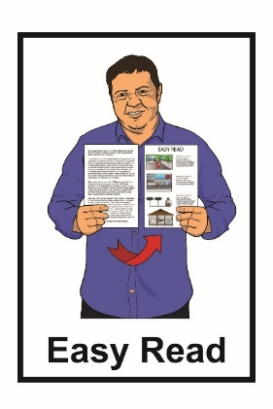
It has been translated into Easy Read by the Make It Easy service of People First New Zealand Inc. Ngā Tāngata Tuatahi.
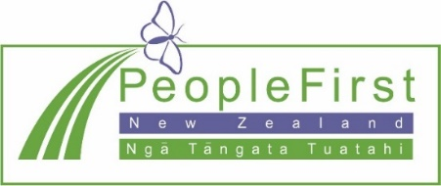
The ideas in this document are not the ideas of People First New Zealand Inc. Ngā Tāngata Tuatahi.
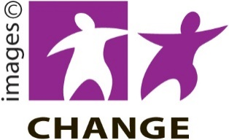
Make It Easy uses images from:
- Changepeople.org

- Photosymbols.com

- Sam Corliss

- Huriana Kopeke-Te Aho

All images used in this Easy Read document are subject to copyright rules and cannot be used without permission.

