Transport information
Location:
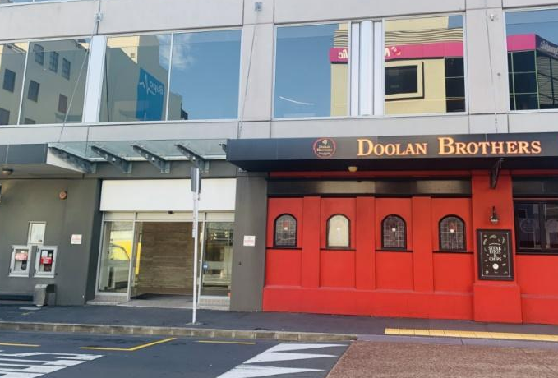
Royal Commission Hearing Space
Level 2, 414 Khyber Pass Road
Newmarket, Auckland

2

The entrance is on Kingdon Street through the glass doors behind Doolan Brother’s Pub.
Click here to see it on google maps.

Drop off:
Map symbol | Item | Details
 | Taxi | Tell the taxis to go to 1 Kingdon Street.
1/2/3 | Loading zones for drop off | There are 3 loading zones close to the drop off space:  - two on Kingdon Street  - one on York Street.  Please note there is a clearway directly in front the of the glass doors on Kingdon Street.  This means no parking between 7-9am and 4-6pm.  This is watched closely by parking people.  Make sure you look at signage at the time you park.  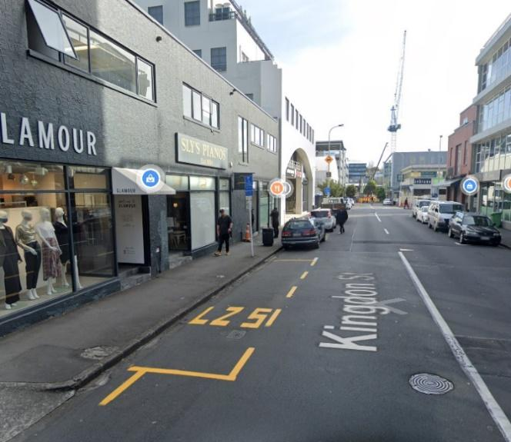
 | Hoist vehicle drop off | The street at the top of Kingdon Street (by the railway tracks) is the place to drop off any people using a hoist vehicle.  Please call 0800 222 727 to talk with a staff member if:  - you need any information  - a meet and greet service from us would be helpful.  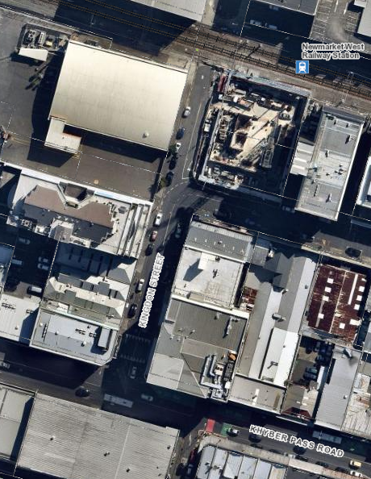  1  2  3  B
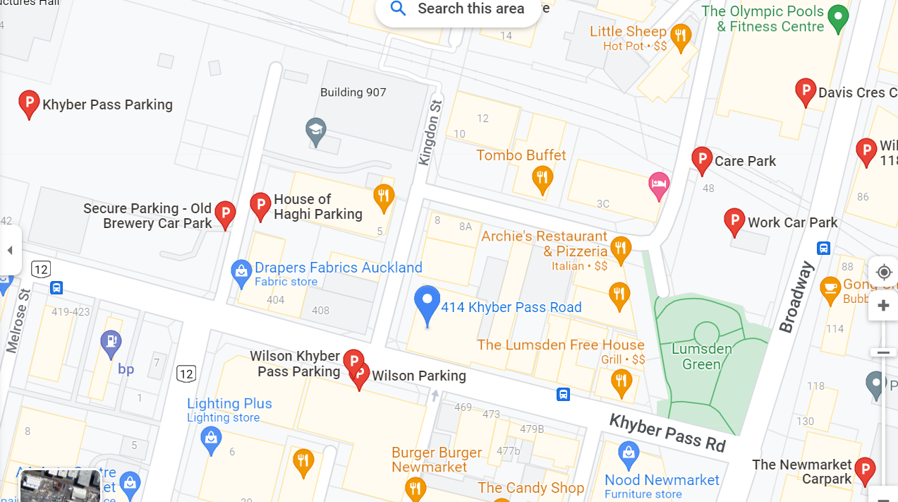

1
2
3
A
B
C
Car parking:
There are many options for carparking.
They are pointed out on the map with this:
A few options are:
- Metered parking on Kingdon Street (this is the same street as the Hearing venue for $2/hour for up to 2 hours, then $4/hour.

- Old Brewery carpark – A on the map

- Wilson carpark across the road (access from York St) – B on the map

- CarePark – C on the map

Public transport
Look at the AT journey planner on this link: AT Journey Planner
There are lots of bus links in the area.

The train
The train station is about 500 meters away from the Hearing venue.
You can get from the train station to the venue through a walkway on Broadway.
The Newmarket train station serves the:
- Southern
- Western
- Onehunga lines.

The bus
There are bus stops on:
- Khyber Pass
- Broadway

The routes are
- the inner and outer link buses
- Routes 30 (to Onehunga)
- 64 (Kingsland via Mt Eden)
- 70 (to Botany)
- 75 (to Glen Innes)
- 309 (to Māngere)
- 866 (Albany).

