Royal Commission of Inquiry into Abuse in Care
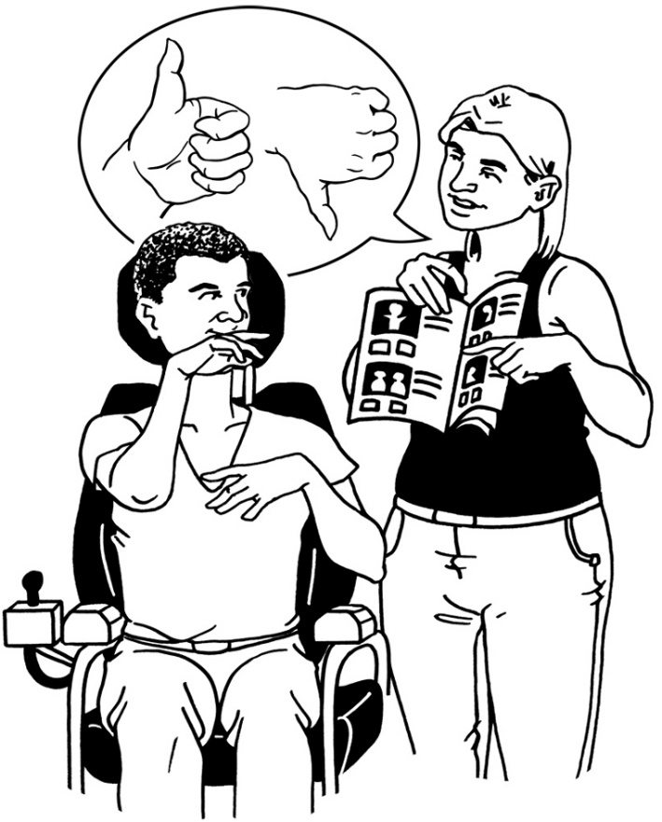

Complaints Policy

Published in Easy Read:
March 2021

What is this Easy Read document about?

This Easy Read document is about how to make a complaint to the Royal Commission about things to do with the Abuse in Care Inquiry.

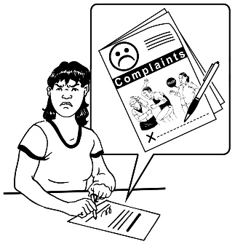
A complaint is when you:

- are not happy about something

- tell someone why you are not happy.

This document is not about how to make a complaint about being abused when you were in care.

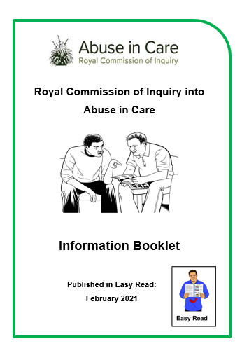
We have another Easy Read booklet called:

Royal Commission of Inquiry into Abuse in Care: Information Booklet.

In that booklet you can find out more information about:

- the work of the Royal Commission of Inquiry – Abuse in Care

- what abuse is

- how to tell us about abuse that you experienced while in care.

You can find this booklet on our website:

www.abuseincare.org.nz

Making a complaint

In this booklet we will call the Royal Commission of Inquiry into Abuse in Care the Commission.

If you are not happy with something we have done here at the Commission you can make a complaint.
Anyone can make complaint to the Commission about something they are not happy about.

You may want to ask someone to assist you to make a complaint.

You can send a complaint to the Commission at any time.

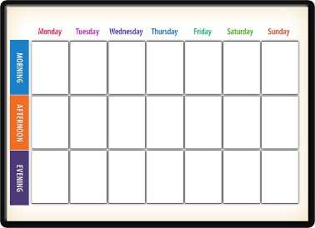
It does not matter how long ago the thing you want to complain about happened.
This Photo by Unknown Author is licensed under CC BY-SA
It is good to send us a complaint as soon as you can so we can:
- find out what happened quickly
- reply to you as soon as we can.

We want to:

- make it easy for people to make a complaint to us

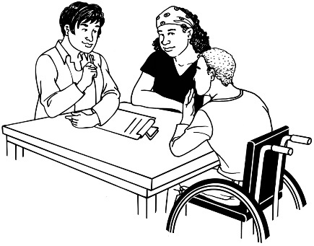
- make sure that we treat all complaints carefully
- be fair in how we deal with complaints.

This Photo by Unknown Author is licensed under CC BY
When we have looked into your complaint we will let you know the about the outcome of your complaint.

If your complaint finds that we did something not right then we will:
This Photo by Unknown Author is licensed under CC BY-SA

- apologise to you which means to say sorry
- do what we can to fix what has happened
- do things to make sure it does not happen again.

We will use what we learn from the complaints so we can do things better.

How the complaints process works
Complaints
Process

A complaints process is the steps that we take to look at the complaint that has been made.
1 2 3 4
There are 4 steps of our complaints process are:
- Early Resolution is when you talk to the person you have a complaint about
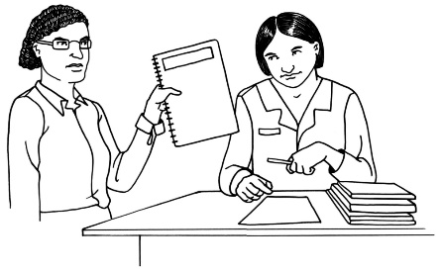
- Stage 1 is the first stage in making a formal complaint
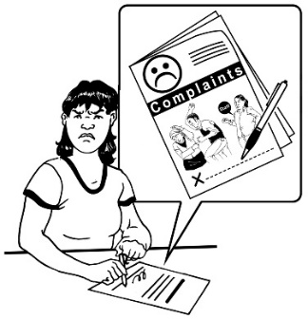
- Stage 2 is when your complaint is looked at by the Executive Director of the Commission
- Stage 3 is when your complaint is looked at by the Chair of the Commission.
Early Resolution
1 2 3 4
The first step in making a complaint is to talk to the person who your complaint is about.
You can ask them to fix the problem you have had with them.

You can contact our team here at the Commission to talk with someone at our contact and support centre by:

Phone: 0800 222 727
Email: contact@abuseincare.org.nz

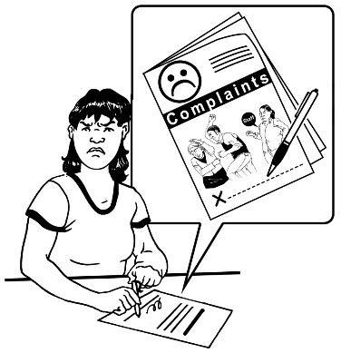
If you are not happy with how your complaint was handled by the person you talked to you can make a formal complaint.

A formal complaint is a written complaint that is sent to the Commission.
A formal complaint will be looked into by people who know what to do.
They can make the right choice about what to do with the complaint.

Stage 1: Making a formal complaint
When you make a written formal complaint we need some important information from you.
If we do not have this information we cannot look into your complaint.
Please make sure your complaint has:

- your first and last names
- your address where you get your mail; or
- your email address.
Please also make sure your complaint has:
- a phone number we can contact you on if you have one.
- other contact details like:
- how to contact your support person if you have one
- how to contact your disability advocate if you have one.
- what the best way for us to contact you is.

You will also need to tell us everything about your complaint such as:
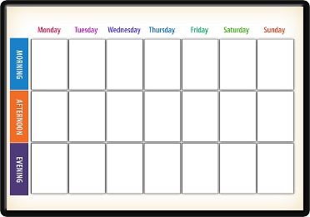
- what happened
- when it happened
- if you have anything that can show us what has happened such as emails
- what you want to happen because of your complaint.

Sometimes talking to the person your complaint is about does not work.

When this happens you need to tell us who assisted you when you called the Commission.
At Stage 1 your formal complaint will be read by a senior manager.

A senior manager is a person who is responsible for a team of people who do work at the Commission.

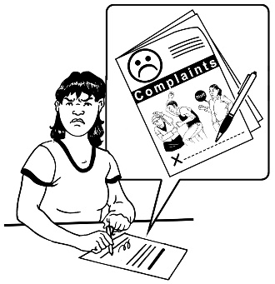
You need to post your written complaint to:

Complaints

PO Box 10071

The Terrace

Wellington 6011

You can also send your complaint in an email to:
complaints@abuseincare.org.nz
Stage 2: Your complaint is looked at by the Executive Director
1

You will move to Stage 2 if you are not happy with the outcome from the senior manager at Stage 1.
If you want us to look at your complaint again you will need to send it to the Executive Director.

The Executive Director is responsible for a lot of things in the Commission.

The Executive Director makes sure the Commission is being fair and impartial.

You also need to tell us why you are not happy with our reply in Stage 1.

You can post your complaint to:

Executive Director
Complaints

PO Box 10071

The Terrace

Wellington 6011

You can also email your complaint to:

complaints@abuseincare.org.nz

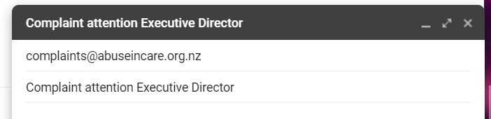
If you email us please type the subject line as:

Complaint attention Executive Director.
Stage 3: Your complaint will be looked at by the Chair
2
Stage 3 is when you are not happy with the outcome after the Executive Director has looked at your complaint in Stage 2.
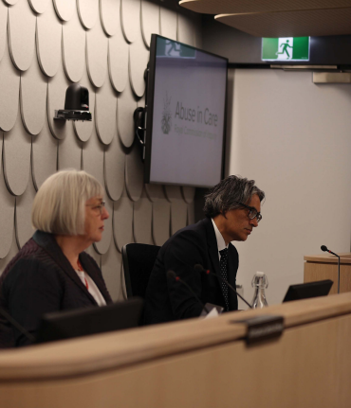
At Stage 3 you send your complaint to the Chair of the Commission.
The Chair is the person who leads the Commission meetings.

The Chair also makes sure the Commission does what it needs to do.

The Chair is the last person to send your complaint to.
1 2 3 4
You need to tell the Chair why you are not happy with how your complaint has been handled.

You can post your complaint in writing to:
Chair

Complaints

PO Box 10071

The Terrace

Wellington 6011
You can email your complaint to the chair at:

complaints@abuseincare.org.nz
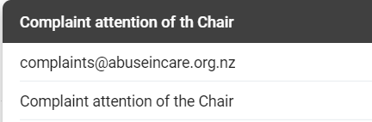
If you email us please type the subject line as:

Complaint attention of the Chair

If your complaint is about the Chair you will need to send it to the Executive Director

You can post your complaint to:

Executive Director

Complaints

PO Box 10071

The Terrace

Wellington 6011

You can also email your complaint to:

complaints@abuseincare.org.nz

If you email us please type the subject line as:
Complaint attention Executive Director.

What we do when we get your complaint
This Photo by Unknown Author is licensed under CC BY-SA
This Photo by Unknown Author is licensed under CC BY-SA
This Photo by Unknown Author is licensed under CC BY-SA
3
We will let you know we have got your complaint within 3 business days.
This Photo by Unknown Author is licensed under CC BY-SA
This Photo by Unknown Author is licensed under CC BY-SA
This Photo by Unknown Author is licensed under CC BY-SA
This Photo by Unknown Author is licensed under CC BY-SA
This Photo by Unknown Author is licensed under CC BY-SA
This Photo by Unknown Author is licensed under CC BY-SA
This Photo by Unknown Author is licensed under CC BY-SA
This Photo by Unknown Author is licensed under CC BY-SA
This Photo by Unknown Author is licensed under CC BY-SA
This Photo by Unknown Author is licensed under CC BY-SA
This Photo by Unknown Author is licensed under CC BY-SA
This Photo by Unknown Author is licensed under CC BY-SA
This Photo by Unknown Author is licensed under CC BY-SA
This Photo by Unknown Author is licensed under CC BY-SA
This Photo by Unknown Author is licensed under CC BY-SA
15
We will answer your complaint within 15 business days of getting your complaint.

Business days are the days most businesses work.

These days are:
- Monday
- Tuesday
- Wednesday
- Thursday
- Friday.

Saturday and Sunday are not business days.

If we cannot answer your complaint within 15 business days we will:
This Photo by Unknown Author is licensed under CC BY-SA
This Photo by Unknown Author is licensed under CC BY-SA
This Photo by Unknown Author is licensed under CC BY-SA
This Photo by Unknown Author is licensed under CC BY-SA
This Photo by Unknown Author is licensed under CC BY-SA
This Photo by Unknown Author is licensed under CC BY-SA
This Photo by Unknown Author is licensed under CC BY-SA
This Photo by Unknown Author is licensed under CC BY-SA
This Photo by Unknown Author is licensed under CC BY-SA
This Photo by Unknown Author is licensed under CC BY-SA
This Photo by Unknown Author is licensed under CC BY-SA
This Photo by Unknown Author is licensed under CC BY-SA
This Photo by Unknown Author is licensed under CC BY-SA
This Photo by Unknown Author is licensed under CC BY-SA
This Photo by Unknown Author is licensed under CC BY-SA
15
- explain why we cannot answer you yet
- tell you how long we think it will take to answer your complaint.
How to contact us

If you have any questions you can contact us.

You can phone us on:

0800 222 727

You can email us at:

contact@abuseincare.org.nz

You may have your question sent to the complaints team if needed.

This information has been written by the Royal Commission of Inquiry into Abuse in Care.

It has been translated into Easy Read with assistance from the Make It Easy service of People First New Zealand Inc. Ngā Tāngata Tuatahi.

The ideas in this document are not the ideas of People First New Zealand Ngā Tāngata Tuatahi.

Make It Easy uses images from:
- Changepeople.org

- Photosymbols.com
- Sam Corliss.

All images used in this Easy Read document are subject to copyright rules and cannot be used without permission.

