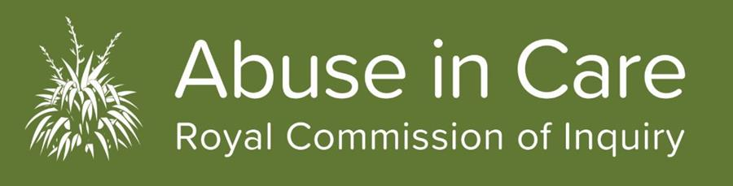
A message from Commissioner Coral Shaw
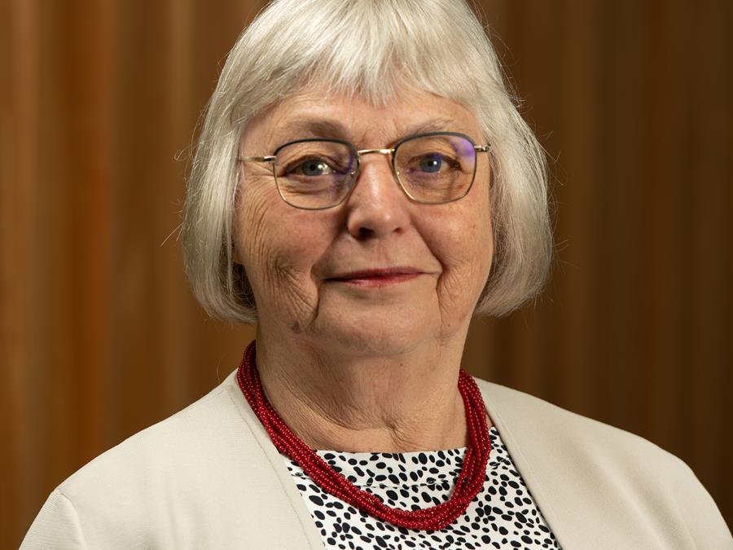
As you may have seen, the media this week published reports about a convicted child sex offender being involved with the Survivors Advisory Group.
I would like to be clear the person is not a member of the Survivor Advisory Group and did not attend any meetings. He had at times been present as a support person at venues where the Group has met. Once we were informed of these convictions in August, we acted swiftly to make sure he had no further engagement with the Survivor Advisory Group or the inquiry.
The safety of survivors remains a primary focus for Commissioners. We have now put in place a comprehensive safety checking system for SAGE members which includes a Police and Ministry of Justice criminal history check for all members of the Group and the support people who accompany them to meetings.
The nature of our work means that many people we work with – employees, supporters, experts, ambassadors – have convictions. We do not want to stop survivors' ability to participate in the Inquiry.
We must continue our work so the experiences of survivors can be heard and we, as a nation, can transform the way we care for our children, young people and vulnerable adults.
Commissioner Coral Shaw
First public hearing just one month away
With just one month to go until the first public hearing, the Royal Commission has published further details of how the hearing will run and a provisional list of speakers.
The Contextual hearing beginning on 29 October at the Rydges Hotel in Auckland will be the first time the Inquiry will hear from survivors in a public hearing.
Survivors, their advocates, academics and experts will speak at the two-week hearing and cover a huge range of issues and topics. It will set the scene for the rest of the Inquiry.
Royal Commission Executive Director Mervin Singham says the hearing will give the public an indication of the depth and context of the issues the Inquiry is investigating.
“We know that for many New Zealanders what witnesses tell us will be hard to hear. But we must listen if there is to be change in the way New Zealand cares for its children, young people and vulnerable adults in future.
“We will hear from survivors about the abuse they experienced and the long-term impact on them and their whānau and families. We will also hear from experts about broader systemic issues that allowed people to be taken into care and the abuse they suffered while there.”
You can find out more about the Contextual hearing and a provisional list of witnesses appearing at the hearing on our website.
A hearing plan with confirmed witnesses and dates and times they will give evidence will be released in late October. A short summary of the topics to be covered by each witness will be published before that.
The hearing is open to the public and will be livestreamed, with NZSL interpreters, on the Inquiry's website for the duration. A recording of the full hearing will be available to watch on the website when it ends.
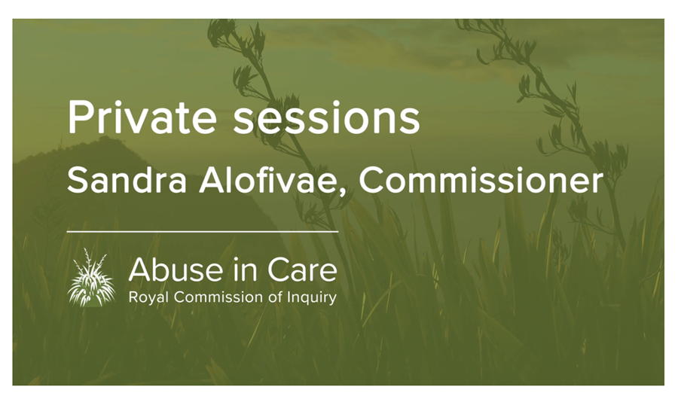

Experiences of abuse revealed in private sessions
Shocking stories are emerging from survivors of abuse in care during private sessions with Commissioners.
Commissioners Ali’imuamua Sandra Alofivae, Andrew Erueti, Coral Shaw and Paul Gibson, along with Commission Chair Sir Anand Satyanand have been travelling the country listening to survivors’ experiences of abuse in care through private sessions.
"They (survivors) come to us because they want to be heard. If anything, they just want to be believed. For many of them, it is the first time they are believed," says Commissioner Sandra Alofivae.
“People are very descriptive and when you hear the same, or similar circumstances, described by different people at different times, you know they cannot be making this up.”
“We are hearing things that most New Zealanders will have never heard before. This is part of our history that many people would be shocked by."
Nearly 150 survivors have shared their experiences with Commissioners in private sessions. Sandra, who has hosted around 30 private sessions so far, says survivors often find the sessions a cathartic experience. Commissioners do a lot of preparation before each session, and so do survivors.
“It is really important for us to understand their specific needs and wellbeing issues because we want to be able to accommodate survivors and make it as unstressful as possible.
"Often they (survivors) are anxious when they come to the session. I have not met anyone who has not been anxious. Even if they have told their story before, it still takes a lot of courage to keep retelling it. We really get to see what resilience looks like. It is a real privilege for Commissioners to receive these stories.”
The Commission has produced a video for survivors on what to expect in a private session. You view it on our website www.abuseincare.org.nz.
Survivors often want Commissioners to help them with issues outside the scope of the Inquiry. Commissioners have been asked for help with historical claims or assistance to get personal information from government agencies. Unfortunately the Commission cannot help with this. However we have compiled a list of links to organisations that can help on our website. You can find them on our website.
Planning ahead for redress hearing in 2020
While the first public hearing is almost upon us, planning for the next substantial hearing in March 2020 on redress is underway.
Redress can take many forms, including apologies, support services and monetary compensation, and can be sought through complaints processes or civil proceedings.
A document setting out the scope of the first public hearing on Redress has been published on the Inquiry’s website.
The hearing will investigate the experiences of survivors making civil claims against the Crown for abuse in State care and whether the Crown’s responses to claims has been adequate and appropriate.
The overall investigation into redress will run throughout the life of the Inquiry. The Royal Commission will examine historic and current redress processes for survivors of abuse in State care and the care of faith-based institutions. The Inquiry will also look at what forms of redress and rehabilitation should be available in the future and how they should be delivered.
In addition to considering past, present and future redress processes, the Commission will also investigate the civil justice system.
The March 2020 hearing will be one of many hearings into redress. Survivors will be able to share their experiences of redress processes through private sessions, submissions to the Royal Commission, participation in focus groups or giving evidence at public hearings when requested to by the Crown.
The Inquiry has published its first Issues Paper on redress and is calling for submissions from all those interested, including individuals, government and non-government organisations. It is available on our website.
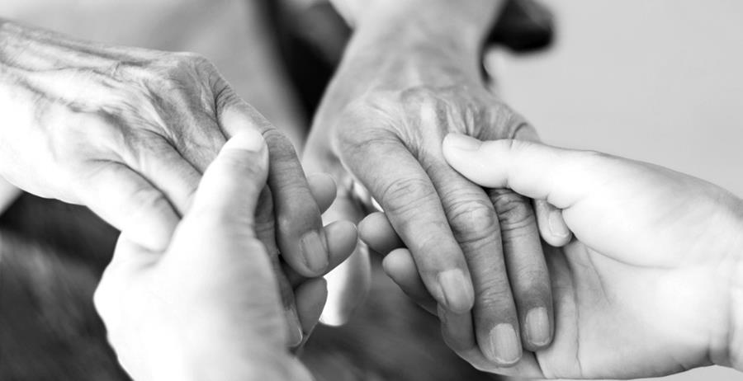
Timely reminder during Mental Health Awareness Week
We know that reliving past abuse can be traumatic for survivors. Counselling and support is available for all survivors engaging with the Inquiry.
Wellbeing support will be discussed with all survivors prior to engaging with the Commission to see what counselling and support may be needed (before, during and after) a private session or public hearing. Survivors can access support at any time during a private session and also if they are appearing at a public hearing. The support is tailored to a survivor's needs and is provided by mental health professionals and approved providers. For more information on counselling and support provided by the Inquiry please visit our website.
For more information about what’s on during Mental Health Awareness Week, please visit www.mhaw.nz.

Royal Commission to set up Legal Assistance Panel
The Royal Commission is setting up a Legal Assistance Panel ​of approved lawyers to provide legal representation, advice and help to people or groups participating in the Inquiry.
While you do not need to have a lawyer to participate in the Inquiry, we know there will be situations where ​some people do need legal help. Legal assistance may, for example, be required by a survivor or group of survivors providing information before or during a public hearing; a survivor preparing a written submission before a private session; or when a person is requested by the Royal Commission to give an interview and/or be a witness at a hearing.
The Royal Commission has put a call out to lawyers interested in being on the panel who will be available to provide legal assistance. The ​Commission is currently waiting for approval for legal assistance funding and once it is approved the Inquiry will publish a panel of approved lawyers, more information about what assistance is available and how to apply.
In the meantime for further information on this visit our website or email counselassist@abuseincare.org.nz.

