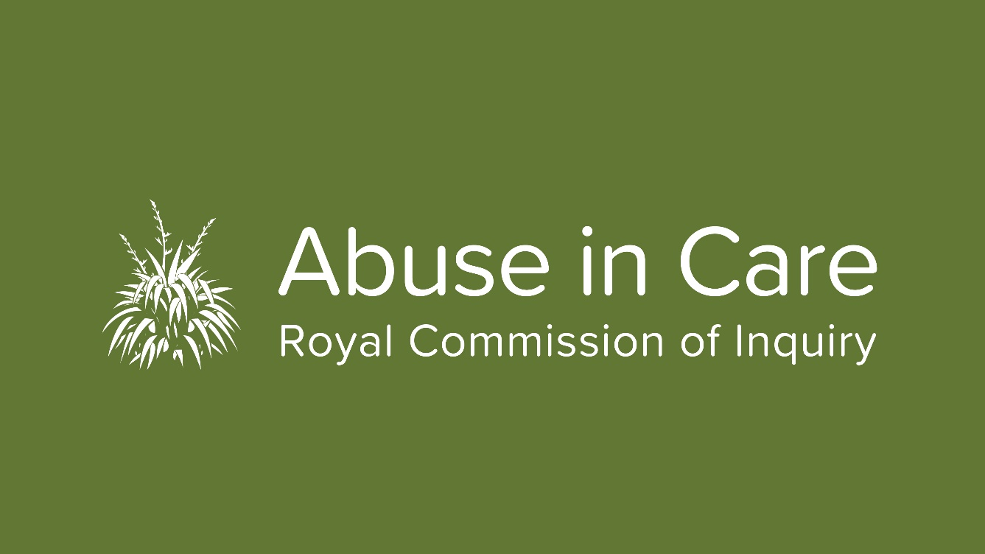

Royal Commission meets royalty at Ngāruawāhia

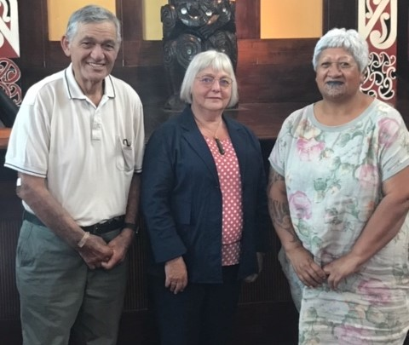
A gracious royal welcome was extended to Inquiry Chair Judge Coral Shaw by the Māori King Tūheitia Paki and his wife Makau Ariki (Royal Consort) Atawhai at Tūrangawaewae earlier this month.

The meeting was part of a series of meetings Judge Shaw has been having with Māori leaders since she became Inquiry Chair. Late last year she met with the New Zealand Māori Council and she will meet with the Iwi Chairs Forum at Waitangi next week.

“Forging strong ties with Māori leaders is an absolute priority for Commissioners," she says. "We are relying on Māori to tell us their accounts and experiences of abuse in care and to come up with solutions that will work for them. We want to work with Māori as a Tiriti partner in its truest sense,” she said.

Judge Shaw said the Māori King was very interested in and enthusiastic about the work of the Royal Commission.

“It was a great meeting held in Turongo House surrounded by all the beautiful carvings. We talked about how abuse in care has affected so many generations of Māori and how it has to be brought to light before it can be stopped. I got the feeling that both the King and his wife regarded the work of the Inquiry as very important. The King was pleased that it was an independent inquiry.”

Of course, you do not have to be Māori royalty to meet and talk to our Inquiry Chair. She and her colleagues want to talk to as many Māori kanohi ki te kanohi (face to face) as they can.

On New Year’s Day Judge Shaw spent the day, as she usually does, at the historic Kawhia Rowing Regatta watching the annual whaleboat races.

“I have been going to the Regatta for years and this year I spent the whole day talking to people about the Inquiry. Everyone I spoke to knew of someone who had been abused in care and wanted to hear about or be involved in the Inquiry. This type of ongoing engagement is very important for the work of the Royal Commission.”

Redress Hearing date set

The Redress hearing will be held in Wellington from 23 March.

Called the 'Public Hearing into the State Response to Civil Redress and Civil Litigation Claims', it will be held in Wellington's Environment Court. It is expected to run for two weeks until 3 April. However two extra days have been allowed for in case it runs over.

The Inquiry will look at the experiences of survivors in seeking and obtaining redress for abuse in care; what processes have been, and still are, available to people who have been abused in care; relevant domestic and international laws; what changes can be made to improve redress processes and what other steps relating to redress can, and should be, taken.

Survivors with experience in redress processes will speak at the hearing as will lawyers who have dealt with government departments on behalf of claimants. Representatives from government departments including Health, Education, Social Development and Oranga Tamariki will give evidence. Crown Law and the Legal Services Commissioner will also give evidence. The public is welcome to attend the hearing. It will also be streamed live on our website so you can watch it online.

This public hearing is just one part of the Inquiry's investigation into redress. The way faith-based institutions have treated survivors' claims will also be investigated in detail.The redress team will carry out research, gather relevant (anonymised) information from survivors’ private sessions, consider evidence from public hearings, and hold roundtable meetings, workshops and hui.

More information about the redress hearing and a list of witnesses is available on our website.

Private sessions coming to a town near you

In 2020 the Royal Commission will be visiting smaller towns and rural areas to make it easier for survivors to share their experiences of abuse in care with the Inquiry.

“We need to get to as many survivors as we can, and we want to make it as easy as possible for survivors to engage with us. Their wellbeing is our main concern,” says Helena Dillon, Head of Survivor Accounts.

The Royal Commission expects to hold around 700 private sessions this year, more than twice the number of sessions conducted in 2019.Private sessions enable survivors to talk to commissioners face-to-face about their experience of abuse in State and faith-based care.

So far this year the private sessions team has visited Invercargill, Ashburton, Albany, Timaru, Hokitika, Greymouth, Masterton, Paraparaumu, Otaki, Levin, Taupo, Rotorua, Mangere and Manukau looking for suitable venues.

“Finding the right space can be a challenge,” says Helena. “We need venues that meet a wide range of requirements. We also need to protect survivors’ privacy as much as possible, so discretion is a priority. Venues need to be in an easy-to-reach location with parking, wheelchair accessibility and preferably away from any triggering environments, for example churches. Rooms need to be soundproof and set up in a way that is comfortable for survivors and the Commission to work in.

To arrange a private session, survivors first need to register with the Inquiry. To do this please call us on 0800 222 727 or email us at contact@abuseincare.org.nz.

Lake Alice investigation underway

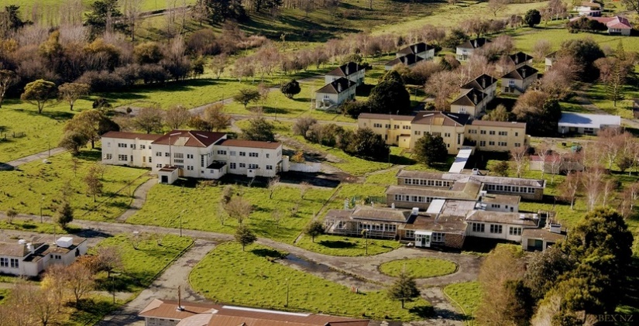
The Royal Commission will conduct a full, independent and impartial investigation into allegations of abuse at the Lake Alice Psychiatric Hospital as part of its Inquiry into Abuse in Care.

You may have seen the news that the United Nations Committee against Torture has found that New Zealand breached the Convention against Torture by failing to properly investigate abuse at Lake Alice Hospital in the 1970's.

Commission Chair Judge Coral Shaw said the Inquiry's investigation into what occurred at Lake Alice has already begun and the team has been working with Paul Zentveld who took the case to the United Nations.

“We have already talked to and heard from a number of survivors of abuse at Lake Alice. The Royal Commission will use its extensive powers to conduct a thorough investigation into what occurred at Lake Alice and the Government’s response. This will include examining the response of the Police and Crown to serious allegations of abuse.

The Royal Commission plans to hold a public hearing into abuse at the Adolescent Unit at Lake Alice later this year as part of a broader investigation into abuse in psychiatric care.

Contact Centre hours extended

From Monday 3 February, our Contact Centre will be open until 6pm. Please call to register or speak to one of our staff on 0800 222 727 between 8.30am and 6pm weekdays. You can also write to us at PO Box 10071, The Terrace, Wellington 6143.

Summer of Engagement

The Abuse in Care Royal Commission of Inquiry will be attending a number of outdoor events over the next couple of months as part of our engagement with the community.

We will be at Te Rā O Te Raukura in Lower Hutt on 1 February, various Waitangi Day celebrations around the country on 6 February and the Newtown Fair in Wellington on 8 March. We will also be having a stand at the Mosaic Symposium in Wellington on February 10. We will also be targeting other events around the country as appropriate.

“Attending events such as these is very important to us,” says Executive Director Mervin Singham.

“We hope our presence will also encourage people to register with us to share their experiences of abuse in care. We also hope that people will tell their family, whanau, friends and colleagues about this Inquiry. The more people that know about it, the more successful it will be."

Arise Sir Robert

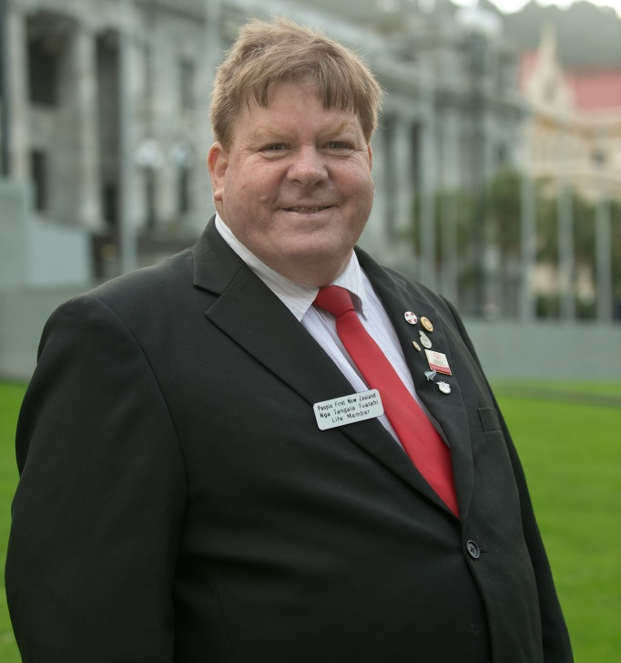
Warmest congratulations to Sir Robert Martin KNZM who has been knighted for his services to people with disabilities. Sir Robert, who gave evidence at our Contextual hearing last November, has represented the rights and interests of people with learning disabilities for more than 30 years. He is the first person with a learning disability in the world to be knighted.

In 2016 he was also the first person with a learning disability to be elected onto United Nations Human Rights Treaty Body, the Committee for the Rights of Persons with Disabilities.

Sir Robert spent most of his childhood and early teenage years in institutions and at the hearing said he did not want disabled people to have the same childhood he did.

“My hope is that there is an end to segregation, institutionalisation and discrimination,” he said.

Sir Robert lives with his wife Lady Lynda in Whanganui.

