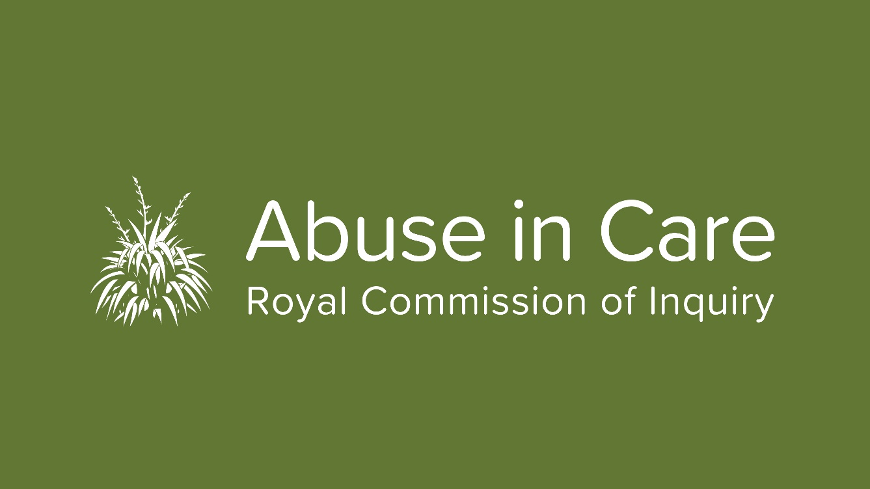
State Redress Hearing deferred due to COVID-19
The Abuse in Care Royal Commission of Inquiry has decided to postpone next week’s Redress hearing in Wellington due to COVID-19.
The first phase of the
State Response to Civil Redress and Civil Litigation Claims hearing was scheduled to be held from 23 March to 3 April.
The second phase of the hearing, set down for 12 - 22 May, has also been deferred. The hearing will now take place in the next few months.
Chair of the Inquiry Judge Coral Shaw says the decision to postpone the hearing was made to give clarity and certainty to survivors now, rather than later.
“The health, safety and wellbeing of survivors and our people is our main priority and that is what has driven our decision to defer the hearing dates," she said.
“We appreciate this will cause inconvenience and in making our decision we have considered the advice from Government agencies.
“Several participants in the public hearing have travelled internationally recently and at least two are required to self-isolate and therefore are unable to participate fully.
“We recognise the trauma many of our survivors feel so it is hugely important we provide a safe, comfortable environment for our survivors to share their stories.
“By deferring the hearing we can achieve this,” says Judge Shaw.
Importantly, the other work of the Inquiry will continue.
Our contact centre remains open from 8.30am to 6pm weekdays if you have any questions.

Inquiry chair attends poukai in the Waikato

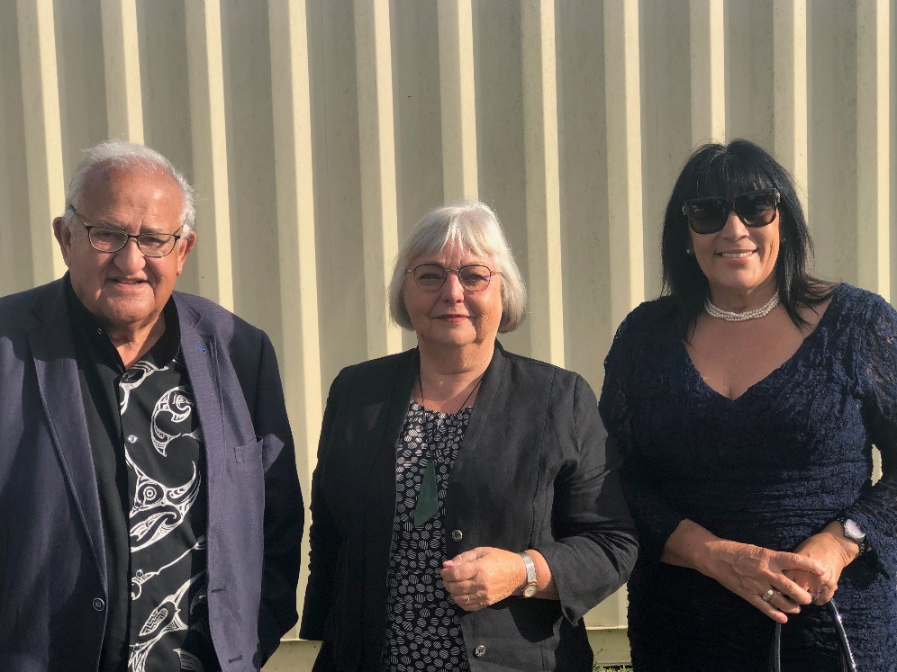
The opportunity to speak about the Abuse in Care Inquiry at two poukai in the Waikato has been invaluable for Inquiry Chair Judge Coral Shaw.
Judge Shaw, pictured above with Neville and Caii-Michelle Baker, was invited to attend the poukai at Pārāwera Marae and Maketu Marae in Kawhia by Māori King Tūheitia Paki when she met with him in January.
The poukai is an annual series of visits by the Māori King to different marae, largely based within the Tainui confederation of tribes in the Waikato region and are held on 29 days of the year. It’s a tradition that dates back 135 years and was started by Kiingi Tawhiao.
HOSTED: Judge Coral Shaw (middle) with Neville and Caii-Michelle Baker at the Parawera Marae

Attendance at these special ceremonies gives Judge Shaw the opportunity to talk about the Inquiry and to continue to forge strong ties with Māori. There was a lot of interest in the work of the Royal Commission.
“We want to work with Māori as a Tiriti partner in its truest sense. Abuse in care has affected so many generations of Māori and it needs to be brought to light before it can be stopped,” she said.

New Zealand Sign Language videos produced
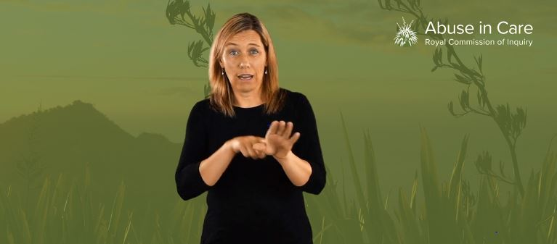
A series of New Zealand Sign Language (NZSL) videos to encourage members of the Deaf community to engage with the Abuse in Care Inquiry have been developed by the Royal Commission.
The three new videos give Deaf survivors information and advice on how they can be involved with the Inquiry and share their stories of abuse in care. They have been made with the assistance of members of the Deaf community.
Executive Director Mervin Singham says it is important for the Royal Commission to make it as easy as possible for members of the Deaf community, who may have been abused in care, to share their stories with us.
“The Commission is committed to hearing from survivors and witnesses from diverse communities, including the Deaf community,” he says.
The videos have been well received and shared in the community. They are just the start of our engagement with the Deaf community. Our staff will also hold public information sessions around the country in the future. More details about those sessions will be available at a later date.
Community event a success
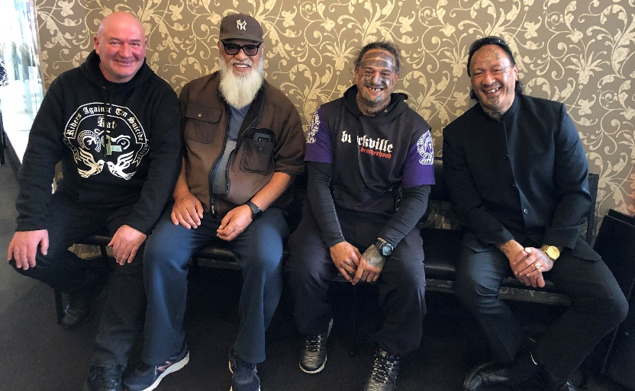
A community event in Dunedin aimed at helping the Inquiry engage with Māori with gang affiliations and experience of State and faith-based care has been hailed a success following the registration of nine survivors who attended.
Survivor Advisory Group member Albie Epere and his partner April Mokomoko hosted the session for their community last Sunday as part of their Kōrero mai – Time to speak up initiative.
ALL SMILES: (left to right) Gazza, Koro Hata and Barry with Albie at the event in Dunedin
Around 30 people attended what was a powerful and, at times, emotional hui. Speakers told of their experiences of abuse in care and the power of telling our Commissioners about that experience in their private sessions. For others, it was the inspiration they needed to register. The pair aim to hold similar sessions in due course. We will keep you updated.
Pasefika fono held in Auckland

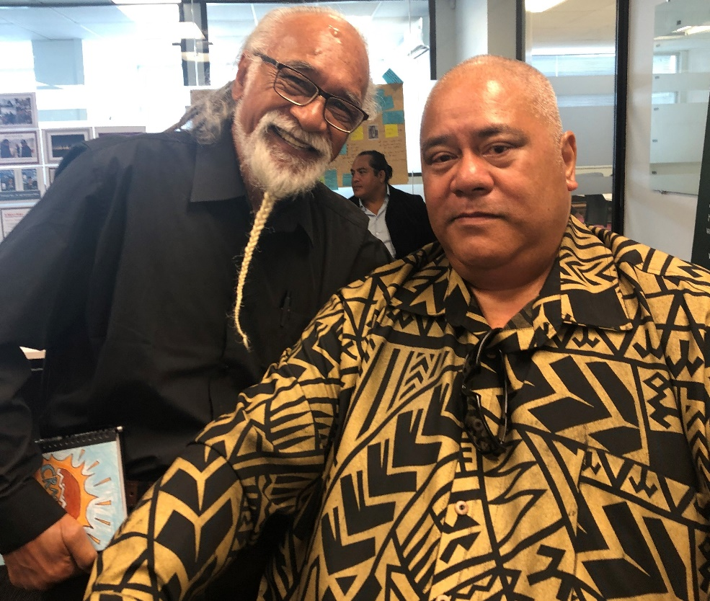
Word is spreading among the Pasefika community about the Abuse in Care Inquiry following a series of fono in Auckland and Wellington.

Around 40 people from organisations and advocates supporting Pacific peoples attended the latest fono in Auckland on March 5.
ROCK ON: Reggae artist and Niuean New Zelaand activist Tigilau Ness (left) and Inquiry Senior Pasefika Engagement Advisor Fonoti Pati Umaga at the fono in Auckland

The fono was led by our Pasefika engagement team and attended by Inquiry Chair Judge Coral Shaw and Commissioner Ali’imuamua Sandra Alofivae.

“Ensuring the Pasefika community knows about the Inquiry and can participate in it is vital,” says Berlinda Chin, Head of Community Engagement.

“We know Pasefika have been disproportionately over represented in care. Our Terms of Reference specifically refer to the need for the Inquiry to recognise this and the status of Pacific peoples in our increasingly diverse country.

“By talking to the community we know we have to find better ways for them to engage with the Inquiry. What is right for one community is not always right for another. We are working on this,” says Berlinda.

The next fono is due to be held in Wellington in April, followed by another one in Auckland in May. Please get in touch with Pati Umaga or Tofa Fagaloa in our Pasefika Engagement Team if you would like more information.

Get in touch

Call us on 0800 222 727 between 8.30am and 6pm weekdays
Email us at contact@abuseincare.org.nz
Write to us at PO Box 10071, The Terrace, Wellington 6143
Visit our website www.abuseincare.org.nz

