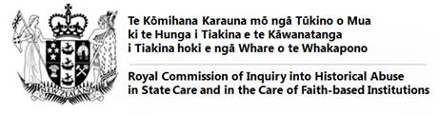

The Royal Commission’s commitment to the Treaty of Waitangi
The Royal Commission will ensure all aspects of the Inquiry are underpinned by and recognise the Treaty of Waitangi and are consistent with New Zealand’s international human rights obligations. This includes:

• Private hearings
• Public hearings
• Research and policy
• Communications and engagement

The following Treaty principles will be used to support decisions on engaging and partnering with Māori and iwi:

• Kāwanatanga – accord a special recognition to Māori rights and interests, and autonomous Māori institutions, while meeting the terms of reference requirements and applicable laws;
• Mahitahitanga – develop meaningful relationships, undertake genuine consultation and engage in good faith with whānau, hapū and iwi Māori organisations in culturally appropriate ways throughout the process;
• Rangatiratanga – recognise the chiefly authority of Māori and their right to pursue self-determination and the protection of taonga including te reo, tikanga, mātauranga and Māori institutions;
• Oritetanga – consider equality of opportunities as appropriate and take active measures to restore balance; and
• Whakaritenga – consider the efficacy of redress recommendations in its report(s) that preserve the dignity of all parties through reconciliation and the restoration of justice.

As a rule of thumb the greater the potential impact of a decision on Māori, the more that needs to be done in terms of engagement, consultation and partnership with Māori.

In adopting this Treaty policy and principles the Royal Commission commits to meeting its international requirements, in particular the United Nations Declaration on the Rights of Indigenous Peoples.

