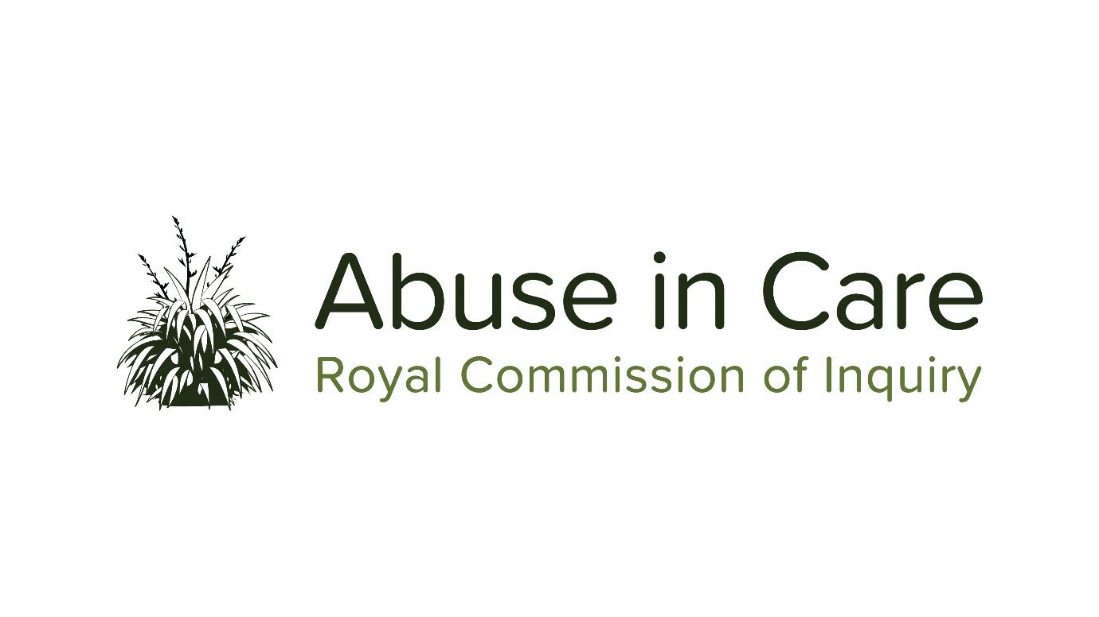
_____________________________________________________________________________

PUBLIC HEARING – MARCH 2020

CIVIL CLAIMS AND CIVIL LITIGATION REDRESS PROCESSES RELATING TO ABUSE IN STATE CARE

BRIEFING PAPER :

FINDINGS AND RECOMMENDATIONS ON
REDRESS AND REHABILITATION PROCESSES FOR
CLAIMS OF ABUSE IN STATE CARE
IDENTIFIED IN RECENT NEW ZEALAND REVIEWS OR INQUIRIES

INTRODUCTION

This briefing paper summarises findings and recommendations relating to redress processes for claims of abuse in state in New Zealand, and, where relevant, the formal Government response to those recommendations. This is in accordance with clause 20(d) of the Abuse in Care Royal Commission of Inquiry’s Terms of Reference.

The information comes from publicly available sources, or information disclosed to the Royal Commission and available for publication. It has been produced to provide context or other information that may be relevant to the public hearing into civil claims and civil litigation redress processes relating to abuse in State care to be held in March 2020.

The international reviews or inquiries covered in this briefing paper are the:
- Gallen Report, 2001
- Te Āiotanga – report of the Confidential Forum for In-Patients of Psychiatric Hospitals, 2007
- Legal Aid Review - Transforming the Legal Aid System, 2009
- Human Rights Commission draft report, 2011
- Some Memories Never Fade – Final Report of the Confidential Listening and Assistance Service, 2015
- Allen + Clarke “Claimant Engagement on Historic Claims Resolution Process, 2018

Gallen Report (2001)

- The Gallen Report was written by retired High Court Justice Sir Rodney Gallen (Justice Gallen) in 2001. It followed initial claims by 88 people that they were abused while children at Lake Alice Hospital. A settlement was negotiated of $6.5 million, and Justice Gallen was appointed to make a division of the settlement between the claimants. Justice Gallen spoke to or read statements of over 80 claimants. As well as deciding the division of money, he completed a report which gave a description of the evidence that he heard from complainants, and described his methodology for allocating payment. The report accepted the truth of the allegations, and in particular accepted that both ECT and paraldehyde injections had been used for punishment. He described the experience of the claimants as living in a state of extreme fear and hopelessness during the period they spent as children at Lake Alice.

- In terms of compensation, the sole question was how to allocate the total amount that had already been agreed between the claimants of the class action. Sir Rodney decided to allocate a substantial proportion of the amount equally between all claimants, on the basis that every child had lived in a state of fear while there. The balance was divided unequally to recognize the different experiences of the claimants, taking into account the age of the claimant when admitted to Lake Alice, the number of admissions, the length of stay, the administration of ECT and the way in which it was administered, the administration of paraldehyde, the use of isolation and other parts of the individual’s experience.

- The Government response to the Gallen Report and Lake Alice Hospital claimant redress processes is outlined in the Royal Commission’s briefing paper titled “Government Policy Between 2000 and 2017”, so is not repeated here.

Te Āiotanga – report of the Confidential Forum for In-Patients of Psychiatric Hospitals (2007)

- The Confidential Forum for In-Patients of Psychiatric Hospitals (Confidential Forum) was established in 2005 to provide a listening ad assistance service for people claiming abuse in psychiatric hospitals. The Forum heard from over 550 registered participants. The Forum did not determine liability or truth, and did not deal with compensation. The Forum’s terms of reference included that it was not to make public any information relating to what it heard, but it nevertheless reported on general themes.

- In relation to redress, the Report Te Āiotanga noted a “hope of many former patients who came to the Forum was that the Government would give a public acknowledgment or apology showing that the Government understood that many former in-patients of psychiatric hospitals had had experiences that were deeply humiliating and demeaning, often taking a lifelong toll. Many who spoke of this said that a public acknowledgment/apology would make them feel valued and accepted in a way that was very important for them, often saying that such recognition of the experiences of former patients would help bring closure.”

Legal Aid Review - Transforming the Legal Aid System (2009)

- This was a review by Margaret Bazley of the wider Legal Aid system, looking at its overall viability and sustainability. In the course of that work there was specific consideration of the approach to historic sexual abuse claims, on the basis that there were a large number of legal aid applications for these claims, which had the potential to be costly and complex. It noted that legal aid on the four cases to date had amounted to $1.4 million, and that although legal aid had been withdrawn in many remaining cases following the lack of success in the initial cases, this was still under review.

- The final report states that “The historic abuse claims in particular have the potential to place enormous pressure on the [Legal Services Agency’s] granting process and on legal aid expenditure, both because of the large number of claims and the high costs involved. Urgent consideration should be given to alternative ways of resolving these claims: the Crown’s strategy of addressing these cases through the courts places pressure on the courts and benefits lawyers rather than claimants. It also leaves the problem to fester: the claimants are likely to consider that the Crown has won on a legal technicality. They will be left feeling aggrieved and that the Crown is not prepared to treat them or their claims with respect and compassion.”

- One of the final recommendations of the review was that “the government should give urgent consideration to alternative ways of resolving the claims of historic abuse of people who were in the care of government agencies.”

- The Government’s policies and actions in relation to these matters is described in the Royal Commission’s briefing paper titled “Government Policy Between 2000 and 2017”, so is not repeated here.

Human Rights Commission draft report (2011)

- In 2011, the Human Rights Commission conducted a review of the State’s response to historic claims of abuse and mistreatment suffered while under the care of the State. The Human Rights Commission determined to undertake the review in light of a 2009 recommendation by the UN Committee against Torture, and the representations received from counsel representing claimants.

- The review focused on processes and procedures for responding to historic claims of abuse and not the merits of any claim. It outlined the various measures implemented by the NZ government, including the Confidential Forum; the Confidential Listening and Assistance Service (CLAS); the Ministry of Social Development’s (MSD’s) Care, Claims and Resolution process; the Crown Health Financing Agency (CHFA); civil litigation; judicial settlement conferences; direct negotiation; and criminal prosecutions. It compared these to measures taken in other jurisdictions.

- The report found that those whose rights had been breached through abuse in care have a number of options available to them, including complaining to the NZ police, seeking informal resolution through MSD’s process or CHFA, in some cases cover under the accident compensation legislation, or bringing civil proceedings. It found that “In this regard New Zealand generally meets the human rights standards that apply to historic claims of abuse and mistreatment while under the care of the State.”

- However, it noted the absence of a comprehensive, independent investigation into the services for children or young people, or the mental health services covering the period of the claim, stating that “there is sufficient material in relation to both children’s services and psychiatric institutions in the historic inquiries and current research to at least question the Government’s perception that the claims generally cannot be taken as indicative of systemic or institutional failure. It is not unreasonable to question whether the abuse and mistreatment that is acknowledged by Government to have occurred can be dismissed as simply the work of a few bad or misguided individuals or an unfortunate product of generally accepted practices of the day. Or whether it is, at least in part, the result of poor policy, or a failure of the State to meet its fundamental duty of care through inadequate oversight at the national regional or institutional level.”

- The report notes that the courts have not proven to be an appropriate forum for the resolution of historic claims of abuse, and that while alternatives including CLAS and MSD’s process meet many international standards they are not a full solution.

- The report recommends that “the priority must be to establish an independent and impartial (in the fullest sense of the word) process to hear, investigate, evaluate and offer redress to claimants”, which applies to all claimants in any care setting and has the power to provide support for rehabilitation, compensation and an apology. It further recommends that the Crown should cease, as far as is possible, invoking time-bar defences in relation to claims of historic abuse and ill-treatment whilst in the care of the State.

- In correspondence during the consultation process, the then Attorney-General Chris Finlayson expressed concern with the conclusions of the report. The final Draft Report was provided to government Ministers on 20 September 2011, noting that “the Commission has agreed to consult on this final draft with the Attorney General and will do so…The review will not be released to the public until it is finalised following this final consultation.” It was never released.

Some Memories Never Fade – Final Report of the Confidential Listening and Assistance Service (2015)

- The Confidential Listening and Advice Service was established in 2008 and ran until June 2015. As with the Confidential Forum, it was outside the scope of CLAS to determine liability or truth; pay or recommend compensation; or acknowledge liability or make an apology.

- The Service met with over 1100 participants, who had been in state care prior to 1992. Participants were given the opportunity to meet with the Panel and have their story recorded, and where requested to identify assistance required. Assistance given included requesting of the participants’ files held by state agencies including their record of care and treatment, counselling, and/or referrals to the appropriate agency (most commonly MSD, but also Health, Education, Police, and Health Camps, as well as church agencies and non-governmental agencies) for further investigation of their claim. This included referring 514 people to the Historic Claims process of MSD, and 89 referrals to police for investigation of offending.

- The CLAS Report made several recommendations relating to redress for claims of abuse in care. These included to:

- Take urgent steps to complete the task of resolving the claims of abuse and neglect of people in care before 1992, including claims in the High Court;

- Design and implement an independent body to resolve historic and current complaints in order to hold the sector to account;

- Offer a public statement to the people of NZ about what happened to those who suffered abuse and neglect in state care;

- Create an independent listening and advice service for prisoners who have concerns about abuse and neglect of them as children in state care.

- The Government response to the report is contained in a paper to the Cabinet Social Policy Committee by the then-Minister for Social Development Anne Tolley. In the response, it is noted that the final report is written from the experience and knowledge of CLAS, and that CLAS did not undertake any consultation with agencies to validate the report’s findings or provide an opportunity to correct any inaccuracies.

- The Government noted that MSD was at that time “refining its approach in order to provide people with timely resolution of their claims in a way that is restorative and continues to allow claimants to share their story.” It acknowledged its commitment to resolve all historic abuse claims by 2020, and noted that the Fast Track process was implemented in 2015, and offers had been made to all eligible claimants that were not legally represented (85% of which were accepted). The process in relation to legally represented claimants was put on hold due to the judicial review proceeding pursued on behalf of those claimants, which had recently been dismissed.

- The Government did not accept the recommendation to create an independent body to resolve historic and current complaints to hold the sector to account, stating that the concurrent review by an expert panel of the operating model for provision of services to children, young people and their families would address the concerns raised in the report.

- In response to the recommendation of a public statement the Government response states:

[10] The Service recommends a public statement to the people of New Zealand acknowledging those who suffered abuse in care. This recommendation is not supported on the basis that the Government considers that the majority of children in care did not suffer abuse, so a universal apology is not warranted. However, apologies are made to individual claimants whose claims are accepted.
23. The Expert Panel Final Report “Investing in New Zealand’s Children and their Families” (April 2016) did not directly address any mechanism for dealing with historic complaints.

Allen + Clarke “Claimant Engagement on Historic Claims Resolution Process (June 2018)

- This was one of two reports commissioned by the Ministry of Social Development in relation to the Claims Resolution processes utilised by MSD. Allen + Clarke was requested to engage with claimants to understand their experience of the Claims Resolution Process, and to seek feedback on the proposed process designed by MSD.

- Allen + Clarke engaged with 13 claimants and two support people, across Auckland, Waikato, Hawke’s Bay and Christchurch.

- The report listed a number of areas for improvement as identified by claimants:

Initial claim and intake
- Provide access to a counsellor or other mental health professional to help support people through the process of reading through the personal file information.
- Go through the file with claimants during the intake interview, so that concerns and questions could be addressed immediately.
- Provide sufficient notice (one month suggested) when arranging the intake interview, to allow time for the claimant to organise work and childcare arrangements.
- Consider increasing length of time for the intake interview to three hours.
- Investigate options for a different resolution process that is concluded on a single day with only one meeting with the claimant.
- Consider using staff with a shared lived experience to engage with claimants.
- Ensure all staff that have direct contact with claimants have specialised training in discussing abuse and neglect.
- Provide claimants access to appropriate mental health support as soon as they lodge a claim and maintain support throughout the process, for as long as this is needed.
- Consider also providing support to cover the logistics of accessing mental health services (e.g. transport and childcare).

Reviewing claims
- Make pro-active contact with claimants from the beginning of the process to check in and update on progress (phone, email or letter).
- Develop an online ‘tracking’ system where claimants could log in and see the progress of their claim.
- Reduce the timeframes from lodging to resolving claims to less than 12 months.
- Develop a single claims resolution process for all abuse regardless of the entity involved.
- Set up a claims resolution process that is independent of MSD.

Claims resolution
- Determine payment levels by the impact of the abuse rather than the type of abuse experienced.
- Explore options for any claimant to have access to subsidised mental health support regardless of the type of abuse suffered.
- Consider providing a hand-written letter of apology as this is seen as somewhat more genuine.
- Develop a feedback loop for claims resolution to policy in Oranga Tamariki.
- Establish a peer support network that claimants can choose to connect with.
- Consider providing access to other mental health support services after claim closure.

- MSD released a response to the two consultations. It does not deal specifically with each recommendation from the Allen + Clarke report, but responds and makes suggestions that are relevant, including:

- MSD agrees there is a need to improve communication with claimants to ensure they are aware of the process upfront and kept in the loop throughout. It will ensure its communication strategy addresses these aspects of communication, and will investigate options for a case management system with unique identifier number so that claimants do not have to give details of their claims multiple times.

- MSD acknowledges the process currently takes too long, and notes it is designing a new process to improve service to claimants.

- MSD will develop a recruitment strategy that builds diversity into the workforce, and investigate inclusion of support workers and facilitators in the workforce model.

- MSD notes that access to counselling is already part of the service to claimants, and commits to improve communication to ensure claimants can access the services, and investigate other wraparound services that enable claimants to access services throughout the process.

- MSD also commits to exploring how records can be presented in a way that aids comprehension and understanding.

- In relation to the recommendation for an independent claims body, MSD noted that any decision on the establishment of an independent claims body is outside the remit of the Claims Resolution Team or MSD. It considered the Royal Commission of Inquiry is likely the right forum to discuss and consider this issue.

The Gallen Report is attached and discussed in a supplementary submission of the Citizens Commission on Human Rights New Zealand to the United Nations Committee Against Torture in April 2012 - https://tbinternet.ohchr.org/Treaties/CAT/Shared%20Documents/NZL/INT_CAT_NGS_NZL_14979_E.pdf
Subsequently, a second round of settlement was made with payments to a further 90 claimants, leading to a total of $10.7m in settlement with 183 claimants.
https://ndhadeliver.natlib.govt.nz/ArcAggregator//arcView/resource/IE12126512//http://www.dia.govt.nz/diawebsite.nsf/Files/CFPages070627/$file/CFPages070627.pdf
https://www.beehive.govt.nz/sites/default/files/Legal%20AidReview.pdf
The draft report is an appendix to the brief of evidence of Rosslyn Noonan at the contextual hearing of the Royal Commission - file:///C:/Users/HJ/AppData/Local/Packages/Microsoft.MicrosoftEdge_8wekyb3d8bbwe/TempState/Downloads/15.-Rosslyn-Noonan.pdf
Under s 5 of the Human Rights Act 1993.
https://www.dia.govt.nz/diawebsite.nsf/Files/Confidential-Listening-and-Assistance/$file/Confidential-Listening-and-Assistance-Service-Final-Report-Some-Memories-Never-Fade.pdf See also evidence of Judge Carolyn Henwood at the Royal Commission’s contextual hearing: file:///C:/Users/HJ/AppData/Local/Packages/Microsoft.MicrosoftEdge_8wekyb3d8bbwe/TempState/Downloads/01.-Judge-Henwood.pdf
See also Royal Commission’s briefing paper titled “Government Policy Between 2000 and 2017”
https://www.msd.govt.nz/documents/about-msd-and-our-work/publications-resources/corporate/expert-panel-cyf/investing-in-children-report.pdf
https://www.msd.govt.nz/documents/about-msd-and-our-work/work-programmes/historic-claims/report-from-engagement-with-claimants.pdf
The second was a consultation with Māori claimants carried out with the support of a Senior Māori Leaders Group, which is discussed in the Royal Commission’s briefing paper titled “Findings on application of Te Tiriti o Waitangi Principles, Māori Consultation and Information Gathering Identified in Recent Reports, Reviews or Inquiries”
See link to Government response at: https://nzfvc.org.nz/news/msd-revising-process-responding-claims-historic-abuse-state-care

