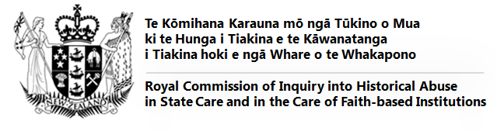

Terms of Reference – Plain English version

Why the Inquiry was set up
The Government set up this Inquiry in response to public calls for a broad-based inquiry into abuse and neglect, both in State care and in the care of faith-based institutions.

What we can investigate
We will investigate the abuse and neglect of children, young people and vulnerable adults who were in the care of State and faith-based institutions in New Zealand between 1950 and 1999. We may also consider abuse and neglect that happened before 1950, or after 1999, including people who are still in care now.

What questions we will look at
These include:
- Why people were taken into care – including if there was bias, discrimination or bad decision-making by agencies.
- What abuse and neglect occurred - what took place and to what extent?
- Why it happened – what made it possible for abuse and neglect to happen to people?
- What effects this had – on the person abused, their family/whānau and others. This includes long-term effects and effects on future generations.
- What was learned – what changes were made over the years in response to abuse and neglect, including to laws, rules, and efforts to monitor places where care is provided?
- How well the systems are working now – including current redress and rehabilitation processes.
- How things can be done better in the future.

How we will work
We will receive information in many ways: by listening to people, holding public hearings, receiving submissions in writing and by obtaining documents and records. We will also conduct research. We have powers to require people and institutions, including Government agencies, to give us information and documents.

How we will hear from people
We will have several ways to hear from people:
- in private meetings (which will also be known as Tukutuku / Private Meetings);
- in public hearings;
- in round table discussions;
- by submissions.

Our principles
We recognise Te Tiriti o Waitangi. We are also guided by a set of principles including:
- doing no harm;
- focusing on victims and survivors;
- taking a whānau-centred view;
- working in partnership with iwi and Māori;
- working inclusively with Pacific people;
- facilitating the meaningful participation of people with disabilities or mental illness;
- responding to differential impacts on any particular individuals or groups;
- being sensitive to the different types of vulnerability that arise for people in care;
- ensuring fair and reasonable processes for individuals and organisations associated with providing care; and
- avoiding being too legal.

Our independence

The Royal Commission is independent of the Government and faith-based institutions. We will reach our own conclusions and recommendations in our own way.

How we will report

We will prepare at least two reports:

- Before the end of 2020. This will cover what we have learned by then, the main themes, and how many people have come forward so we can estimate the resources needed to complete the work. We can make recommendations for change at this stage, rather than wait until the end of the Inquiry.
- Before January 2023. This is our final report. We will report on what we found out about the nature of the abuse, the extent of it, what impact it had on people, what has improved, and what may still need to be done.

We will make recommendations to the Government and faith-based institutions about:

- changes to laws, rules, and ways of working;
- what needs to happen to prevent and respond to abuse and neglect in the future;
- what needs to be done to support people who have been abused or neglected (redress, rehabilitation and compensation processes);
- how to address the harm caused; and
- apologies.

We have prepared this summary to help people understand the Terms of Reference.
It does not replace the full Terms of Reference.

