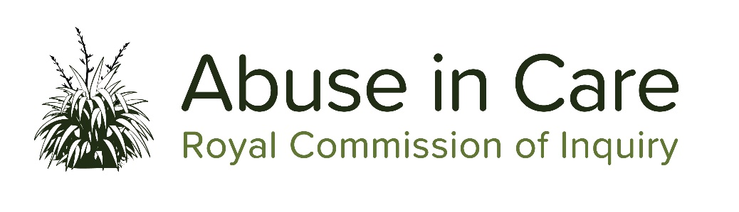

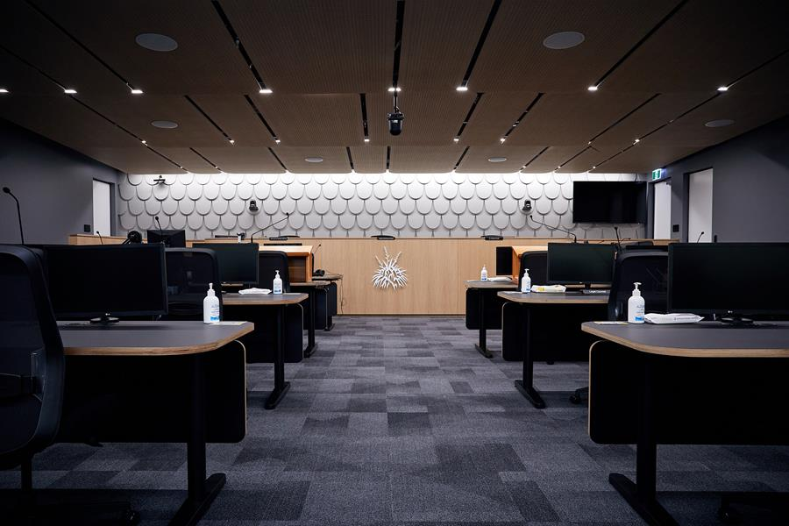
Photo: Public Hearing Space in Auckland

State Redress public hearing concludes
We recently concluded Phase 2 of our State Redress hearings. During Phase 2, we heard from witnesses of the Crown. Crown witnesses included representatives from the Ministry of Social Development, Ministry of Education, Ministry of Health, Oranga Tamariki, Ministry of Justice and the Solicitor-General. Witnesses responded to survivor evidence and answered questions about past and current redress policies and processes.
Videos and transcript testimonies of the hearing are available on our website.
Here are some of the points made at the hearing:
- The Ministry of Social Development spent $80 million resolving claims of abuse in its care since 2007. Just under 40% has gone to survivors, with 60% going towards legal fees and operational costs.
- During questioning, Ministry of Health Chief Legal Advisor Philip Knipe acknowledged that although the Ministry of Health’s redress process has a reasonable degree of impartiality, it is not an independent process.
- As of 30 June 2020, the Ministry of Social Development has received 4,177 claims and has closed 1,942 of them. Questioning revealed that despite no budget constraints, there was still a backlog of unresolved claims.
- Ministry of Social Development General Manager of Historic Claims, Linda Hrstich-Meyer says, “For us, success would be if everyone could go through an alternative disputes resolution (instead of litigation) if that is what claimants choose.”
- Solicitor-General Una Jagose QC acknowledged the pain and frustration survivors suffered in engaging with the Crown while seeking redress for their experiences. She also acknowledged that the Crown, as litigator, hasn’t always been survivor-focused but there have been significant shifts in litigation processes and that the Crown are listening. She also acknowledged the intergenerational damage felt by Māori survivors of abuse.
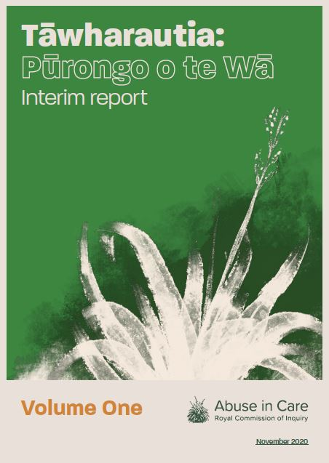

Tāwharautia: Pūrongo o te Wā Interim Report to be published soon
The Royal Commission’s Interim Report is due to be published in early December.
The Interim Report is a progress report on the inquiry’s work to date and identifies what we have learned about survivors and others, about the nature and extent of abuse, redress processes and our ongoing approach.
It includes the information and testimonies gathered from survivors and other witnesses of abuse through private sessions, written accounts, evidence statements and public hearings.
The report is in two volumes – Volume One the Interim Report and Volume Two, Survivor Voices. Volume Two sets out stories and experiences of 50 survivors, in anonymised format, who have shared their experiences with Commissioners.
The Interim Report will be presented to the Governor-General. We will share more about the report in the next newsletter.
The Interim Report will be available on our website in different forms when it’s released.
A final report will be delivered at the end of the Royal Commission.
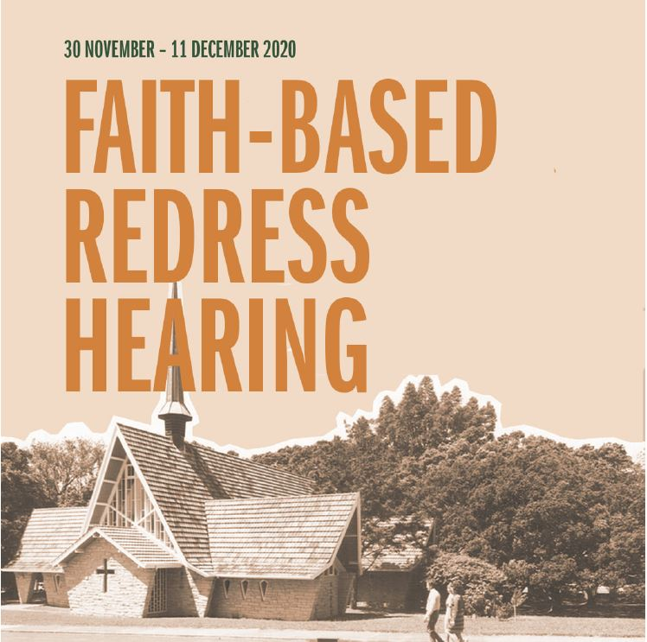
Upcoming Faith-based Redress hearing: 30 November to 11 December
The next public hearing is Phase 1 of our Faith-based Redress hearing. The hearing is from Monday, 30 November to Friday, 11 December. Survivors of abuse in faith-based institutions will tell us about their redress experiences with the Catholic Church, Anglican Church and the Salvation Army, and what support they need. This hearing is part of our Redress investigation.
The witness list is available on our website
The hearing is open to members of the public and will be live-streamed on our website.
Location: Level 2, 414 Khyber Pass Road, Newmarket (entrance via Kingdon Street).

Age Concern New Zealand and Royal Commission raising awareness within the seniors’ community
Age Concern New Zealand, a charity dedicated to supporting older New Zealanders, is supporting the work of the Inquiry by raising awareness of the Inquiry’s work within the seniors’ community. They have 40 locations across the country, that are often the first port of call for older people in their communities. Local Age Concern’s provide older people with support and educational services including elder abuse and neglect prevention support.
The Royal Commission will support the awareness raising efforts of Age Concern New Zealand and is committed to ensuring that older people and those who support them can have the opportunity to participate meaningfully over the life of the Inquiry. A significant cohort of abuse in care survivors and witnesses are 65 years old and over.
Click here to read more about this new relationship

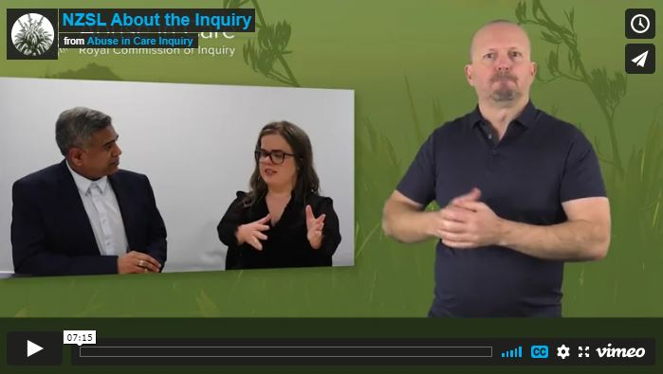
Raising awareness with the Deaf community
As part of the Deaf Engagement strategy, the Inquiry has continued to develop videos in New Zealand Sign Language for the Deaf community to find out more about the Royal Commission. We have recently released two videos featuring the Executive Director Mervin Singham, and Counsel Assist Ruth Thomas and Nicolette Levy. They cover why the Inquiry was set up, why it is important we hear from Deaf survivors, and how investigations work.
There is another video soon to be added, this one will focus on how a survivor can share their story with the Inquiry and what wellbeing support might look like for a survivor.
Deaf survivors are encouraged to register with the Royal Commission via email contact@abuseincare.org.nz or phone with a video interpreter 0800 222 727
The videos can be found https://www.abuseincare.org.nz/about-us/deaf-community/
Private sessions
The main way that most survivors choose to share their story with us is through a private session with one of our Commissioners. The Royal Commission will work with you to make sure you feel comfortable and can participate fully on the day. This includes transport arrangements, wellbeing and counselling support, and the option to bring along a support person. You can also share your experience by video or in writing. Group sessions are also an option. You can learn more about private sessions on our website.
Please contact us to organise a private session. Call 0800 222 727 (8am to 6pm Mon to Fri), email contact@abuseincare.org.nz, or write to us at:
Royal Commission of Inquiry
PO Box 10071
The Terrace
Wellington 6143

Mission statement places survivors at the centre
Ensuring survivors are recognised as being at the centre of our work is the basis of the Royal Commission’s mission. Our mission statement is:
To acknowledge and respond to survivors of abuse in State and faith-based care, and to produce robust and effective recommendations for transformative change to the way New Zealand looks after those in care.
This is about ensuring survivors can come forward and be heard, while receiving all the support they need on their journey. It’s about giving mana to everyone contributing and offering a safe place to share these stories, so the Royal Commission can hear and learn and ensure we can transform the way we look after those in care. Our values of Aroha, Transparency, Fairness and Balance, and Determination guide the way we work and support our mission.
Get in touch
Call us on 0800 222 727 between 8.30am and 4pm weekdays
Call from Australia on 1800 875 745
Email us at contact@abuseincare.org.nz
Write to us at PO Box 10071, The Terrace, Wellington 6143
Visit our website www.abuseincare.org.nz

