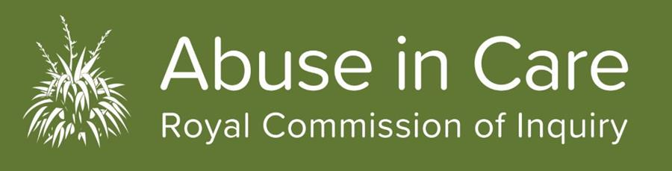

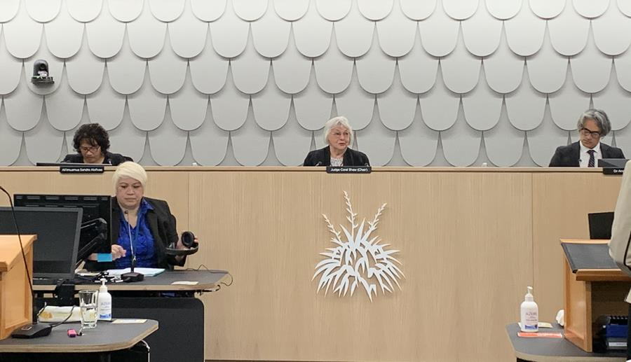

Photo: Public Hearing Space in Auckland showing clockwise from L-R Commissioner Sandra Alofivae, Judge Coral Shaw, Commissioner Anaru Erueti, and Registrar.
Moving testimony as State Redress Hearing underway
Survivor stories were to the fore at the first of two State Redress hearings held at our Tāmaki Makaurau office from 21 September to 2 October. In this first phase, the Inquiry heard evidence from survivors of abuse in care about civil claims made against the State. It also heard from survivors about civil litigation in the courts and before the Human Rights Tribunal.
Testimony was moving with survivors and their advocates sharing personal and sometimes emotional stories about their experiences of abuse and neglect in care. We salute all the witnesses – survivors, advocates, whānau and others who are taking part. Your courage and that of the many others who have shared their stories through private sessions and written accounts is something we thank you for.
The second Redress hearing starts on 19 October and will run until 3 November, focusing on witnesses for the Crown. With Auckland now at COVID-19 Level 1 (and if that’s still the case), the hearing will go ahead without the restrictions of the first hearing. This will ensure we can provide capacity for more survivors and members of the public to attend.
All future hearings can be viewed on the Live Stream by visiting the home page of our website at: https://www.abuseincare.org.nz and clicking through to the hearings.

Hearings dates for late 2020 and 2021 announced
The Royal Commission has determined public hearing dates for the remainder of this year and the first half of 2021. As we move closer to each hearing there will be further information provided to victims and survivors and their advocates, witnesses and other interested parties.
Please note the next hearing State Redress: Witnesses for the Crown will commence on 19 October. Information about this hearing including witnesses is here
Public hearings are one way of gathering information to support our investigations into abuse and neglect that occurred in State and faith-based care settings, and into themes and systemic issues identified in our Terms of Reference.
Investigations use different ways of gathering information to answer the questions in our Terms of Reference, including witness statements, research, roundtables, hui and fono, analysis of anonymised information from private sessions and written accounts, public hearings, submissions, and policy analysis.
Most of our public hearings will take place at our Auckland hearing centre at 414 Khyber Pass, Auckland.
- Redress: Faith-based: Phase1: 30 November – 11 December 2020
This hearing will focus on evidence of redress processes from survivors of abuse in the care of the Catholic Church in Aotearoa New Zealand, Anglican Church in Aotearoa, New Zealand and Polynesia and the Salvation Army New Zealand. The scope document can be read here
- Redress: Faith-based Phase 2: 22 March -1 April 2021
This hearing will focus on evidence on redress processes from witnesses called on behalf of the Catholic Church in Aotearoa New Zealand, Anglican Church in Aotearoa, New Zealand and Polynesia and the Salvation Army New Zealand. The scope document can be read here
- Abuse in State children’s residential care: 27 April-7 May 2021
The topic of this public hearing will be announced shortly. More information can be read here
- Abuse in State psychiatric care: 14-25 June 2021
This hearing will focus on evidence about abuse of children and young people in the care of the Child and Adolescent Unit at Lake Alice psychiatric hospital in the 1970s. The scope document can be read here
Dates for future hearings will be announced as soon as they are confirmed.
If you have any questions about the hearings, please get in touch with us through our Contact Centre 0800 222 727 8am to 6pm Monday to Friday. There will be updates about hearings on our website: www.abuseincare.org.nz and in future editions of this newsletter.
Selection of survivor witnesses for hearings
Public hearings are only one part of ​our wider investigations, examining a theme or particular institution​ in a public forum.
It is unfortunately not possible to have the thousands of survivors who will engage with the Royal Commission over the next few years feature as witnesses in our hearings.
We ​can only select a small number of survivors from those who have provided formal witness statements to the Royal Commission to then also share their experience at a public hearing​, if they wish to do so.
However, all ​information about abuse ​in care given to us by survivors ​is important. The experiences of all survivors who participate in the Inquiry (through witness statements, written accounts, sharing important information with Commissioners and others), are, and will continue to be analysed and the themes and issues that are relevant, will be included in our findings and any recommendations to Government.

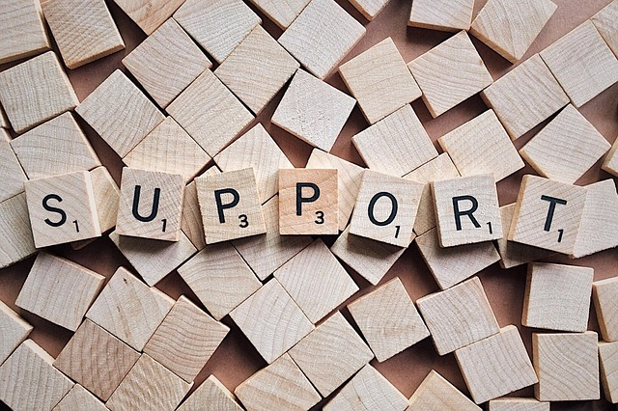

Survivor support is available
With hearings underway witnesses are presenting evidence that may result in a range of emotional responses. Wellbeing support is available for all registered survivors. If you need support or just want someone to talk to please get in touch with our Contact Centre on Freephone 0800 222 727 8am-6pm (NZT) Monday to Friday or email contact@abuseincare.org.nz
You can also register, with us, if you haven’t already through the Contact Centre.

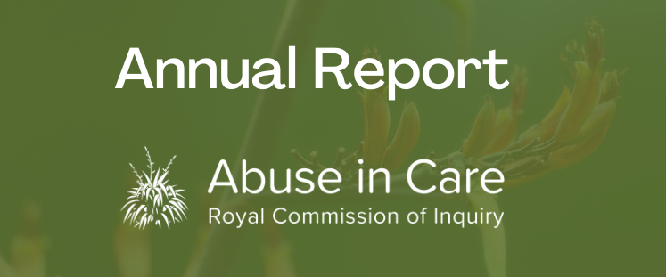

Annual Report
The Abuse in Care Royal Commission has released its annual report to 30 June 2020 which provides a comprehensive update on the work of the Royal Commission over the past year. The Annual Report can be found here. If you would like a hard copy please get in touch with our Contact Centre on Freephone 0800 222 727 8am-6pm (NZT) Monday to Friday or email contact@abuseincare.org.nz

Film: Savage

The film Savage is currently on general release in New Zealand cinemas. The film is inspired by the true stories of New Zealand's street gangs across 30 years.
There is footage in the film related to residential care institutions. Some of this footage may trigger anxiety, trauma or other emotions.
If you are a survivor of abuse or neglect and you need support you can get in touch with our Contact Centre. Our staff can talk to you confidentially and arrange appropriate wellbeing support.
Please phone the Contact Centre on 0800 222 727 8am-6pm (NZT) Monday to Friday or email: contact@abuseincare.org.nz.
Get in touch
Call us on 0800 222 727 between 8.30am and 4pm weekdays
Call from Australia on 1800 875 745
Email us at contact@abuseincare.org.nz
Write to us at PO Box 10071, The Terrace, Wellington 6143
Visit our website www.abuseincare.org.nz

