

**Kia ora koutou**

**Conflict of Interest**

**Key Dates**

Commissioners began their work at the start of this year and are now planning how the Inquiry will run. Careful planning is needed to make sure survivors and their information are safe for the duration of the Inquiry. To make well informed findings and recommendations Commissioners need to get the very best information.

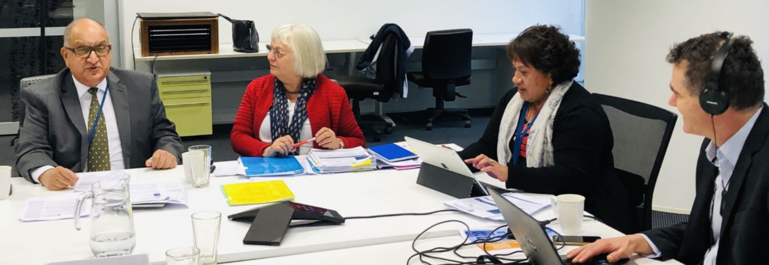

**How will that happen?**

People who want to share their experiences can do so in a number of ways:

* Giving accounts in private sessions
* Written statements
* Public hearings – giving evidence under oath
* At round table sessions, where groups can present their stories in an informal setting.

**When will it begin?**

Announcements will be made on our website, Facebook and in the media.

As you may have heard, a new Conflict of Interest Policy is on our website. This is about making sure the Commission has a way of identifying and managing conflicts. A conflict management plan is being put together by Commissioners to address any perceived, potential or actual conflicts of interest they may have.

**April 2019** Royal Commission of Inquiry into Historical Abuse

newsletter

**Pānui**



**Follow us on Facebook**

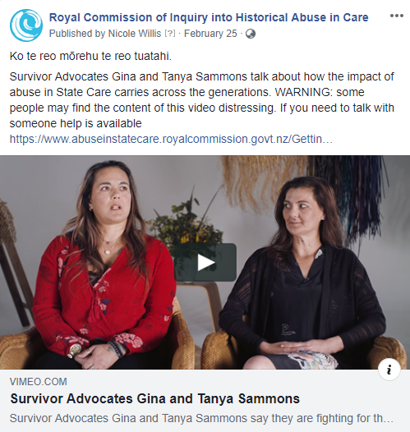

**Follow us on Facebook**  
 [Facebook.com/abuseincareRCNZ](https://www.facebook.com/abuseincareRCNZ/)

­­­­­­­

If survivors wish to share their experiences with Commissioners we encourage them to register at

**www.abuseinstatecare.royalcommission.govt.nz**

or call **0800 222 727**

The Terms of Reference describe what the Commission can look into and how it will carry out its work. There is now a plain English, two page version of the Terms of Reference on the Inquiry website. This document is being translated into 7 different languages, EasyRead and i-sign.

**49 applications for Survivor Advisory Group**

**Easy to read Terms of Reference**

There’s been lots of interest in our Survivor Advisory Group with 49 people putting their hands up. Commissioners are reviewing the applications and will make an announcement shortly. The first meeting of the group is expected to be in May.

THANKS to the survivors and advocates who recently met with Commissioners. These people gave us an understanding of what they want from the Inquiry and how they would like it to run.

**Thanks for the feedback**

Following months of discussion with key parties last year, Sir Anand pushed for the Inquiry to include faith-based care. This was accepted by the Government when the final Terms of Reference were announced.

A number of faith-based survivors asked how the Terms of Reference would apply to their particular circumstance. Commissioners have clarified the Inquiry will cover:

* A person abused by a priest/clergy in a church setting.
* A person abused by a priest/clergy while away on a trip (an 'errand', a day trip or overnight trip, for example).
* A person abused by a priest/clergy while paying a visit to them in their home

We asked the Chief Archivist to issue a disposal moratorium and this is now in place. Government agencies have now all been told they can’t destroy information that may be relevant to the Inquiry. The Royal Commission expects all organisations and faith-based groups to supply documents when asked, or explain publicly why they can’t.



**Documents can’t be destroyed**

**Faith-based answers**