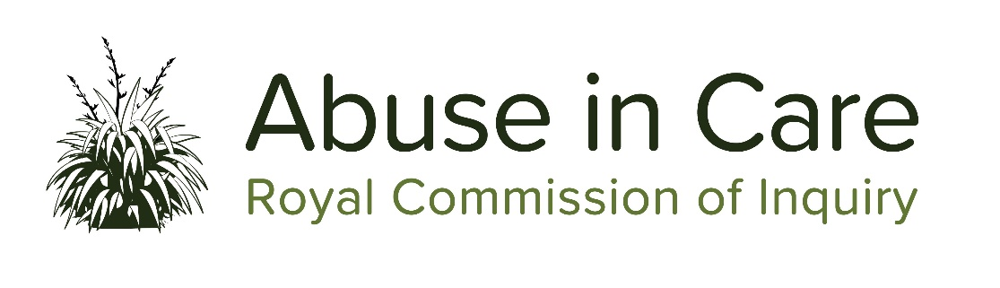

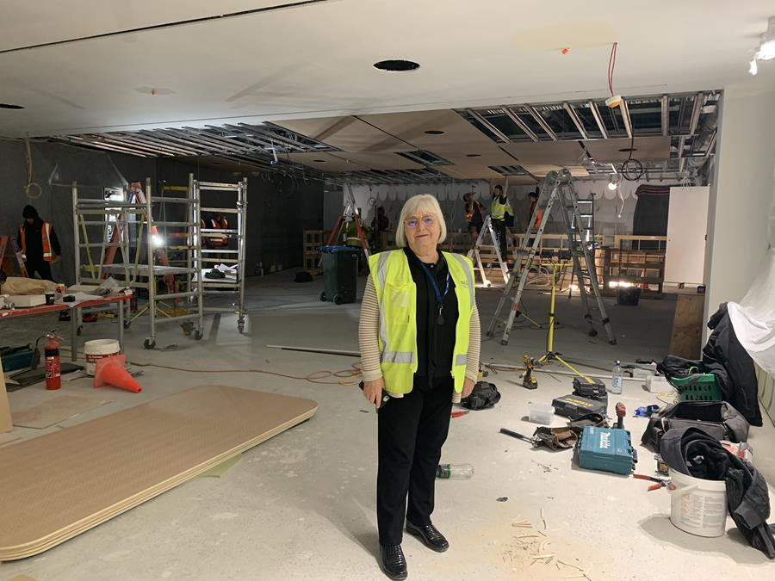

Photo: Royal Commission Chair, Coral Shaw, pictured in new survivor space under construction.
Auckland multi-purpose survivor space nears completion
A survivor centric space will soon be completed and operational. The space on Level 2 of our Tāmaki-makau-rau office will be officially opened next month and will provide a user friendly, structured space for commission engagements including public hearings, private sessions, roundtables and community engagements.
Executive Director of the Royal Commission Mervin Singham says: "The space will embrace the concepts of toroa, whānau and kaitiakitanga – respect for the environment and culture. It is a modern space built to ensure survivors, their whānau and advocates, and our people are safe, secure and comfortable."
“The space is set out with distinct areas for the public hearings (including the public gallery), private meetings, Commissioner space and waiting and respite areas with up to date media and audio visual capability.”
With the redress hearing starting on 21 September (deferred from earlier in the year), it is not long until the facility will be fully operational. Most public hearings over the course of the Inquiry

will be held in this space and when hearings are not scheduled, survivor private sessions will be conducted here.
“It will well and truly be worth the wait. We are looking forward to welcoming our visitors very soon,” says Mervin.
All public hearing testimony will be live streamed to our website www.abuseincare.org.nz

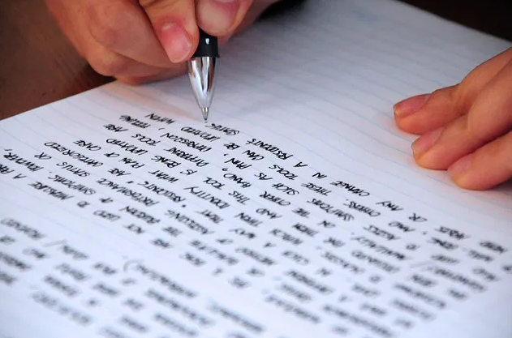

Literacy support for survivors - it's about breaking down barriers
Breaking down barriers for survivors to tell their story is an absolute priority for the Royal Commission. Literacy support is one of the most important ways the Inquiry will achieve this.
Three leading literacy support providers, NZ Howard League Trust, Literacy Aotearoa and The Personal Advocacy and Safeguarding Adults Trust, are now assisting survivors. These are national providers with a history and track record of providing support to New Zealanders with literacy, learning and intellectual disabilities.
Inquiry Chair, Coral Shaw wants the Inquiry to reach and support as many survivors as possible so that they can share their experiences with us. “This could be support to write a personal account or simply get information they need. It is about opening new doorways.”
Survivors or their advocates who need more information about literacy support can contact the Royal Commission on our Freephone number 0800 222 727 weekdays from 8:30am - 4pm or email contact@abuseincare.org.nz

Private sessions up and running again
In June Commissioners recommenced private sessions around Aotearoa with survivors who wanted to share their stories. The COVID-19 lockdown resulted in sessions being put on hold until there was assurance for the safety of survivors and our people. We held 94 private sessions between early June until 24 July.
The Royal Commission also invites people to share their stories in writing by getting in touch with our Contact Centre on 0800 222 727 or by email at: contact@abuseincare.org.nz.
Once registered, survivors are provided information on how to submit their story in writing. We can provide support to help survivors complete their stories if they need it.
General information about private sessions can be found on our website here: https://www.abuseincare.org.nz/survivors/private-sessions/
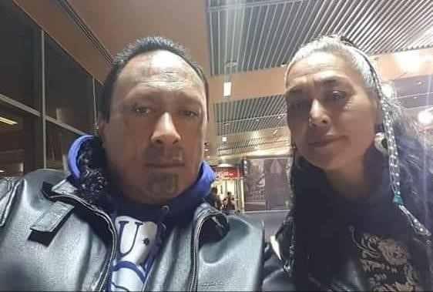

Photo: Survivor Advisory Group member Albie Epere and his partner April Mokomoko, will host whānau sessions for their community to gather survivor accounts and registrations as part of their Kōrero mai – Time to speak up initiative.
Whānau session in Dunedin to engage with wahine Māori
The Royal Commission has partnered with a Dunedin-based community group to help the Inquiry engage with more wahine Māori with gang affiliations and experience of State and faith-based care.
Survivor Advisory Group member Albie Epere and his partner April Mokomoko, will host whānau sessions for their community to gather survivor accounts and registrations as part of their Kōrero mai – Time to speak up initiative.
Royal Commission staff will attend the second hui which is being held at Tiffany's Cafe, 113 Great King Street, Dunedin on Sunday, 16 August at 11am.

Working with whānau and community will help us reach socially isolated whānau with experiences of abuse in care. We hope this will lead people to come to the Inquiry, tell us about their abuse in care and give us a fuller picture of the experiences of all who suffered. We cannot do this on our own,” says Donna Matahaere-Atariki, General Manager Treaty Engagement.
Of the total number of Māori survivors who have registered with the Inquiry to share their stories of abuse in care, just 35 percent are women.
Kōrero mai - Time to speak up was developed to encourage whānau to speak up before it was too late. “We wanted to connect with survivors and tell them it’s time for our stories to be told. This Inquiry is our chance to encourage our whānau and survivors to come forward and speak up, in a safe space,” Albie says.

In the media
There have been some interesting news stories recently about the mahi of the Royal Commission.
Reaching out to Pacific communities across Aotearoa to hear the stories from Pacific people is hugely important to the Royal Commission. Fonoti Pati Umaga, Senior Pasific Engagement Adviser and Ataga’i Esera, Counsel Assist to the Commission of Inquiry appeared in a Facebook Live post talking about the Inquiry, the scope of its work and what it means for Pacific communities. The link to the Facebook post is here:
https://www.facebook.com/531pi/videos/211232780192489/
Restoring the mana of our most vulnerable was an article in In Te Karaka - the magazine of Ngāi Tahu. The article features interviews with Royal Commission Commissioner, Anaru Erueti, and General Manager Treaty Engagement, Donna Matahaere-Atariki and two people we have been working closely with on engaging with socially isolated communities, April Mokomoko and Albie Epere. The story is here:
https://ngaitahu.iwi.nz/our_stories/restoring-the-mana-of-our-most-vulnerable-tk86/

Get in touch
Call us on 0800 222 727 between 8.30am and 4pm weekdays
Call from Australia on 1800 875 745
Email us at contact@abuseincare.org.nz
Write to us at PO Box 10071, The Terrace, Wellington 6143
Visit our website www.abuseincare.org.nz

