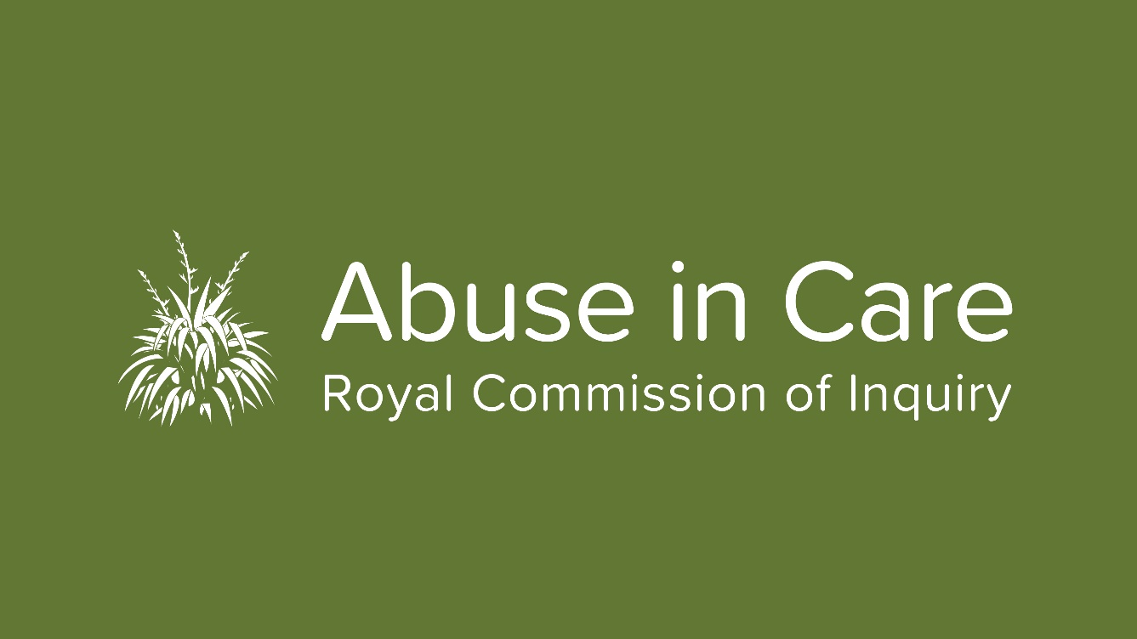

Redress Hearing split into two phases
Survivors and non-Crown witnesses will be given more time to present evidence at the Public Hearing into the State Response to Civil Redress and Civil Litigation Claims (State Redress hearing).
Initially set down for a two-week period, the hearing has been extended and will now be held in two phases over four weeks in March/April and May. The first two weeks from 23 March to 3 April will be dedicated to hearing evidence from survivors and non-Crown witnesses, including survivor legal representatives.
“It is essential that we do justice to the survivor evidence and that we do not rush it. It will give more certainty to survivors of the timing of their appearance and also their wellbeing,“ Counsel Assisting the Royal Commission Simon Mount, QC said.
“Lawyers appearing on behalf of their clients have been asking for more time and while our hearings timetable is tight, fortunately we are able to oblige,” he said.
The Crown witnesses will give evidence in the second part of the hearing from 12-22 May.
The first two weeks of the hearing in March/April will be held, as planned, in the Environment Court in Wellington. Phase 2 in May will be held in the Tribunal Hearings Centre in Wellington. Witness lists for both phases of the hearing will be published closer to the time. The hearing will be livestreamed on the Inquiry’s website during all four weeks.
The public hearing is just one part of the Inquiry's investigation into redress. The way faith-based institutions have treated survivors' claims will also be investigated in detail. The redress team will carry out research, gather relevant (anonymised) information from survivors’ private sessions, consider evidence from public hearings, and hold roundtable meetings, workshops and hui.
More information about the State redress is on our website.

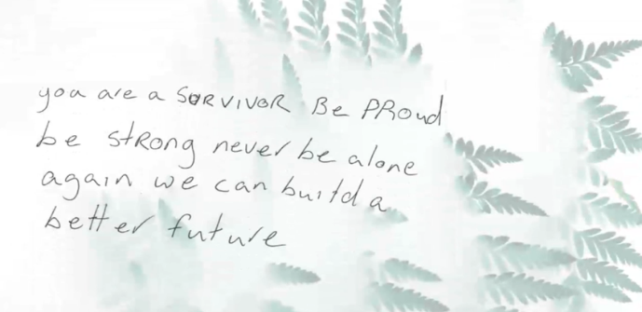
Heartfelt messages from survivors published
The Abuse in Care Inquiry has begun publishing Messages to Aotearoa New Zealand from survivors of abuse in care.
Survivors who engage with the Inquiry are offered the opportunity to write a Message to Aotearoa New Zealand on a postcard. They have been writing about their experience of abuse in State or faith-based care, how they think it can be stopped from happening and their hopes and aspirations for the future.
“We need to accept it, we need to change it and become one with it. Don’t be afraid of the dark. There is light,” one survivor wrote.
“There is always hope for change,” wrote another.

The messages are anonymous and will be published on our website for the remainder of the Inquiry. They will be on display at our public hearings in Auckland and may also be included in a commemorative book at the completion of the Inquiry.

Whānau session to engage with wahine Māori
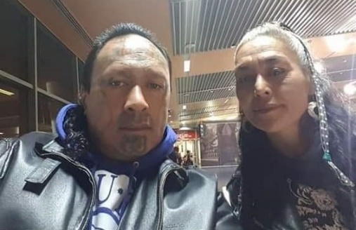
The Royal Commission has partnered with a Dunedin-based community group to help the Inquiry engage with more wahine Māori with gang affiliations and experience of State and faith-based care.
Survivor Advisory Group member Albie Epere and his partner April Mokomoko (picture left), will host whānau sessions for their community to gather survivor accounts and registrations as part of their Kōrero mai – Time to speak up initiative. The first session is being held next month in Dunedin.
“Working with whānau and community will help us reach socially isolated whānau with experiences of abuse in care. We hope this will lead people to come to the Inquiry, tell us about their abuse in care and give us a fuller picture of the experiences of all who suffered. We cannot do this on our own,” says Donna Matahaere-Atariki, General Manager Treaty Engagement.
Of the total number of Māori survivors who have registered with the Inquiry to share their stories of abuse in care, just 35 percent are women.
Kōrero mai - Time to speak up was developed to encourage whānau to speak up before it was too late. “We wanted to connect with survivors and tell them it’s time for our stories to be told. This Inquiry is our chance to encourage our whānau and survivors to come forward and speak up, in a safe space,” Albie says.

Commission staff will be at the hui which is being held at Tiffany's Cafe, 113 Great King Street Dunedin on Sunday, 15 March at 10.30am.
Auckland public hearing space underway
Construction has begun on a dedicated space for public hearings in Auckland. The premises in central Auckland have been designed with survivors in mind and the concept of the toroa, whānau and kaitiakitanga - respect for the environment and culture. The space makes the most of natural resources and has been designed in a way that is mindful of those that will be using it; their journey, discovery and growth.
As well as a hearing room, the space will contain a lobby area and survivor suite with a kitchen, lounge, wellbeing spaces and rooms.
It is expected to be completed in June and will be officially opened in a ceremony with local iwi Ngāti Whātua Ōrākei.
The premises will be used for private sessions when hearings are not taking place.

Summer of Engagement continues
Keep looking out for our stands at events across the country. This Saturday 29 February, we will be at the Creekfest in Porirua. On 8 March we will have a stand at the Newtown Festival in Wellington. We hope our presence will encourage people to register with us to share their experiences of abuse in care. We also hope that people will tell their family, whānau, friends and colleagues about this Inquiry. The more people that know about it, the more successful it will be. Please come and talk to us at events around the country.

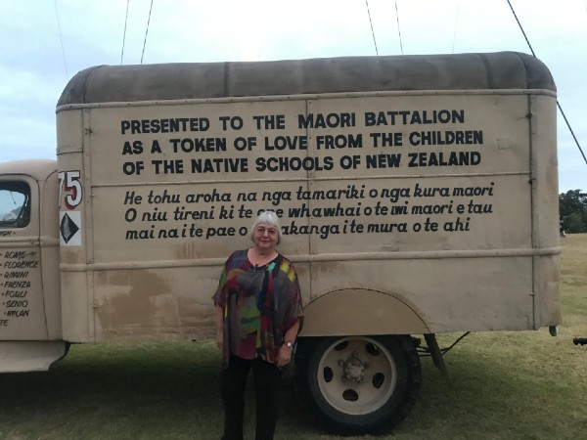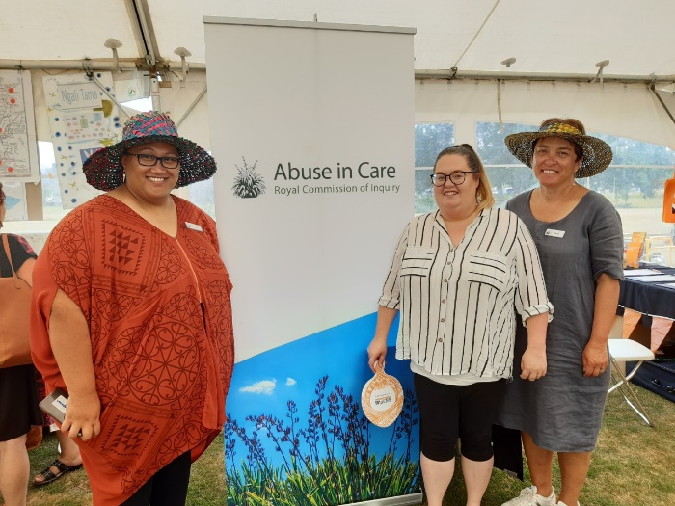
OUT AND ABOUT: Judge Coral Shaw at Waitangi and Royal Commission staff at Te Ra o te Raukura in Lower Hutt recently.

Get in touch
Our contact centre hours have been extended till 6pm weekdays, so do please get in touch with us.
Call us on 0800 222 727 between 8.30am and 6pm weekdays
Email us at contact@abuseincare.org.nz
Write to us at PO Box 10071, The Terrace, Wellington 6143
Visit our website www.abuseincare.org.nz

