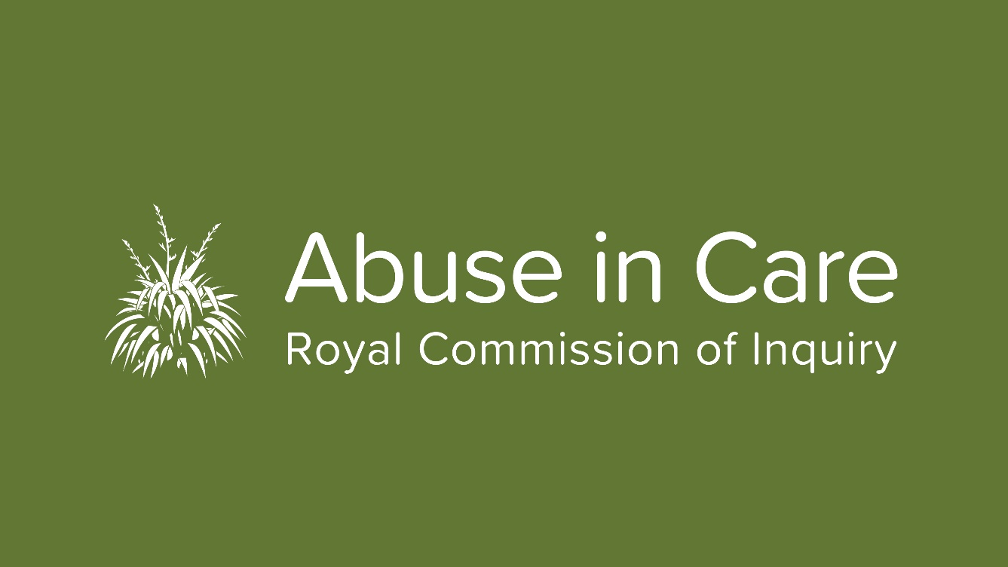

Photo: Julia Steenson, new Commissioner.
Welcome to Julia Steenson, new Commissioner appointed to help oversee the Inquiry
The Royal Commission has welcomed a new Commissioner, lawyer Julia Steenson.
Ms Steenson joins Chair Judge Coral Shaw, and Commissioners Sandra Alifovae, Andrew Erueti and Paul Gibson in overseeing the Royal Commission of Inquiry into Abuse in State and Faith-based Care.
The government has been searching for some time for a suitable candidate to take the role left by Coral Shaw, when she became Chair late last year, taking over from retiring Chair Sir Anand Satyanand.
Julia Steenson (Ngāti Whātua, Waikato/Tainui), is a qualified lawyer who has worked in the finance and education sectors, as well as in legal practice. She currently works in governance and is the founder of Ture.co.nz, an online marketplace for legal services which aims to provide a better way for everyday people to have easy access to and knowledge of legal services. She also hosts the NZFreelaw podcast to provide free legal information to large audiences.
An elected representative on the Ngāti Whātua Ōrākei Trust (NWO) Board, Ms Steenson sits on the commercial board of NWO Whai Rawa Limited. She is a member of the Risk Assurance and Audit committee for the NWO group and is Chair for Kia Puawai Limited; a health and wellbeing charity.
Previously, she worked as General Counsel for Te Wānanga o Aotearoa where she presented on Intellectual Property at the World Indigenous People Conference in Toronto.
Ms Steenson was appointed this week by the Governor General. Minister Tracey Martin, in announcing the appointment, indicated there will be a sixth Commissioner appointed, with the role to be filled after the General Election.
Coral Shaw said, “It is a great privilege to welcome Julia Steenson as a Commissioner. Ms Steenson’s background and expertise in Te Ao Māori will be an asset to our work given that Māori ore over-represented in current and historical care statistics.
To ensure the Royal Commission’s recommendations are sound, we must fully understand the specific burden for Māori who have been in care, including the impacts on their whānau through the generations. Ms Steenson will give great strength to this work”.
On her appointment, Ms Steenson said “the Commission allows people with historical grievances the opportunity to be heard and to be acknowledged.”
“I am excited to be joining this significant Kaupapa and look forward to contributing to constructive outcomes.”

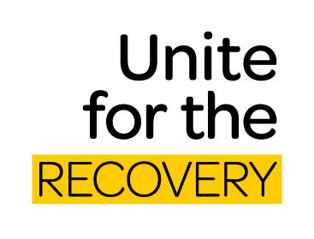
COVID Level One – What it means for the Inquiry
With the country in Level one the Inquiry has moved back to delivering some of the services that were on hold due to COVID-19 restrictions. Many of our staff are now working back in the office on rotation.
During lockdown face-to-face private sessions and public hearings were put on hold. Since the first week of June private sessions have resumed in the Auckland and Wellington regions. It is our plan to see survivors in these regions over the coming two months, before we look at travelling further afield with plans to move to other centres from July. Through the lockdown period survivors who had scheduled sessions were contacted and new sessions were rescheduled.
Sessions through Zoom (live video) have also been held and this option will continue for those who are happy to have them.
Public hearings in redress were deferred form March, due to COVID-19, with new dates set for September and October for state-based care redress hearings and November faith-based care redress hearings (see the story below).
Work is also underway on the Inquiry’s Interim report due for delivery later in the year.
If people need to contact the Inquiry, please get in touch and call us on 0800 222 727. The Contact Centre is open weekdays from 8:30am - 4pm. You can also email us at: contact@abuseincare.org.nz
The mailing address is:
Royal Commission of Inquiry
PO Box 10071
The Terrace
Wellington 6143
Redress Hearing dates confirmed
The Redress Hearing set down for late March - early April was deferred due to COVID-19. New dates have been set for the state and faith-based hearings with the state hearing being split into two phases.
In the first phase the Inquiry will hear evidence from survivors of abuse in care about civil claims made against the State. It will also hear from survivors about civil litigation in the courts and before the Human Rights Tribunal. In the second phase of the State Redress Hearing, witnesses for the Crown will give evidence.
- State Redress: Evidence from survivors of abuse - Monday 21 September to Tuesday 6 October
- State Redress: Witnesses for the Crown - Monday 19 October to Tuesday 3 November
A separate faith-based hearing is scheduled from 23 November to 11 December. There will be a focus on the redress processes of the Catholic Church, Anglican Church and the Salvation Army.
The Royal Commission will investigate the adequacy of redress and what needs to be done to support people who have been abused or neglected in Faith-based institutions.
We are keen to hear from people who have experienced abuse or neglect in any faith-based denominations or institutions (such as a church or religious school). Please contact 0800 222 727 or email solicitorassisting@abuseincare.org.nz
Further information is on our website: www.abuseincare.org.nz
Anyone taking part will be provided with wellbeing support.
The hearing will also be livestreamed on our website.

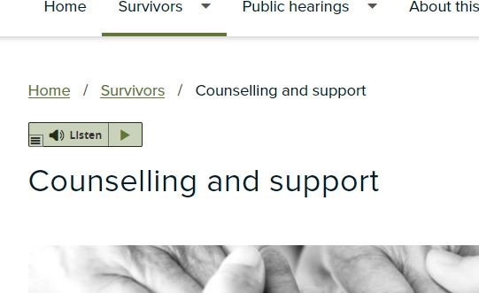
You can now listen to our website
We need to hear from as many people as possible who have experience of state or faith-based care to make findings, reach conclusions or make recommendations.
The website www.abuseincare.org.nz is now easier to access if you prefer to listen to information rather than read it. There is a new feature that will read out loud the words on the page. There is a ‘Listen’ button just above the main title on each page. With one click you can play, pause, fast forward, go back, and control the volume and speed of the speech.

We hope this tool makes our website accessible to a broader audience allowing us to gather vital information that can help us make recommendations about ways to prevent and respond to abuse in the future.
Care-experienced children get improved access to Royal Commission through new MOU
The Royal Commission has signed a Memorandum of Understanding (MoU) with VOYCE – Whakarongo Mai, a community organisation that advocates for children and young people who have experience in the care system.
The MoU includes a set of key principles - such as good faith, autonomy, cooperation, communication and timeliness - that will guide how the organisations will work together going forward.
VOYCE – Whakarongo Mai works to ensure the voices of care-experienced children are heard, to positively influence their individual care and collectively affect change in the wider care system.
A working group with members from the Royal Commission and VOYCE is now planning the work programme for phases agreed in the MoU.
Inquiry Chair Coral Shaw said that although the Royal Commission’s core focus is historical abuse between 1950 and 1999, it also has discretion to hear about any abuse or neglect before or after these dates.
“Forming strong relationships with key stakeholders like VOYCE is essential to reaching the tens of thousands of children, young people and vulnerable adults who experienced abuse while in State care or faith-based institutions.”
“This agreement will help to ensure all survivors, including Māori, Pasefika, LGBTIQ+, the disabled or those with mental health disorders, know about and can engage with the Royal Commission,” said Shaw.
VOYCE Chief Executive Tracie Shipton said that children and young people in State care need to be listened to and their voices kept at the centre of all decisions made about them. “This partnership will help break down barriers and create safe ways for care-experienced people to engage with this process” Shipton said.

Get in touch

Call us on 0800 222 727 between 8.30am and 6pm weekdays
Email us at contact@abuseincare.org.nz
Write to us at PO Box 10071, The Terrace, Wellington 6143
Visit our website www.abuseincare.org.nz

