H



**Private Sessions have begun**

**Disabled people**

**Key Dates**

Commissioners have started to listen to the experiences of survivors of State and faith-based institutions in private sessions.

More than 40 registered survivors have been heard as part of a pilot in Wellington and Christchurch. More survivors will talk to Commissioners this week (27-29 May) in both Hamilton and Auckland.

The private sessions will run for the length of the Inquiry. So don’t worry - there is plenty of time to register and if you are registered already we will get to you. You can register or pull out at any time.

Priority will be given to older people or those who are unwell.



Research shows disabled people have a high chance of being abused in care. Disabled people are often invisible. The Commission is eager to include disabled people in the Inquiry. If you are a disabled person who has been in care we want to hear from you. You, or someone you trust can ring us free on 0800 222 727 (10am – 4pm weekdays).

**May 2019** Royal Commission of Inquiry into Historical Abuse in Care

newsletter

**Pānui**



**Follow us on Facebook**

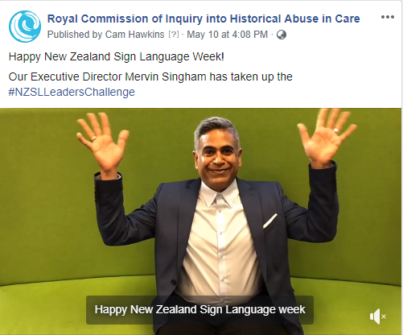

**Follow us on Facebook**  
 [Facebook.com/abuseincareRCNZ](https://www.facebook.com/abuseincareRCNZ/)

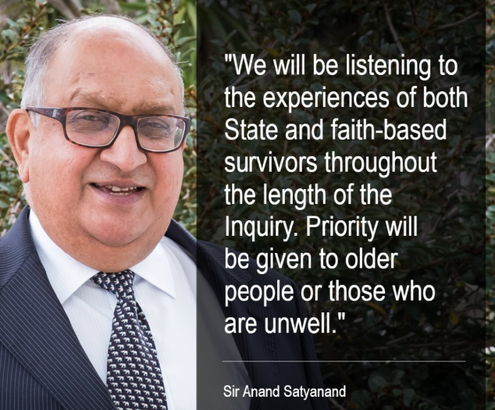­­­­­­­

We are building a new Inquiry website that is survivor centred, accessible and easy to understand. While this is happening, we have made changes to our current website (<http://www.abuseincare.org.nz>) to make it easier to find information.

If you have any feedback and ideas please email abuseinstatecare@royalcommission.govt.nz.

The Commission has put together a timeline about what has been done so far and what is coming up. The timeline can be found on our website and is a good way of keeping up to date with what’s going on.

**Timeline**

The short version of the Terms of Reference can now be viewed in a Sign Language video on the website.

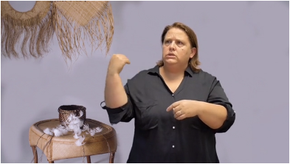

**Terms of Reference in NZ Sign Language**

**New website coming**

The Royal Commission has appointed a Survivor Advisory Group to guide the work of the Inquiry.

Almost 50 people applied to be on the Survivor Advisory Group.

The following people were selected: Carol Beckett, Tyrone Marks, Keith Wiffin, Kath Coster, Rangi Wickliffe, Greg Molony, Toni Jarvis, Albert Epere, Jane Stevens, Piripi Gray, Steve Goodlass, Emily Holden, Jim Goodwin, Anne Stephenson, Michael Chamberlain, Gary Williams, Johnny Siaosi, Sally Champion and Josie Khoury.

The Survivor Advisory Group will meet at least four times per year in either Auckland or Wellington.

If you are a survivor and wish to share your experiences with Commissioners we encourage you to register at

[**www.abuseincare.org.nz**](http://www.abuseincare.org.nz)or call **0800 222 727   
(10am-4pm weekdays)**

**Survivor Advisory Group announced**