Pānui September 2022

Royal Commission Faith-based Institutional Response Hearing
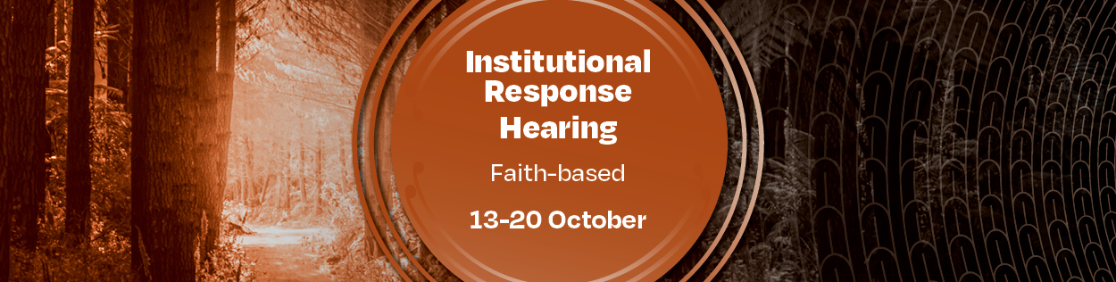
It is time for Aotearoa New Zealand to hear from the faith-based institutions responsible for the thousands of children, young people and vulnerable adults abused in faith care since the 1950s.

It is critical we find out what went wrong in the past to ensure it doesn’t keep happening.

From Thursday 13 October to Thursday 20 October, the Royal Commission’s Institutional Response public hearing in Auckland will listen to the response of faith leaders and executives.

These leaders will be questioned on whether they met their obligation under te Tiriti o Waitangi, how systems were monitored for neglect and abuse, including psychological, sexual, physical and racial, as well as how complaints were handled.

In August this year we heard from the leaders of State agencies. Videos and statements from this hearing can be found on the Royal Commission’s website.

Hearing open to the public, livestreamed on our website
The Faith-based Institutional Response public hearing will take place from 13‒20 October 2022 at 414 Khyber Pass Road, Newmarket, Auckland.

It will be open to the public and live streamed on the Royal Commission’s website abuseincare.org.nz

You can find information about accessibility of the space here. The hearing will have New Zealand Sign Language and verbal audio-description of witnesses.

Faith-based institutions we will be hearing from
The hearing will examine witnesses from particular faith institutions on matters set out in the Royal Commission’s Terms of Reference focusing on failures by faith-based institutions to prevent and respond to abuse in faith-based care.
Witnesses will include church leaders, which will ensure the Royal Commission hears senior leadership perspectives.
Witnesses will be called from:
- Gloriavale Christian Community
- Dilworth School
- Anglican Church in Aotearoa New Zealand
- St Patrick’s College, Silverstream
- Dioceses and congregations of the Catholic Church of Aotearoa New Zealand
- Wesley College
- Methodist Church of New Zealand
- Presbyterian Support Central
- Presbyterian Support Otago
- Presbyterian Church of Aotearoa New Zealand

The hearing will have both a historical and contemporary focus. You can read more about this public hearing here.
If you want more information about this Institutional Response public hearing, please call us on 0800 222 727 during weekday working hours or email contact@abuseincare.org.nz

Following this hearing we will send you a new pānui, with a summary about what was said at the hearing.
We understand that some people will find the hearing evidence distressing. Remember, we are here for you, and you can call us on 0800 222 727 during weekday working hours, or email us on contact@abuseincare.org.nz

Engaging with communities, focusing on the future
The Royal Commission is continuing to engage with communities that have been affected by abuse in care. As we move closer to the end of our Inquiry, the focus of our engagement is shifting to what needs to be done to make sure the abuse experienced by survivors never happens again. What we hear through these engagements will inform the recommendations we make in our final report next year.
We are also focusing our efforts on engaging with groups we would like to hear more from, to make sure the voices of these groups are reflected in our findings and recommendations.
In September, Ali’imuamua Commissioner Sandra Alofivae and Executive Director, Helen Potiki met with a panel from the Pacific MVPFAFF+ community to better understand the cultural considerations and identities that are unique to survivors of this community.
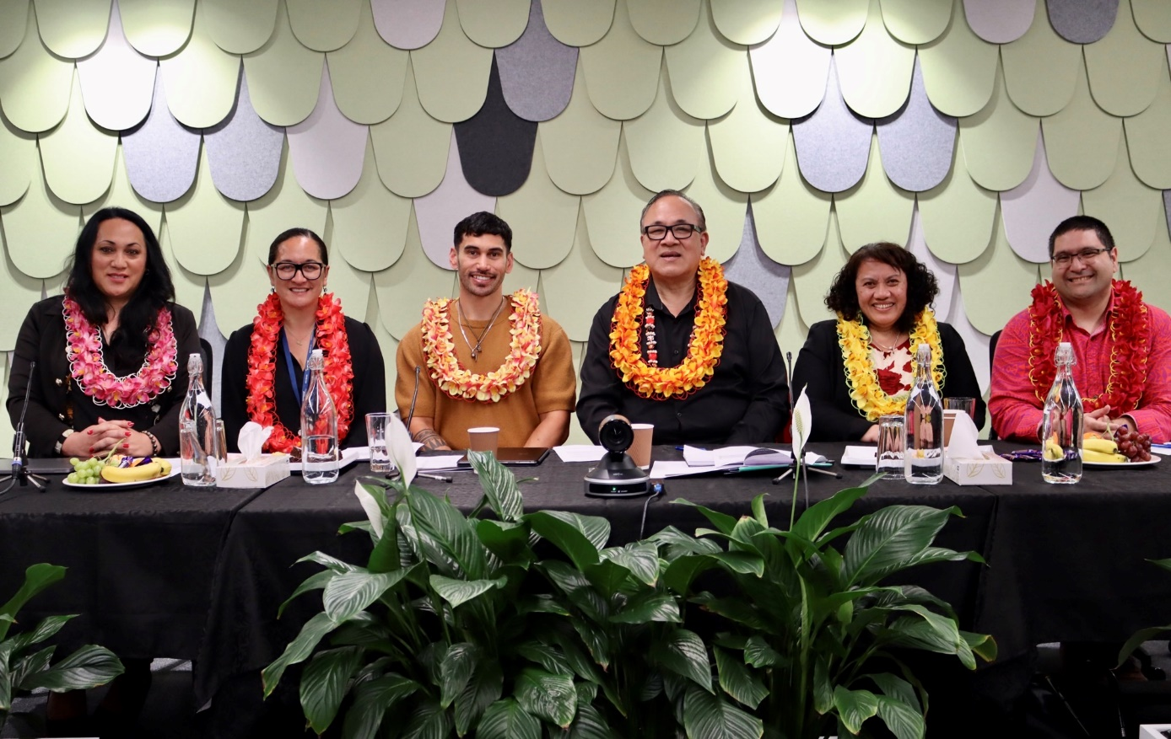
From left, Phylesha Brown-Acton of Niue descent. Royal Commission Executive Director Helen Potiki, with Dr Sam Manuela of Cook Islands descent, Fuimaono Dr Karl Pulotu-Endermann MNZM, of Samoa descent, Ali’imuamua Commissioner Sandra Alofivae and Dr Filipo Katavake-McGrath of Tonga/Māori descent.

We held wānanga with tangata whaikaha Māori and tangata turi in Tamaki Makaurau and returned to Tairāwhiti, East Coast to visit with iwi and hapū as a continuation of our haerenga, or journey.
Commissioner Paul Gibson visited Ōtepoti Dunedin to meet with patients at the forensic unit at Wakari Hospital, and participated in a panel discussion on ‘keeping people in the community safe’ at the Enabling Good Lives Mid Central Leadership annual event the following day. Commissioner Gibson and Royal Commission kaimahi also attended online hui with international experts on disability and mental health, to understand current best practice and inform the recommendations we make next year.
Coming up, the Commission is holding an online hui with people from rainbow communities across Aotearoa on 11 October. More details are available on our website. Later in October we will be inviting people who are disabled, Deaf or experience mental distress – and those who support and advocate for them – to share their thoughts and ideas about the future of care.

Survivor Accounts
The Commission is continuing to collect survivor accounts. If you know someone who is a survivor of abuse in State or faith-based care, it’s not too late for them to contact the Royal Commission and share their experience with a Commissioner or Kaitakawaenga.
Our website has more information on how survivors can share their experience.
If you have already registered and have not had a chance to share your experience then we will be trying to reach you and will call soon. If you have changed email address or phone number please get hold of us 0800 222 727.

Reporting our findings and recommendations in 2023
The Royal Commission will produce a single comprehensive report in June 2023 setting out the context of abuse in care, findings and recommendations to ensure the future safety and wellbeing of tamariki, rangatahi and adults at risk.
This final report will be an impartial and impactful account of what we have found during our Inquiry and the specific investigations we have carried out as part of the Inquiry.
The report will reflect what we have heard from survivors and communities who have suffered or been impacted by abuse and neglect in care – in particular Māori, Pacific, people in faith-based care, people who are disabled, Deaf or have experienced mental distress, and people who experienced abuse in social welfare settings.
We had initially intended to produce several interim reports on key settings and themes. We now know we need to make the most of the time available to deliver a comprehensive and impactful final report next June. Separate reports on our case studies on the Lake Alice Child and Adolescent Unit and St John of God at Marylands School will be submitted to the Governor-General ahead of the final report, as planned.

