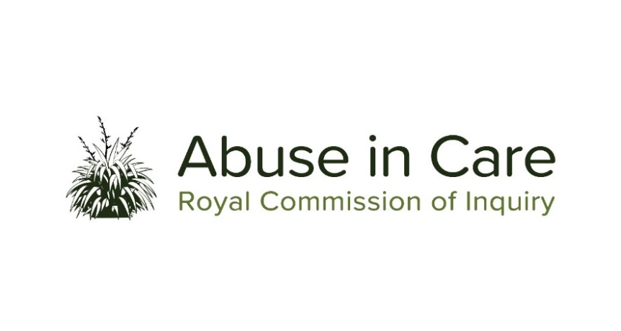
INVESTIGATION INTO ABUSE IN THE CARE OF
THE ANGLICAN CHURCH

SCOPE OF INVESTIGATION

- The Inquiry will investigate the abuse of children, young persons and vulnerable adults in the care of the Anglican Church in Aotearoa New Zealand, and its subsidiaries and affiliated entities and institutions (the Anglican Church).
- Abuse is defined in the Inquiry’s Terms of Reference as meaning physical, sexual, emotional or psychological abuse, and neglect. It includes inadequate or improper treatment that resulted in serious mental or physical harm to a person in care. Neglect is not defined in the Terms of Reference, but the Inquiry considers neglect may include physical, emotional and psychological, medical, educational, spiritual and cultural neglect.
- The main period of investigation is 1950 to 1999, however the Inquiry has discretion to consider issues and experiences prior to 1950, and may also consider issues and experiences after 1999, in order to inform its recommendations.
- During the course of this investigation the Inquiry will select themes, settings or institutions as case studies of abuse and may conduct research and examine relevant matters in public hearings, roundtables, wānanga, hui and fono.
- The Inquiry will seek out and consider the voices and experiences of victims and survivors of abuse in the care of the Anglican Church. It will investigate and make findings on what happened and why, including by examining:
  - The circumstances in which children, young persons and vulnerable adults were in the care of the Anglican Church, including where the Anglican Church provided care on behalf of the State;
  - The nature and extent of abuse of children, young persons and vulnerable adults in the care of the Anglican Church;
  - The impact, including any differential impact, of abuse on victims and survivors, and on their families, whānau, hapū, iwi and communities. This will include consideration of:
    - Principles of tikanga Māori when considering the impacts of abuse on Māori victims and survivors and their whānau, hapū and iwi;
    - Pacific cultural norms and values when considering the impact of abuse on victims and survivors among Pacific Peoples;
    - The impact of abuse on religious beliefs held by victims and survivors;
    - Particular impacts related to disability and mental health status, including additional barriers to understanding and recognising abuse, disclosing abuse, accessing specialist wellbeing supports to respond to trauma, and receiving redress
  - Whether individuals experienced abuse in the care of the Anglican Church because of nationality, race, ethnicity, religious belief, age, gender, gender identity, sexual orientation, or physical or intellectual disability or mental health status;
  - Any structural, systemic, practical or other factors that caused or contributed to the abuse of children, young persons and vulnerable adults in the care of the Anglican Church;
  - The adequacy of any actions by the Anglican Church to prevent and respond to abuse in its care, including any lessons learned and changes made;
  - Obligations under domestic and international law, including human rights law;
  - Applicable principles and obligations under Te Tiriti o Waitangi/the Treaty of Waitangi;
  - The adequacy of the Anglican Church’s redress and rehabilitation processes for victims and survivors of abuse in its care.
- The Inquiry will also assess and make recommendations on:
  - The Anglican Church’s current structures and frameworks, and any gaps in legislation, canon law, Church policy, rules, standards and practices that require change to prevent and respond to abuse in its care;
  - Any changes required to the Anglican Church’s redress, rehabilitation and compensation processes for victims and survivors of abuse in its care;
  - Any other steps the Anglican Church should take to address the harm caused by the abuse in its care.
- Where relevant, the Inquiry may make findings of fault or that relevant standards have been breached, or both. The Inquiry does not have the power to determine the canonical, civil, criminal or disciplinary liability of any person but may make recommendations that further steps be taken to determine liability.

