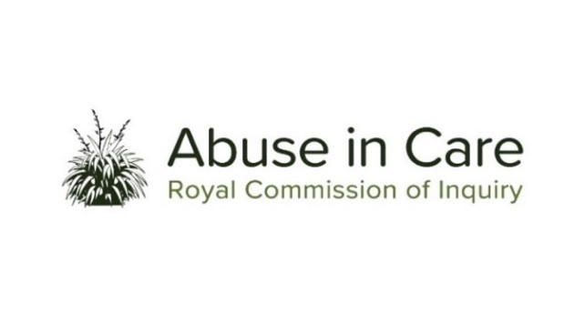
PACIFIC INVESTIGATION
INVESTIGATION INTO THE PACIFIC PEOPLE’S EXPERIENCE OF ABUSE IN CARE

- The Inquiry’s Pacific investigation will examine issues that are particularly relevant to the experiences of abuse of Pacific people across all State and faith-based care settings included in the Terms of Reference, and will work alongside the Inquiry’s other investigations.
- Abuse is defined in the Inquiry’s Terms of Reference as meaning physical, sexual, emotional or psychological abuse, and neglect. It includes inadequate or improper treatment that resulted in serious mental or physical harm to a person in care. Neglect is not defined in the Terms of Reference, but the Inquiry considers neglect may include physical, emotional and psychological, medical, educational, spiritual and cultural neglect.
- The main period covered by this investigation is 1950 to 1999. However, the Inquiry has discretion to consider issues and experiences prior to 1950, and may also consider issues and experiences after 1999 in order to inform its recommendations.
INVESTIGATION OVERVIEW
- The Pacific investigation will undertake two key strands of work – looking back and looking forward.
- With that dual focus, the Pacific investigation will investigate:
- The number of Pacific people in care from 1950 until the present day;
- What happened to Pacific people abused in care and why;
- The current systems for preventing and responding to the abuse of Pacific people, whether these are fit-for-purpose, and what changes need to be made as a result. In short, how to ensure that what occurred cannot happen again; and
- The impact, including any differential impact of abuse on victims and survivors, and on their families, extended families and communities.
STRAND 1 – LOOKING BACK
- The Inquiry will investigate and make findings and recommendations on what happened to Pacific children, young people, and vulnerable adults in care and why it happened, including:
- The circumstances that led to Pacific people being taken into or placed in care;
- The appropriateness of care placements including whether Pacific people were placed with family, extended family or their wider community, or placed in non-kin or residential care;
- The factors that contributed, or may have contributed, to the decision-making process leading to Pacific people being taken into or placed in care;
- The nature and extent of abuse of Pacific people in care between 1 January 1950 and 31 December 1999;
- The factors, including structural, systemic, or practical factors, that caused or contributed to the abuse of Pacific people in care;
- The response of the State and faith-based institutions to the abuse of Pacific people during this period;
- Obligations under domestic and international law, including human rights law;
- The impact of the abuse on Pacific people who were in care, their families, extended families, and communities, including immediate, long term, and intergenerational impacts;
- What lessons were learned from past instances of abuse of Pacific people in care; and
- What changes were made to legislation, policy, rules, standards and practices to prevent and respond to the abuse of Pacific people in care.

STRAND 2 – LOOKING FORWARD

- In order to inform its recommendations for the future, the Inquiry will investigate and make findings and recommendations on:
- Pacific people’s experience of abuse in care since 1999 and currently;
- The intergenerational impact of abuse in care on Pacific people, their families, extended families, and communities; and
- The current frameworks and any gaps in legislation, policy, rules, standards and practices, including oversight mechanisms, that require change to prevent and respond to the abuse of Pacific people in care.
- The Inquiry will also investigate and make recommendations on:
- Any changes required to redress, rehabilitation and compensation processes for Pacific survivors and victims of abuse in care; and
- Any other steps the State and faith-based institutions should take to address the harm caused by the abuse of Pacific people in care.
- Where relevant across both strands, the Inquiry may make findings of fault or that relevant standards have been breached, or both. The Inquiry does not have the power to determine the civil, criminal or disciplinary liability of any person but may make recommendations that further steps be taken to determine liability.

