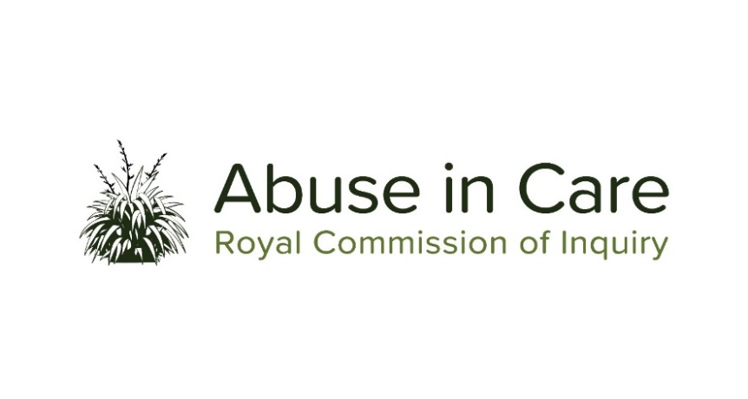

INVESTIGATION INTO ABUSE IN STATE PSYCHIATRIC CARE

A CASE STUDY INTO ALLEGATIONS OF ABUSE AT THE CHILD AND ADOLESCENT UNIT AT LAKE ALICE PSYCHIATRIC HOSPITAL

- As a case study within the investigation into abuse in State psychiatric care, the Inquiry will investigate:
  - The context in which the Lake Alice Child and Adolescent Unit (the Unit) was established, operated and closed
  - The circumstances in which children and adolescents were placed in the Unit and the appropriateness of those placements
  - The nature and extent of any abuse of children and adolescents placed in the Unit
  - The factors that caused or contributed to such abuse
- Whether children and adolescents in the Unit experienced abuse differentially whether by virtue of disability, mental health status, race, ethnicity, gender, gender identity and/or sexual orientation
- The extent to which Police, government and professional bodies were aware of allegations of abuse at the Unit and failed to take appropriate steps to respond to it during the Unit’s operation and subsequently.
- In relation to any established incidents of abuse, the Inquiry will investigate:
- The immediate, long-term and intergenerational impacts of abuse on victims and survivors of the Unit and their families and whānau, hapū, iwi and communities. The Inquiry will consider:
  - Principles of tikanga Māori when considering the impacts of abuse on Māori victims and survivors
  - Pacific cultural norms and values when considering the impact of abuse on victims and survivors among Pacific People
  - Additional barriers when considering the impact of abuse on victims and survivors with disability and/or mental illness
  - Particular impacts of abuse on victims and survivors given their age at the time.
- The extent to which Police, government and professional bodies protected children and adolescents from abuse, and held perpetrators to account
- The applicable principles of Te Tiriti o Waitangi/the Treaty of Waitangi
- The State’s obligations under relevant domestic and international law, including international human rights law
- The adequacy of the State’s redress and rehabilitation response to victims and survivors of abuse at the unit.

