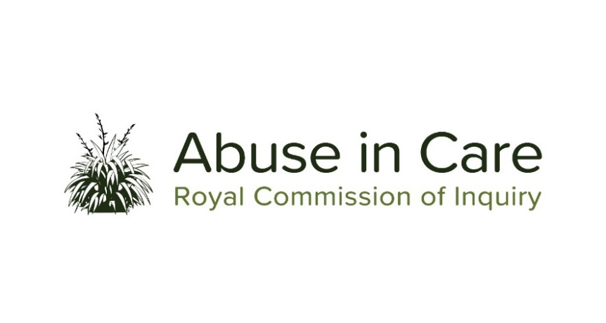

INVESTIGATION INTO ABUSE IN THE CARE OF THE CATHOLIC CHURCH

A CASE STUDY INTO ABUSE IN THE CARE OF THE HOSPITALLER BROTHERS OF ST JOHN OF GOD AT MARYLANDS SCHOOL, CHRISTCHURCH

The Hospitaller Brothers of St John of God (Order of St John of God) is a religious order of the Catholic Church whose members cared for children and young people in Christchurch from the early 1950s onwards. As part of its investigation into abuse in the care of the Catholic Church, the Inquiry will undertake a case study, including a public hearing, into abuse in the care of the Order of St John of God.
- The Inquiry will investigate:
  - The circumstances in which the Order became involved with and operated Marylands School (Marylands) in the Diocese of Christchurch
  - The circumstances in which children and young people came into the care of the Order there
  - The nature and extent of abuse of children and young people in care by individuals associated with the Order of St John of God including, but not limited to, religious brothers, visiting clergy or religious
  - The immediate, long-term and intergenerational impacts on victims and survivors of abuse at Marylands and their families and whānau, hapū, iwi and communities. This will include consideration of:
    - Additional barriers when considering the impact of abuse on victims and survivors with disabilities, mental illness or both
    - The principles of tikanga Māori when considering the impacts of abuse on Māori victims and survivors
    - Pacific cultural norms and values when considering the impact of abuse on Pacific victims and survivors.
  - The nature and extent of any failures of the Order of St John of God, the Catholic Church or the State to protect children and young people in care from abuse by individuals associated with the Order
  - The adequacy of the response of the Order of St John of God, the Catholic Church and the State to allegations of abuse by individuals associated with the Order, including the redress and rehabilitation processes available to victims and survivors of abuse at Marylands.
- The Inquiry will also examine:
  - The nature of the relationship between the Order of St John of God and the Catholic Church and how it impacted on issues of child protection
  - The extent to which structural, systemic or other factors relevant to the Catholic Church caused or contributed to the abuse, or affected responses to complaints of abuse at Marylands.

