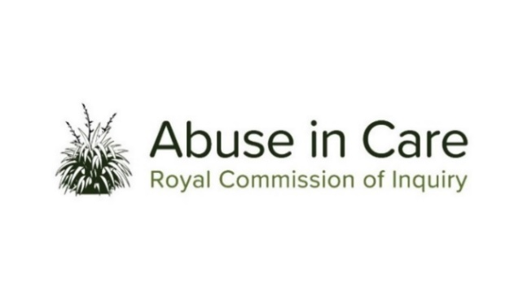
PACIFIC INVESTIGATION
TULOU – OUR PACIFIC VOICES
Tatala e pulonga

  - The Inquiry’s Pacific Investigation will examine the experiences of Pacific victims and survivors who were abused in State and faith-based care, from 1950 to the present day.
  - The Pacific Investigation’s public hearing will hear evidence from survivors as well as non-survivor witnesses and expert witnesses. It will examine:
  - The context in which Pacific people were taken into or placed in care, including cultural, geographical, social and political factors;
  - The circumstances that led to Pacific people being taken into or placed in care;
  - The factors that contributed, or may have contributed, to the decision-making process leading to Pacific people being taken into or placed in care;
  - The appropriateness of care placements, including whether Pacific people were placed with family, extended family or their wider community, or placed in non-kin or residential care;
  - The nature and extent of the abuse of Pacific people in care, including any differential abuse as a result of, for example, nationality, race and ethnicity;
  - The factors, including structural, systemic or practical factors, that caused or contributed to the abuse of Pacific people in care, and current frameworks for the prevention of and response to the abuse of Pacific people in care;
  - The experiences of Pacific people, including any cultural barriers, in reporting and/or disclosing abuse in care, and seeking redress;
  - The immediate, long-term and intergenerational impacts of the abuse on Pacific people and their families, extended families and communities. This will include consideration of the interplay with Pacific cultural norms and values;
  - The adequacy of redress, rehabilitation and compensation processes for Pacific survivors and victims of abuse in care; and
  - Any other steps the State and faith-based institutions could take to address the harm caused by the abuse of Pacific people in care.

Tulou is a word commonly used in many Pacific Island languages to excuse yourself or apologise for invading someone’s personal space. It can be used when you are talking about things that are uncomfortable or might offend. Tatala e pulonga means ‘lifting the dark cloud’ in Tongan language. This is a metaphor commonly used by Tongans to demonstrate the lifting of darkness and dark history.

