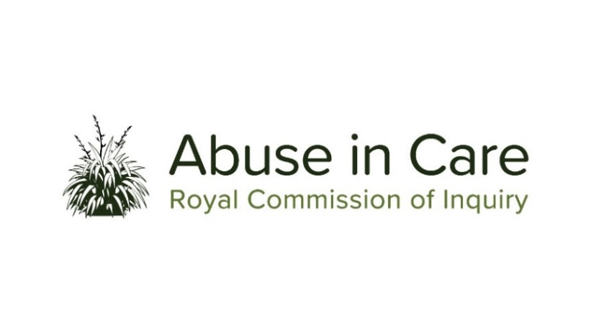
INVESTIGATION INTO DISABLED PEOPLE’S EXPERIENCES OF ABUSE IN CARE
SCOPE OF INVESTIGATION

- This investigation will examine issues and themes that are particularly relevant to disabled people’s experiences of abuse in care. The investigation will work alongside all of the Inquiry’s other investigations when their work involves the experiences of disabled people, so that all evidence and issues across the Inquiry are given a disability perspective.
- Abuse is defined in the Inquiry’s Terms of Reference as meaning physical, sexual, emotional or psychological abuse, and neglect. It includes inadequate or improper treatment that resulted in serious mental or physical harm to a person in care. Neglect is not defined in the Terms of Reference, but the Inquiry considers neglect may include physical, emotional and psychological, medical, educational, spiritual and cultural neglect.
- Disability is a broad and evolving term used in this investigation to include all physical, psychosocial, psychiatric, neurological, and sensory impairments, and learning disabilities. The term disabled people includes those perceived to be disabled.
- The main period covered by this investigation is 1950 to 1999. However, the Inquiry has discretion to consider issues and experiences prior to 1950, and it may also consider issues and experiences after 1999 in order to inform its recommendations.
- The investigation will look back and look forward and will seek out and consider the voices and experiences of disabled people who are victims and survivors of abuse in care. It will select issues, themes and kaupapa as case studies, and may conduct research and examine relevant matters in public hearings, roundtables, wānanga, hui and fono.
- The Inquiry will investigate and make findings and recommendations about what happened to disabled people who were abused in care and why, including:
  - The circumstances of disabled people being taken into or placed into care, and the appropriateness of those placements;
  - The number of disabled people in the care of the State and faith-based institutions from 1950 to the present day, and the nature and extent of abuse of disabled people in care;
  - The impact, including any differential impact, of abuse on victims and survivors of abuse, and on their families, whānau, hapū, iwi and communities. This will include consideration of:
    - The impact of discrimination against disabled victims and survivors;
    - Particular impacts related to disability and mental illness, including additional barriers to understanding and recognising abuse, disclosing abuse, accessing specialist wellbeing supports to respond to trauma, and receiving redress;
    - Principles of tikanga Māori when considering the impacts of abuse on Māori victims and survivors and their whānau, hapū and iwi;
    - Pacific cultural norms and values when considering the impact of abuse on victims and survivors among Pacific peoples.
  - Whether individuals experienced abuse in care because of nationality, race, ethnicity, religious belief, age, gender, gender identity, sexual orientation, physical or learning disability or mental health status;
  - The factors, including structural, systemic or practical factors that caused or contributed to the abuse of disabled people in care;
  - The adequacy of any actions by the State and faith-based institutions to prevent and respond to abuse of disabled people in care, including any lessons learned and changes made;
  - The applicable principles and obligations under Te Tiriti o Waitangi/the Treaty of Waitangi;
  - Obligations under domestic and international law, including human rights law;
  - The adequacy of redress and rehabilitation processes for disabled victims and survivors of abuse in care.
- The investigation will also assess and make recommendations on:
  - Any gaps in legislation, policy, rules, standards and practices including oversight mechanisms that require change to prevent and respond to abuse of disabled people in care;
  - Any changes required to redress, rehabilitation and compensation processes for disabled victims and survivors who were abused in care.
  - Any other steps the State and faith-based institutions should take to address the harm caused by abuse in care.
- Where relevant, the Inquiry may make findings of fault or that relevant standards have been breached, or both. The Inquiry does not have the power to determine the civil, criminal or disciplinary liability of any person, but may make recommendations that further steps be taken to determine liability.

