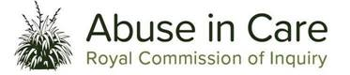
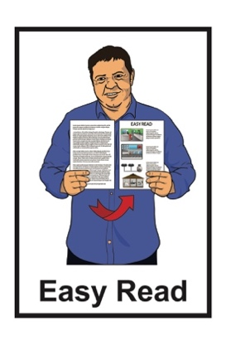

Stolen Lives, Marked Souls
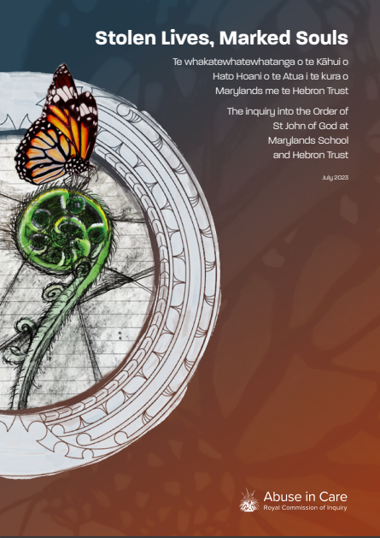

A report about abuse by the
Order of Saint John of God at
Marylands School and Hebron Trust
Published: July 2023

Before you read this

This Easy Read document is about a report written by the Royal Commission of Inquiry into Abuse in Care.

Some of the information and pictures used in this document is very upsetting.

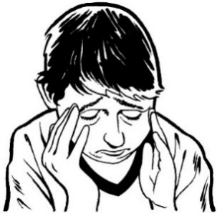
This document is about children being badly hurt by people who were meant to look after them.

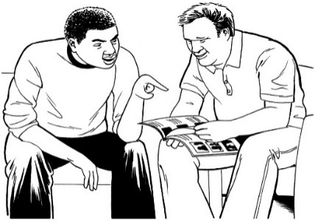
Before you read it you might want to make sure you:
are in a safe place
have people who can support you.
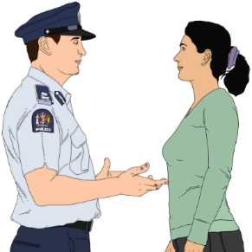
If you do not feel safe call the police on 111.

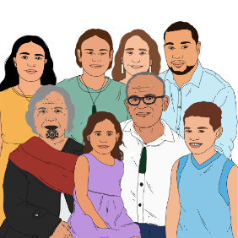
If you are upset after reading this document you can talk to your:
whānau / family
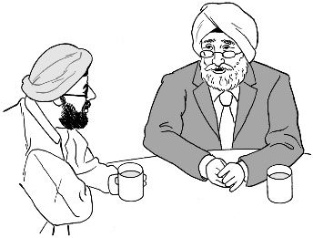
friends.

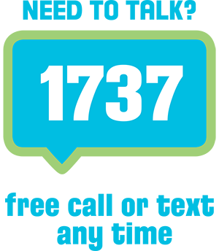
You can also talk to a counsellor at Need to Talk by:
calling 1737
texting 1737.

It does not cost any money to call / text 1737.

If you are still worried you can also talk to someone at the Royal Commission of Inquiry into Abuse in Care:

Phone: 0800 222 727

Text: 8185
Email: contact@abuseincare.org.nz

You can also find support through the Survivor Experiences Service.

You can contact them by:

Phone: 0800 456 090

Text: 8328

Email:

contact@survivorexperiences.govt.nz

What is in this document

Page number:
About the Royal Commission of
Inquiry into Abuse in Care 6

About this document 9
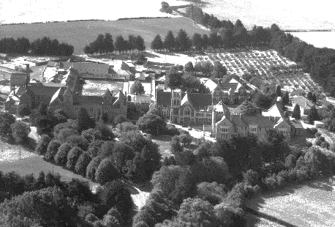

Marylands School 11

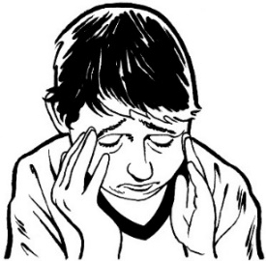
Hebron Trust 22

Effects of the abuse 26
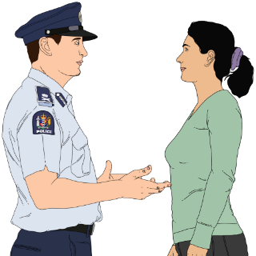

Complaints and what happened
with them 30

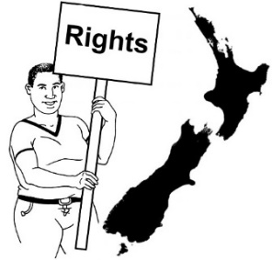
Page number:

Human rights 42
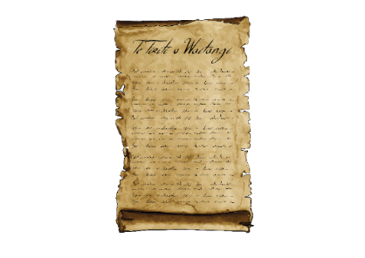

Te Tiriti o Waitangi /
The Treaty of Waitangi 45

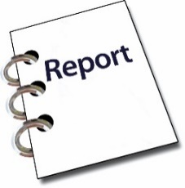
What the Commission found 46

More information 53

About the Royal Commission of Inquiry into Abuse in Care

The Royal Commission of Inquiry into Abuse in Care is looking into abuse that happened to people
in care.

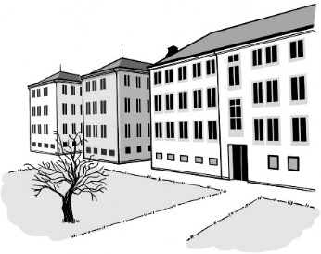
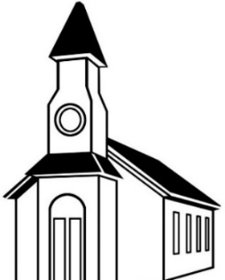
In this document being in care means that the Government or a faith-based institution was in charge of your care.

Faith-based institutions are run by religious groups like churches.

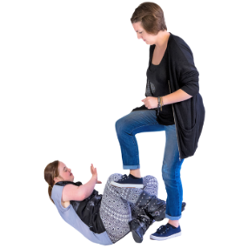
Abuse can be:
- physical – a person kicking or hitting you
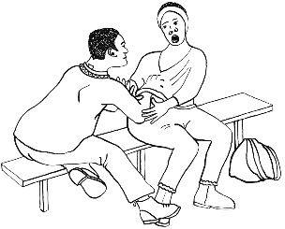
- sexual – a person doing sexual things to you that you do not want them to such as:
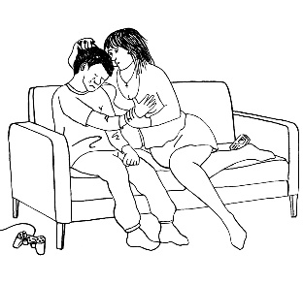
- touching your body or private parts
- kissing you
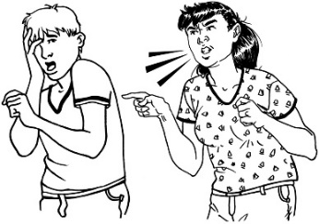
- making you have sex with them – this is called rape
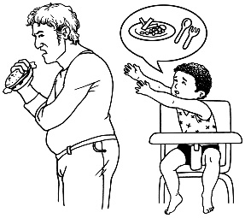
- emotional – a person yelling or saying things to you that are not nice
- neglect – a person not giving you the things or care you need.

The Royal Commission of Inquiry into Abuse in Care is also called the Commission.

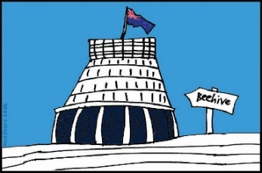
The Commission is not part of the Government.

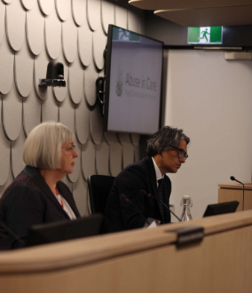
The Government cannot tell the Commission what to do.

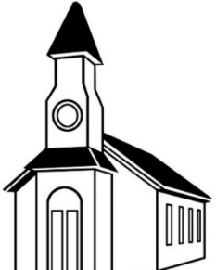
The Commission is not part of any faith-based organisations like churches.

The Commission calls people who have been through abuse in care survivors.

About this document

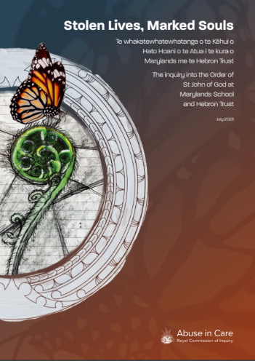
This Easy Read document is a summary of a report called:
Stolen Lives, Marked Souls:
The Inquiry into the Order of St John of God at Marylands School and Hebron Trust

A summary:

is shorter than the main report

says the most important things.

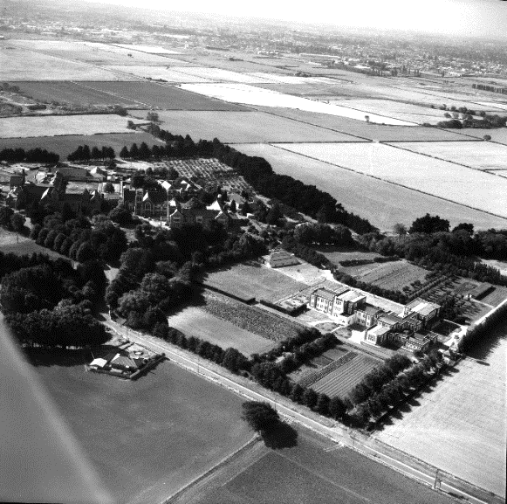
The report is about abuse that happened at:
a school called Marylands School
places young people were sent to live or attend programmes at called the Hebron Trust.
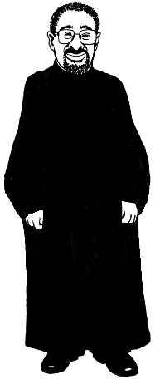
Both of these places were run by a group called the Order of the Brothers of Saint John of God.

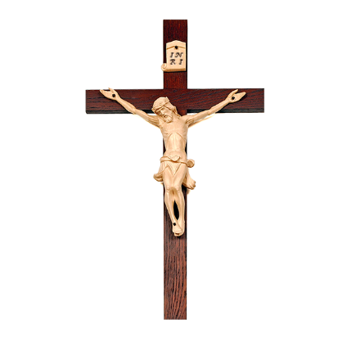
The Order of the Brothers of Saint John of God is part of the Catholic Church.

In this document we will call the Order of the Brothers of Saint John
of God the Order.

Members of the Order are called Brothers.

This does not mean they:
have the same parents
are related.

Marylands School

Marylands School was:
a school for disabled boys
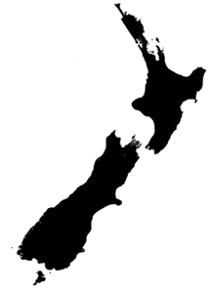
started in 1955
in Christchurch.

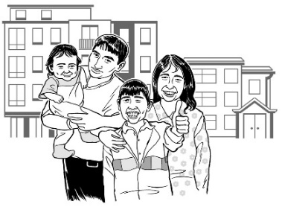
Until the 1980s the Government thought disabled children should not stay with their family.

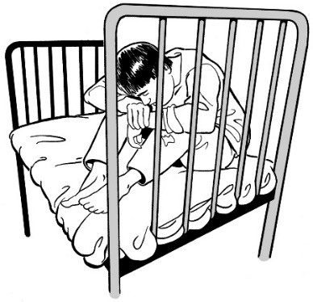
The boys lived at the school away from their:
families
communities.

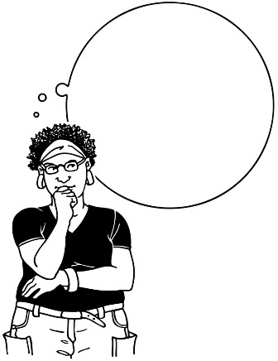
The way the boys were sent to the school showed that how people thought at the time included:
ableism
eugenics.

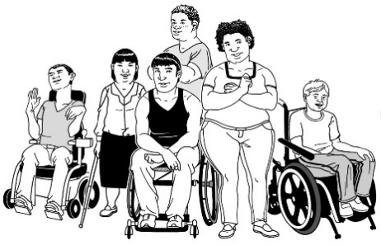
Ableism is the idea that disabled people are less important than other people.

Eugenics is the idea that:
some people are better than others
we should make sure only the better people are born
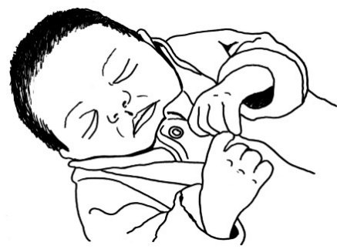
disabled people should not be:
- born
- allowed to have children.
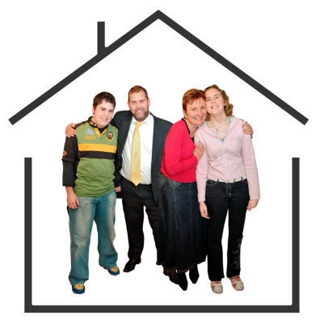
Parents believed the school was a good place for children.

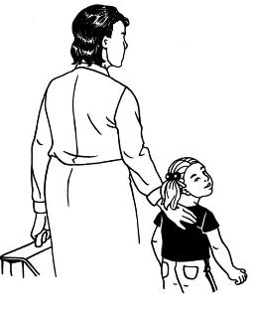
Some children were sent to Marylands School by:
- welfare agencies
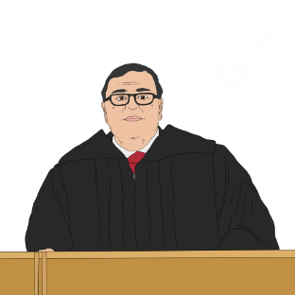
police
courts.

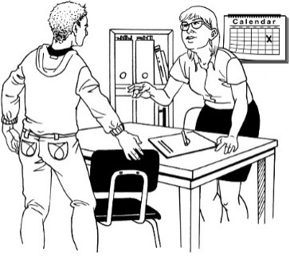
This was because people:
thought the school supported young people
liked the Brothers who were teachers at Marylands School.

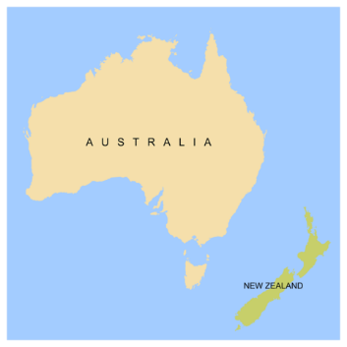
The Order brought Brothers from Australia to work at the school.

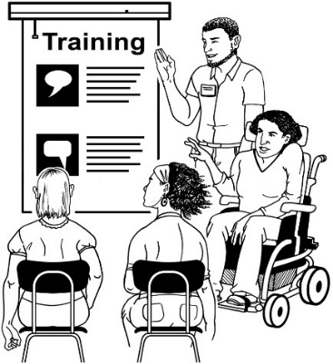
Most of these Brothers had no training in:
teaching
working with disabled children.
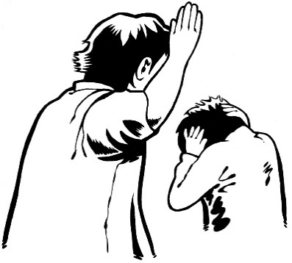

Survivors have said students were abused by Brothers throughout the 30 years the school was open.

Some boys may have been abused every day.

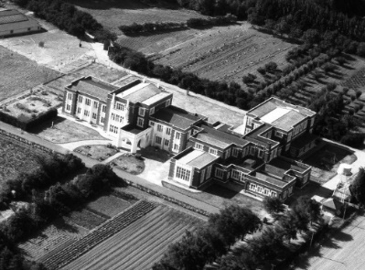
St Joseph’s Orphanage was:
near the school
run by a different Catholic group.
The Royal Commission is not looking at St Joseph’s Orphanage.

Some people who were in the Orphanage have told us they were also abused by the Brothers in the Order.

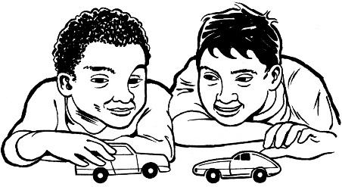
The Order did not:
understand the needs of the boys
keep track of their
- disabilities
- ethnicities.

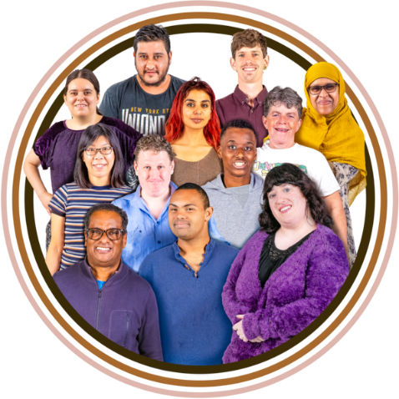
Ethnicity means if you are:
Māori
Pākehā / European
another ethnicity like Asian or Pasifika.
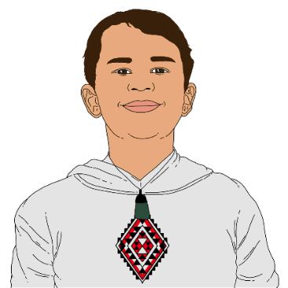

Some of the people at the school were rangatahi Māori / Māori young people.

Instead of teaching the boys the Order made them work:
in the laundry
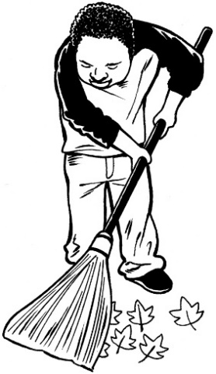
in the kitchen
on the land.

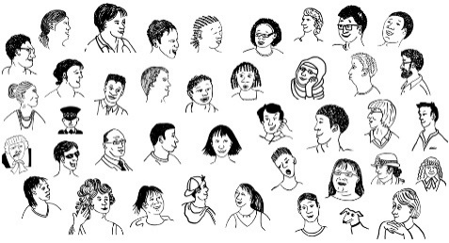
More than 5 hundred boys went to Marylands School.

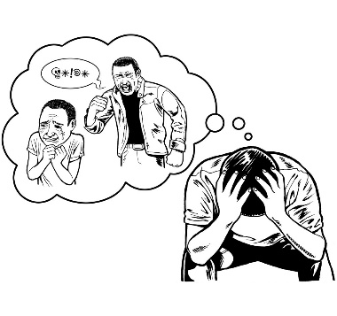
More than 1 hundred of those boys said the Brothers abused them.

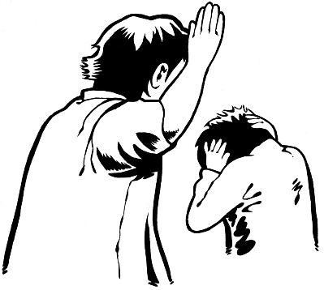
The abuse at Marylands School included:
physical violence which means hurting the body
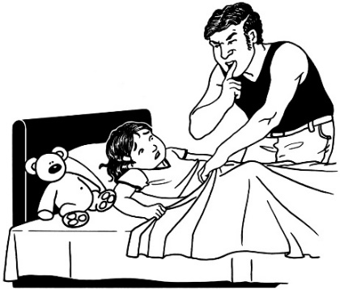
rape which means forcing someone to have sex
other sexual abuse.
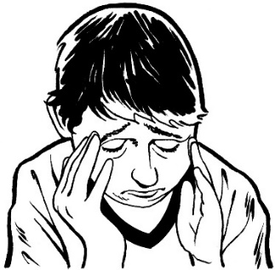
Sometimes boys were abused in front of other boys to scare or punish them.

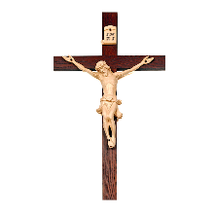
The Brothers used religion as part of the abuse.

The children were always afraid.

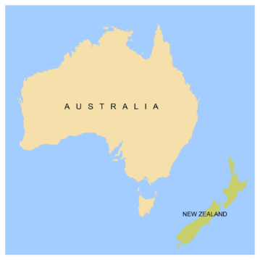
The Brothers at Marylands School were from Australia.

They went back to Australia after their time in Aotearoa New Zealand.

The Brothers did not know about:
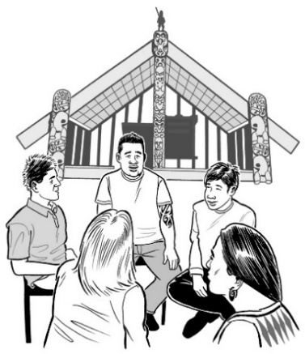
the culture in Aotearoa New Zealand
te ao Māori / the Māori world
what other cultural groups needed.

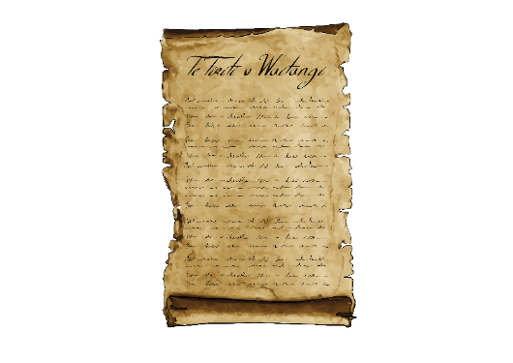
The Catholic Church / Bishop of Christchurch did not check that the Order were following te Tiriti o Waitangi / the Treaty of Waitangi.

The Bishop of Christchurch is in charge of the Christchurch part of the Catholic Church.

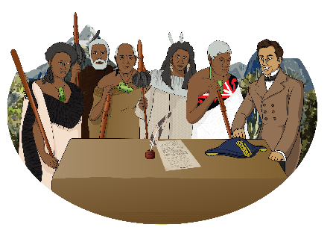
Te Tiriti o Waitangi is a legal document that was signed in 1840.

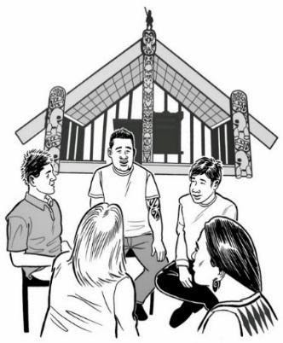
The Treaty / Te Tiriti is important to New Zealand.

It is about Māori and the New Zealand Government:
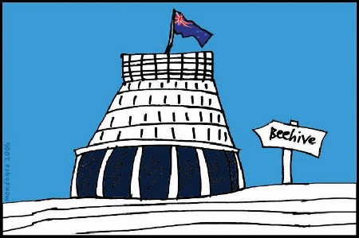
making decisions together
protecting things that are important to Māori.
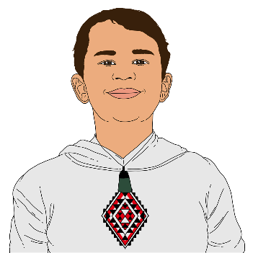
Some Brothers were racist to Māori students.

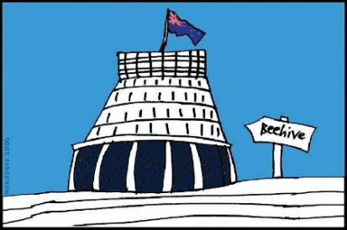
The Government was part of:
setting up Marylands School
paying for Marylands School for 30 years.

The Government did not:
seem to care about the boys at Marylands School
check that the boys were being cared for.

Life at Marylands School was awful for the boys there.

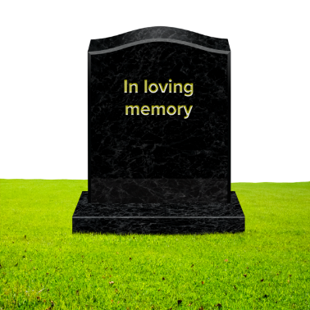
Some boys saw violence that they think may have caused the deaths of other boys.

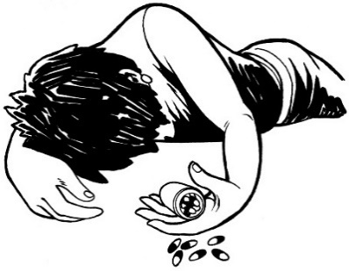
Some boys talked about killing themselves.

Hebron Trust

The Government took over running Marylands School from the Brothers in 1984.

In 1986 the Brothers started the Hebron Trust in Christchurch.

The Government let Hebron Trust become a state service provider in 1990.

Being a state service provider means the Government pays them to provide services.

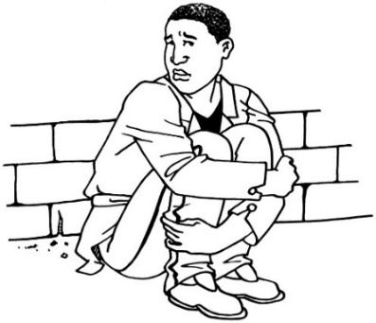
Hebron Trust was meant to care for young people who needed support like those who did not have anywhere to live.
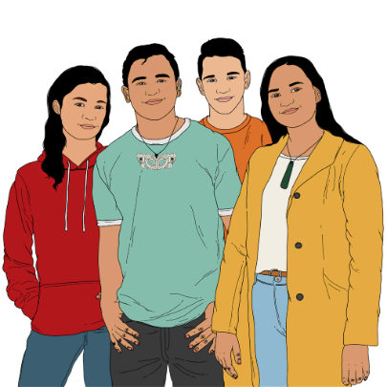

Many of these young people were Māori.

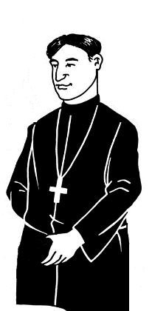
Brother McGrath was in charge of how things worked at Hebron Trust.

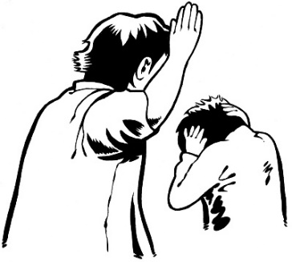
Brother McGrath used his job to abuse many of the young people he was meant to care for.

This abuse included:
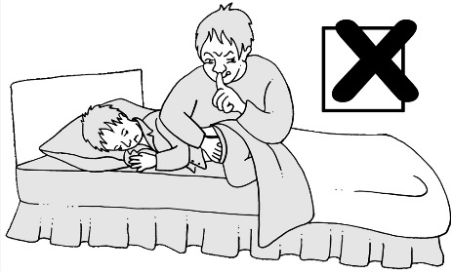
physical abuse
rape.

The abuse of rangatahi / young people by Brother Garth at Hebron Trust kept getting worse.

Brother McGrath was able to abuse other young people who lived in the Christchurch community.

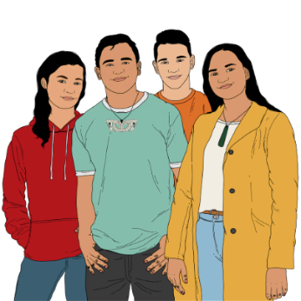
He often abused rangatahi Māori / young Māori.

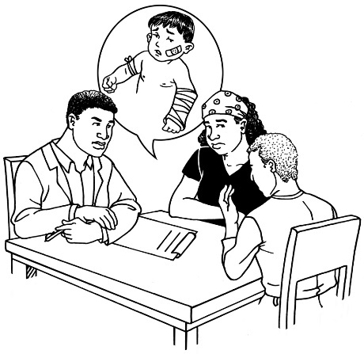
28 people at the Hebron Trust said they has been abused by Brother McGrath.

Most of these people were under 18 years old when the abuse happened.

The Order was also told Brother McGrath had abused a staff member.
Even though the Order knew Brother McGrath had abused people at Marylands School they did not:
check on him
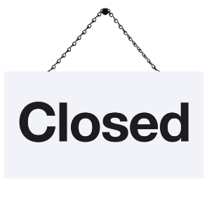
look into abuse at Hebron Trust they had been told about.

Hebron Trust closed in 1993.

We will probably never know about all the abuse Brother McGrath did.

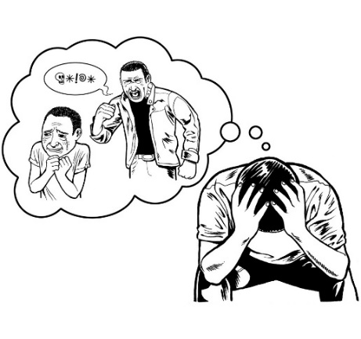
The abuse at Hebron Trust caused a lot of harm to survivors.

Effects of the abuse

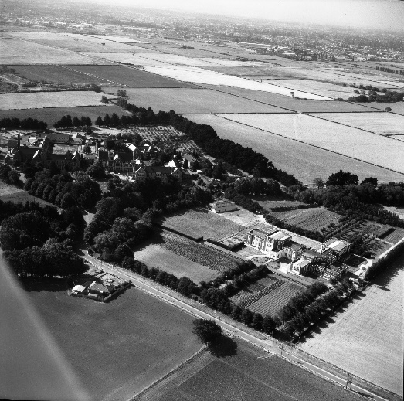
The abuse had many effects on the boys at:
Marylands School
Hebron Trust
St Joseph’s Orphanage.

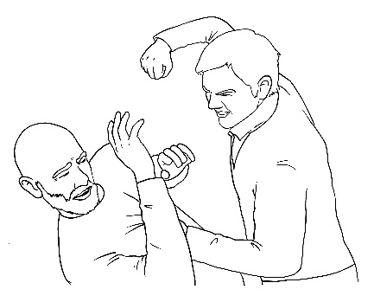
Some of the boys:
became violent
did sexual things they should not be doing.

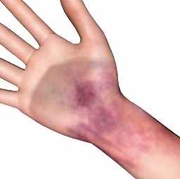
Some had injuries from the abuse that:
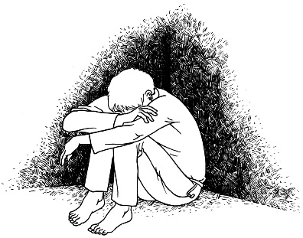
were painful
lasted a long time.

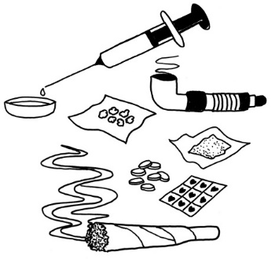
Many of the survivors that the Commission spoke to said they used drugs or alcohol to cope with the abuse.

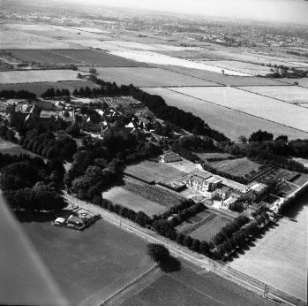
Some started using drugs or alcohol when they were still at school.

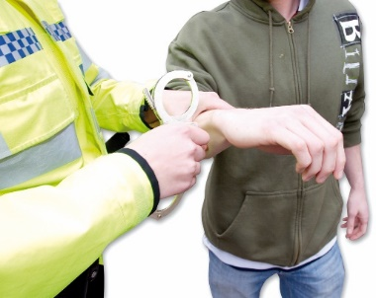
Often this led to the boys:
doing crimes / breaking the law
joining gangs.

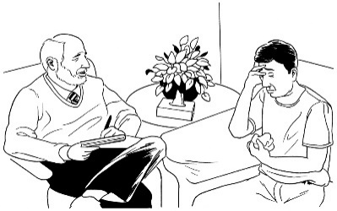
Survivors also talked about:
being very upset
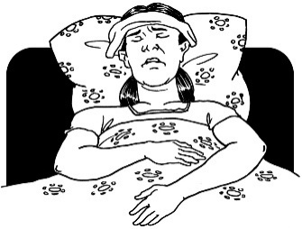
having medical issues to do with their bodies
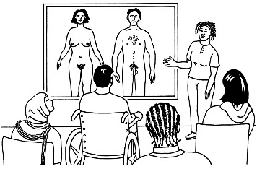
being confused about things to do with sex.

The abuse meant some survivors:
stopped believing in their religion
could not trust people
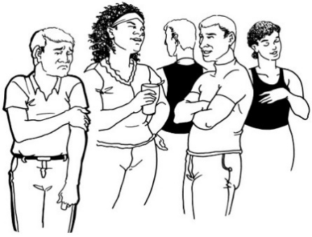
found it hard to:
- make friends
- have good relationships with people like their children or partners.

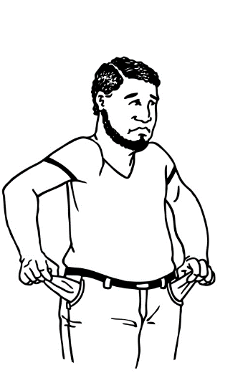
As there was not good education most of the survivors were only able to get jobs that paid badly.

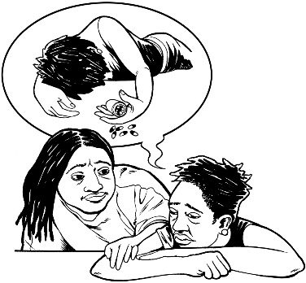
Many survivors told us they had:
thought about suicide
tried to die by suicide.
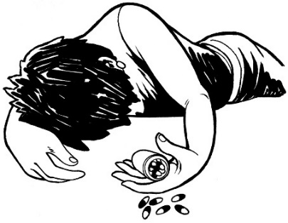

Suicide is when someone kills themselves.

Other people who were abused have died by suicide.

Complaints and what happened with them

Children told lots of people about abuse including:
Brothers
the leaders of the Order
social workers
police.

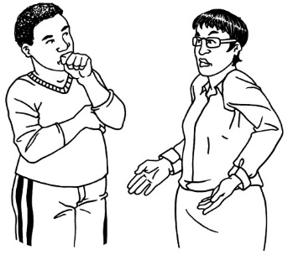
Most of the time the children were not believed.

Almost every time they were told about abuse the Order / Catholic Church did not do anything.

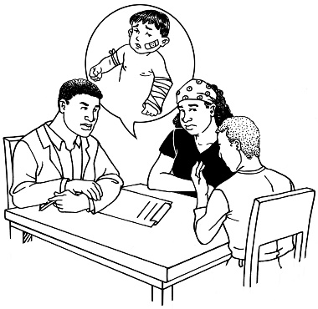
The leaders of the Order were told about abuse by the Brothers lots of times between:
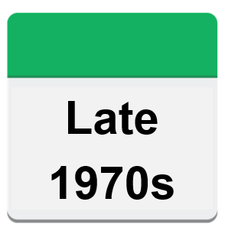
the late 1970s
and

the early 2000s.

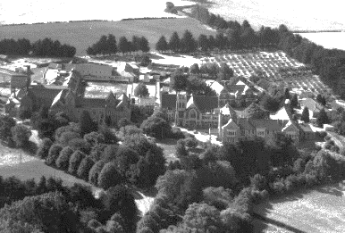
37 Brothers worked in Christchurch during the time the Order was running Marylands School.

21 of those Brothers had someone say they had been abused by them.

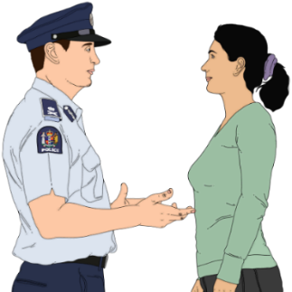
The police tried to look into what happened 2 times.

Both times the Brothers / Order were not helpful to the police.
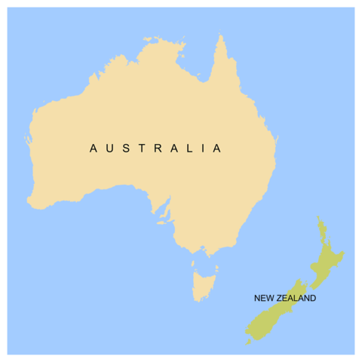
The Order spent lots of money to stop Brothers being sent back to Aotearoa New Zealand from Australia so they could be sent to court.

The police / courts did not support survivors.

Police did not:
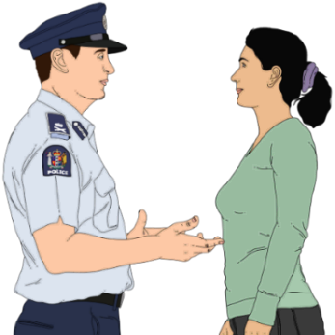
keep information about survivors who were disabled
ask for support to communicate with disabled survivors
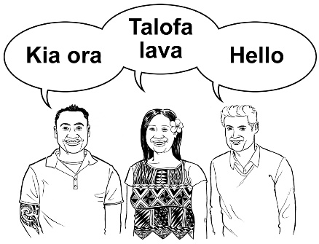
do things in a way that was a fit for the culture of Māori and Pacific people.

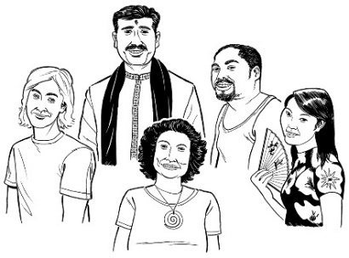
Culture is a way of:
thinking that a group shares
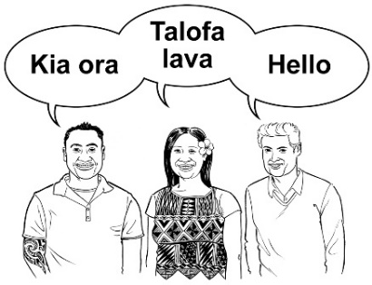
doing things as a group.

There are many different cultures in
Aotearoa New Zealand.
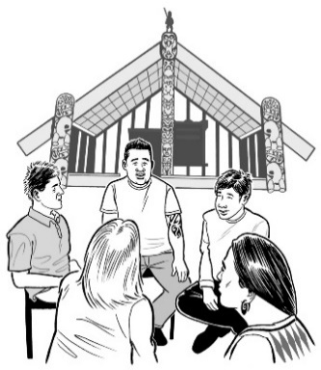

Some examples of the different cultures are:

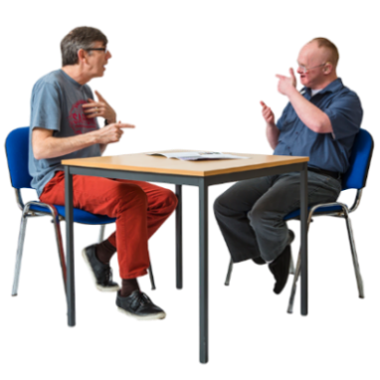
Māori culture
Pacific culture
Deaf culture.

New Zealand Police agreed it can be hard for disabled survivors to be treated fairly in court.

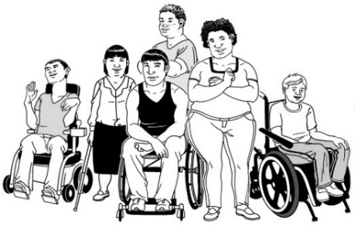
The Commission was told by survivors and their whānau / families that the criminal justice process:
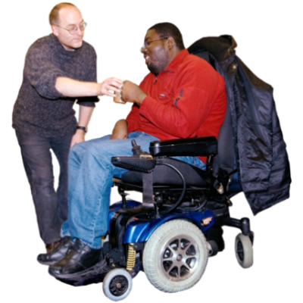
did not care about how survivors were affected by disability
did not allow them to have the support they needed when talking in court
did not care about their disability when they were being asked questions in court
ignored what they had to say.

The criminal justice process means things to do with:
police
courts.

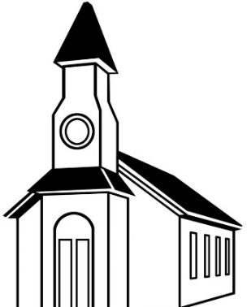
The Bishop of Christchurch:
supported the Order in New Zealand
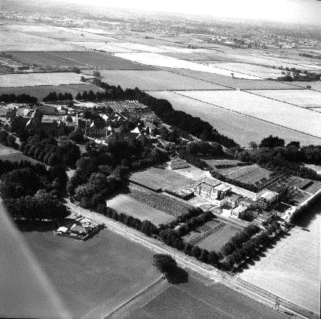
did not carefully look at what the Order did at Marylands School and Hebron Trust.
When people found out about the abuse in 2002 the Bishop:
did not take any responsibility
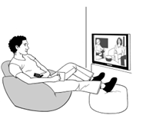
said he was unhappy about the abuse being in the media
wanted to make sure people did not think bad things about the church.

Media means things like:
- radio
- television
- newspapers.

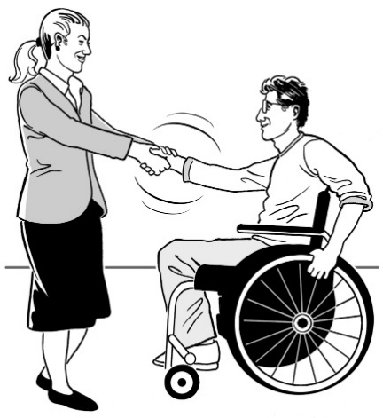
Taking responsibility means you say you:
should have done things differently
have a part to play in making things better.

Brother McGrath

The courts said Brother McGrath had sexually abused children.

This was said by the courts:
in 1993 in Aotearoa New Zealand
in 2006 in Aotearoa New Zealand
in 3 court cases in Australia.
Brother McGrath was found gulity of breaking the law more than
1 hundred times.
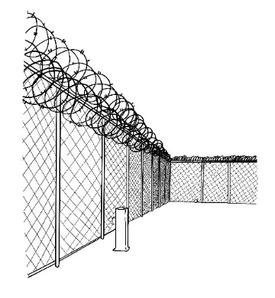
Brother McGrath will likely spend the rest of his life in prison in Australia.

Brother Moloney

Brother Moloney led Marylands School in the 1970s.

The court said he had broken the law 7 times.
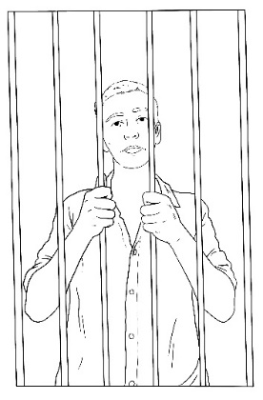

He was sent to prison for 2 years and 9 months.

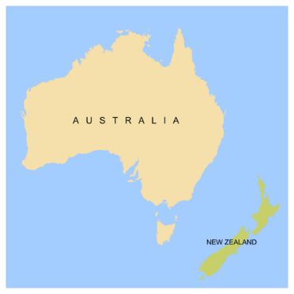
He went back to the Order in Australia after he was let out of prison.

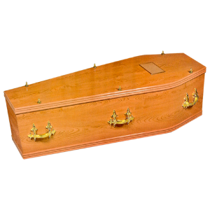
He died in 2019.

Brother Garchow

Brother Garchow was going to be in court in 2008.

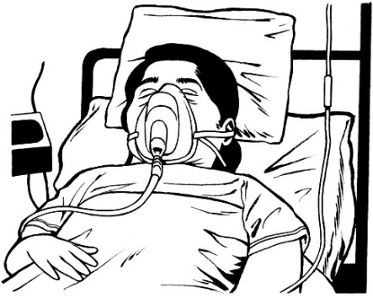
The court case did not happen because:
he was ill
some of the survivors were ill.
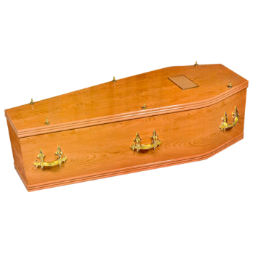
Brother Garchow died in 2011.

Brother IU

The courts say we cannot use the real name for Brother IU.

We are calling him Brother IU instead.

Brother IU was going to have a trial in 2008.
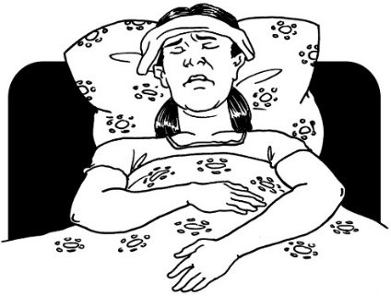

The trial did not happen because some of the survivors were ill.

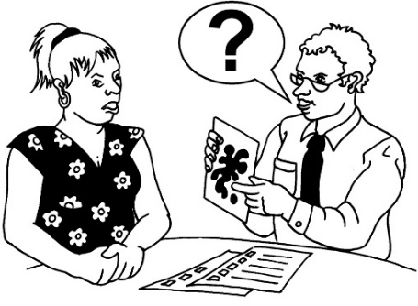
Brother IU tried to make people who said he had abused them have a test of their mind.

The police thought this was to try and make the survivors look wrong.

Brother IU had his charges removed because:
the tests took a long time
the charges were about things that happened a long time ago.

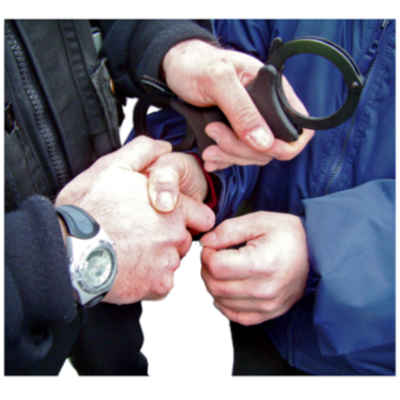
Charges are when the police say:
they think you did a crime
you have to go to court.

Human rights

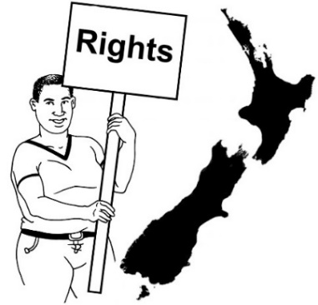
The Government has to protect the human rights of those in care.

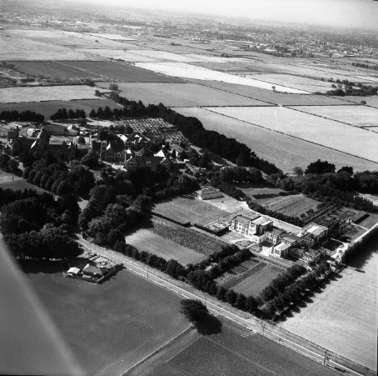
The Government may not have done what it needed to at:
Marylands School
Hebron Trust.

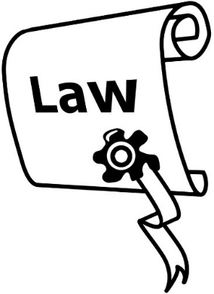
The Order may be legally responsible for those who got services from Hebron Trust.

Being legally responsible means that:
the law says you have to do something
the courts can take action if you do not.

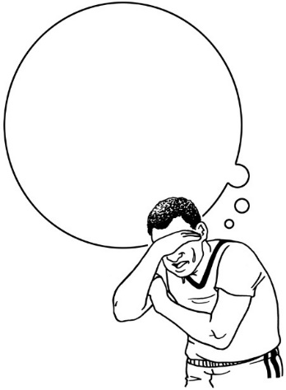
The Commission cannot say which people are legally responsible.

The Commission thinks the Government and the Order should think about if they are legally responsible.
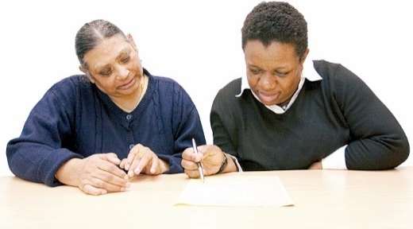

Taking a person or organisation to court is hard for anyone.

Survivors should also get support with access to justice.

Access to justice means things like being able to take the people / organisations responsible to court.

Te Tiriti o Waitangi / The Treaty of Waitangi

Te Tiriti o Waitangi / The Treaty of Waitangi means there are things that must happen for tamariki Māori / Māori children when they are cared for by:
the State
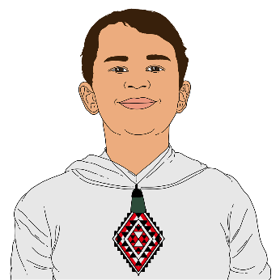
faith-based institutions.

The boys did not get care that fitted with te Tiriti o Waitangi.

State care is when a child is placed in care that is managed by the Government.

What the Commission found
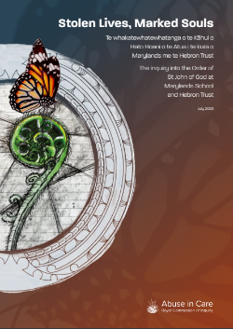

In the full report the Commission outlines 42 things they found out.

The things they found out were about the failures of:
the Order
the Catholic Church
the Government / country.

Failures are when people did not do what they should have done to keep people safe.

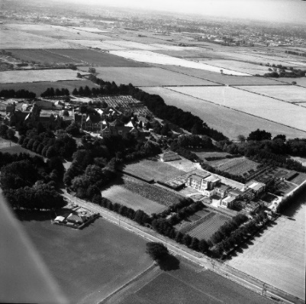
Some of these failures were that the Government:
was part of setting up Marylands School and Hebron Trust
gave money to Marylands School
sent young people to Hebron Trust without checking if they would be safe
did not check that Maryland School and Hebron Trust supported te Tiriti o Waitangi
did not make sure people were held responsible for the abuse.

The Catholic Church and the Order of the Brothers of St John of God failed to give the children:
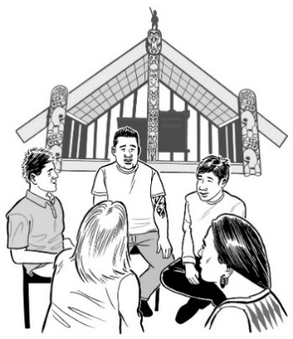
support
learning
understanding of te ao Māori / the Māori world.

The Brothers caused very bad harm to these young people.

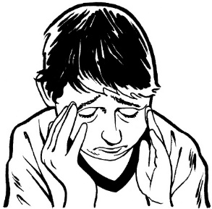
The Brothers also kept trying to avoid responsibility for the terrible things they did.

The Order has still not tried to support survivors.

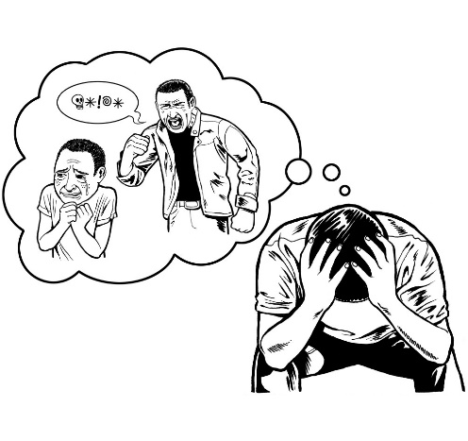
When boys told social workers or police about the abuse they did not do anything.

The Catholic Church and the Order have never tried to find out why abuse at Marylands School was so bad.

This report is not just about:
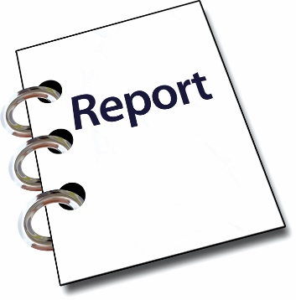
a few people who did abuse
the crimes the courts have said the Brothers did.

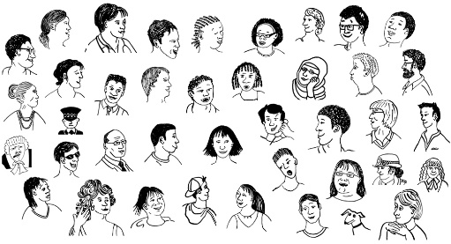
The Commission heard from hundreds of:
survivors
whānau / families.
The Order / Church have not:
been found responsible for the many terrible things that happened at Marylands School / Hebron Trust
taken responsibility for not dealing with what was happening.

The Government has also not been found responsible or taken responsibility.

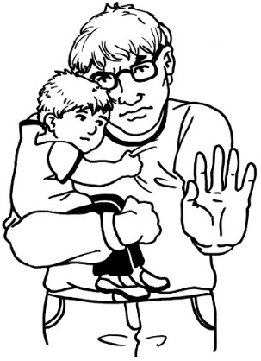
Because they have not been found responsible we cannot be sure something like this will not happen again.

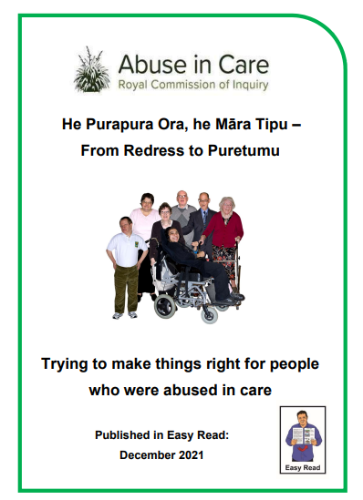
In December 2021 we wrote an Easy Read document called:
He Purapura Ora, he Māra Tipu – From Redress to Puretumu.

You can find this document on the Commission website at:
www.abuseincare.org.nz/our-progress/reports/from-redress-to-puretumu/

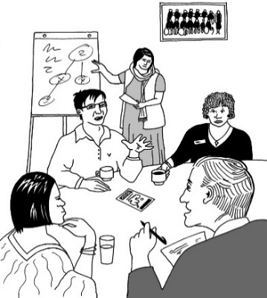
This document talked about a way of making things right for survivors called a puretumu system.

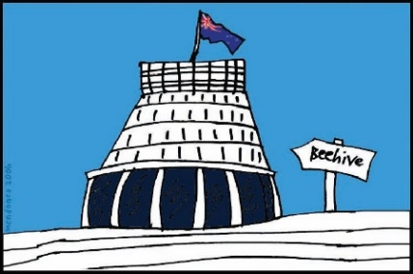
What we have found here supports the idea that the puretumu system must be for both:
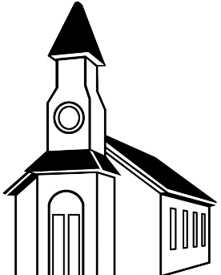
places run by the Government
faith-based institutions which means places run by religious groups like churches.

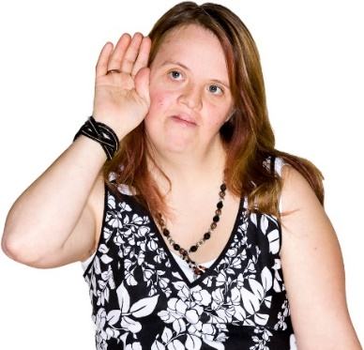
Aotearoa New Zealand must listen to people saying there should be justice.

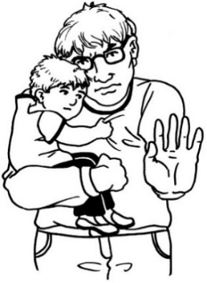
Big changes are needed to make sure nothing like this happens again.

More information

You can find more information on the Royal Commission of Inquiry into Abuse in Care website.

The website is at:

www.abuseincare.org.nz

You can also talk to someone at the Commission:

Phone: 0800 222 727

Text: 8185

Email: contact@abuseincare.org.nz

You can also find support through the Survivor Experiences Service.

Their website is at:

www.survivorexperiences.govt.nz

You can contact them:

Phone: 0800 456 090

Text: 8328

Email:

contact@survivorexperiences.govt.nz

This information has been written by the Royal Commission of Inquiry into Abuse in Care.

It has been translated into Easy Read by the Make it Easy Kia Māmā Mai service of People First New Zealand Ngā Tāngata Tuatahi.

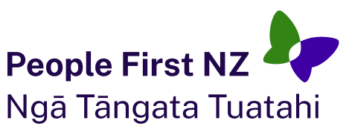
The ideas in this document are not the ideas of People First New Zealand Ngā Tāngata Tuatahi.

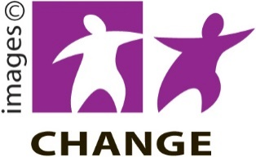
Make it Easy uses images from:

- Changepeople.org

- Photosymbols.com

- SGC Image Works

- Huriana Kopeke-Te Aho.
All images used in this Easy Read document are subject to copyright rules and cannot be used without permission.

